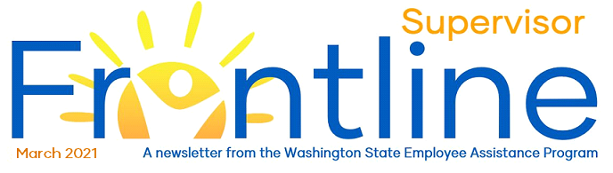
Barn’s burnt down — now I can see the moon. - Mizuta Masahide

Engaging in Race Discussions
In this month’s newsletter:
Engaging in Race Discussions
Critical Incident Response
EAP Live and On-Demand Webinars

Contact EAP
eap.wa.gov
Toll free: (877) 313-4455
Phone: (360) 407-9490
Interpreters available.
TTY: call 711 via WA Relay

(Content adapted from Colorado State EAP’s Guide for Leaders: Engaging in Race Discussions)
The ability to engage in conversations about race and ethnicity is a vital skill for today’s leaders. These conversations can evoke discomfort, stress and even anxiety, but they are crucial for creating a safe, trusting environment.
In the context of EAP’s role in helping people manage stress and anxiety, we offer the below as some suggestions when engaging in race conversations.
Here are some common questions and concerns:

What if I say the wrong thing?
Since we cannot fully understand someone’s felt and/or lived experience, our responses will undoubtedly be imperfect. We might not have all the answers, but we do have control over how we respond. To reduce the chance of saying “the wrong thing”, consider responses like:
- It seems like this is really [important to, painful for, upsetting to] you. I don’t have a full response right now. Can I research this further and get back to you?
- I am willing to learn more about this. Can you tell me more?
- I want to take some more time to think this over. Can we plan a time to talk again?
If you offer a response that suggests you need more time, or an opportunity to research, ALWAYS follow-up with more information or a thoughtful response.

How do I listen without immediately offering suggestions?
Solutions-finding is an important leadership skill. You call upon this skill regularly in your interactions with others, but its use can at times be a barrier to effective communication. The person with whom you are communicating might experience you as being dismissive of the topic of race. Consider the following:
- Listen to understand the speaker
- Be empathetic
- Be curious
- Be aware of defensiveness in your physical or emotional posture

How can I get better at recognizing my own blind-spots and biases?
Supervisors curious about recognizing their own biases can pursue learning opportunities. The Inclusive Leadership Series: Recognizing Implicit Bias workshop helps leaders become more aware of the role and impact of their blind spots on team working relationships. This is a 2-hour workshop designed to help leaders build their leadership competence with a focus on biases. The Mitigating Implicit Bias in the Hiring Process is a 4-hour class designed to develop managers' knowledge, skills and awareness for reducing the impact of bias in hiring processes and decisions.
Leaning into personal development opportunities is an important step in leading your staff more effectively and in addressing concerns and anxiety about navigating courageous conversations.
Leaders can also turn to a curated list of online resources found here: Learning Pathway Resources for Workplace Culture and DEI.
See these two articles relevant to recognizing blind spots and biases:
- 12 Common Biases That Affect How We Make Decisions
- Understanding Your Biases

Critical Incident Response
A critical incident is defined as an event resulting in an impact sufficient enough to overwhelm the coping skills of individuals in a group/team. When a critical incident occurs, the EAP can provide guidance to supervisors, managers and HR personnel on how to support affected employees. Critical incident support can be most helpful 3 to 10 business days following an event. The EAP can assist with:
- Helping to identify critical issues, next steps and potential risks to individuals and groups and the organization.
- Equipping supervisors and managers with the tools and resources to support individuals and groups before, during and after an event.
Please see the Critical Incident Response Guide (PDF) for more information. The guide covers examples of critical incidents, what to expect from impacted employees, making the initial announcement about the incident and ways to support employees.
The EAP offers Live Webinars, COVID-19 Related Webinars and On Demand Webinars to promote workforce well-being. Check the Webinars page for a complete list of all available webinars.

EAP Live and On-Demand Webinars

Upcoming Live Webinars
EAP Orientation – Tuesday, March 16th @ 10:00 AM to 10:30 AM (Registration link)

COVID-19 Related Webinars and On Demand Webinars
Leading Teams and Supporting Employees through COVID-19 (On-Demand, YouTube video)
Leading the Human Side of Change (Presentation slides PDF)

