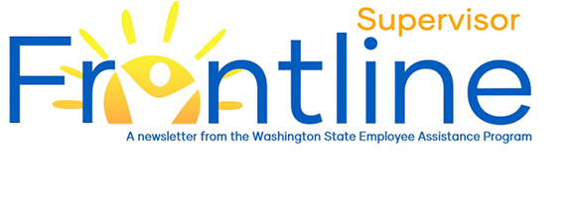
Nov/Dec 2021
Life’s most persistent and urgent question is, ‘What are you doing for others? – Martin Luther King Jr.

Domestic Violence and the Workplace
In this month’s newsletter:
Domestic Violence and the Workplace
Supporting Employees
Resources
Contact EAP
eap.wa.gov
Toll free: (877) 313-4455
Phone: (360) 407-9490
Interpreters available.
TTY: call 711 via WA Relay

While October’s National Domestic Violence Awareness Month has come to an end, the need for awareness, advocacy and support continues.
Domestic violence affects everyone, existing in every community and affecting all people regardless of age, socio-economic status, sexual orientation, gender, race, religion.
The Center for Disease and Control Prevention (CDC) reports one in every four women and one in 10 men will experience domestic violence in their lifetime. Every year, an estimated 1.3 million women are victims of physical assault by an intimate partner and 85 percent of domestic violence victims are women.
The workplace is not immune to the impact of domestic violence. The National Coalition Against Domestic Violence reports that between 21-60% of victims of intimate partner violence lose their jobs due to domestic violence. It is estimated that victims of domestic violence lose a total of 8 million paid workdays every year.
Recognizing the signs of domestic violence can be an important step in supporting employees. Fear and shame often prohibit the targets of domestic violence from telling their supervisors or HR professionals what they are experiencing. The following are some potential signs that an employee might be experiencing domestic violence:
- Marital and/or family problems
- Disruptive personal visits and/or disruptive experiences during videoconference meetings
- Visible poorly explained or unexplained physical injuries
- Suicidal thoughts, statements or attempts
- Absenteeism, lateness, leaving work early, arriving early
- Inability to travel away from the office for work-related events
- Exhibits fear, anxiety, depression and/or fatigue
- Unusual and/or excessive number of phone calls and/or texts
- Shows a decrease in productivity.

Supporting Employees
Supervisors can help employees experiencing domestic violence by directing them to the EAP or to local shelters. Avoid trying to counsel the employee directly. See this Guide for Supervisors from Workplaces Respond to Domestic & Sexual Violence for more information about supporting employees.

Resources
- Domestic Violence Emergency Shelter Programs and Advocacy Services, Washington State Department of Social and Health Services
- Domestic Violence Resources – Compiled by Washington State EAP
- Domestic Violence Leave Policy – Washington State Department of Labor & Industries
- Guidelines for Domestic Violence Protection and Anti-harassment Orders – Washington Courts
- National Coalition Against Domestic Violence (NCADV)
- Resources for Employers and Managers – Workplaces Respond to Domestic and Sexual Violence
- Washington State Coalition Against Domestic Violence (WSCADV)

Upcoming Live Webinars

Orientation to the Employee Assistance Program (EAP)
Wednesday, November 17, 2021 -- 2:00 p.m. - 2:30 p.m. Click to Register

Strategies for Stress Management*
*November and December dates to be announced soon.
Visit the Webinars page for detailed information about our live and on-demand webinars.

