**Contract Management 101**

**Module 3**

**Participant Workbook**

**Essential Elements of Contract Management**

|  |
| --- |
| 03/026/2015 Current Version |
| 12/02/2014 Original Version |

Table of Contents

Essential Elements of Contract Management 2

Course Introduction 2

The Contract Is Signed…Now What? 7

Elements of Contract Monitoring 12

How To Implement Contract Management 21

Resources 49

# Essential Elements of Contract Management

## Course Introduction

**Slide 2 – Course Introduction**

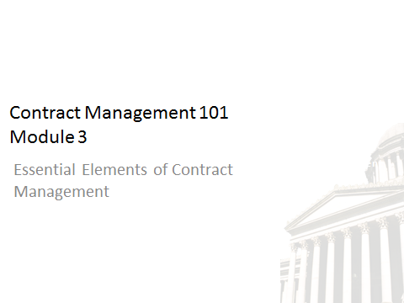

**Welcome to Contract Management 101, Module 3.** This is a new Training driven by Procurement Reform, and is required for all Contract Managers.

In order to receive credit for this course, you will need to score 80% or higher on the module assessment. The assessment will begin at the end of this module. Once you have successfully completed all four modules and assessment, you will receive a Contract Management 101 certificate of completion.

Also included in the training course are knowledge checks. These are not graded; they are simply used to test your knowledge of the materials in the course.

We strongly recommend you print the workbook for the course. As you proceed through the training, use the workbook to write down any notes and/or questions you might have.

The workbook can be accessed here: http://des.wa.gov/about/pi/ProcurementReform/Pages/PRTraining.aspx -or – simply click “Workbook” on the top right corner of the screen. Click on the workbook to download it to your desktop.

**Disclaimer:**

At the time of publication in January 2015, all materials and RCWs referenced are current. Updated course work will be made available if and when revisions are needed. As always, confirm current RCW references.

**Slide 4 – Module Overview**

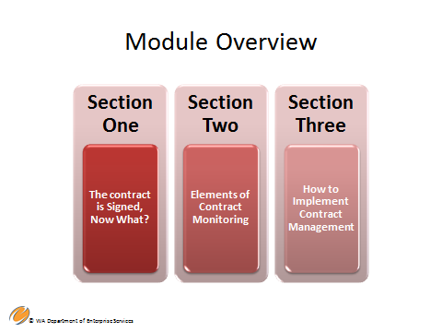

**Contract Management 101 Module Three**

**Section One - The contract is signed, now what? This section contains the following topics:**

* **Things to do first**
* **Communication**
* **Considerations for IT Contracts**

**Section Two - Elements of Contract Monitoring**

* **Documentation and Communication**

**Section Three - How to implement Contract Management**

* **Critical Activities**
* **Monitoring Performance**
* **Contract Extensions and Amendments**
* **Closing the Contract**

**For purposes of this training course, the laws and policies discussed are those of the state and individual agencies and do not reflect federal requirements. Federal requirements tend to be more restrictive and may apply if using federal funds.**

**Slide 5 – Learning Objectives**



**By the end of this course, you will be able to:**

* **Demonstrate the importance of contract execution and monitoring in effective contract management**
* **Recognize the contract management cycle**
* **Apply contract management processes and agency best practices**
* **Practice how to extend and modify a contract**

|  |  |
| --- | --- |
| Notes |  |

**Slide 6 – The Contract Is Signed…Now What?**



**Section One - The contract is signed, now what?** Contains the following topics:

* Things to do first
* Communication
* Considerations for IT Contracts

|  |  |
| --- | --- |
| Notes |  |

**Slide 7 – Project Management**

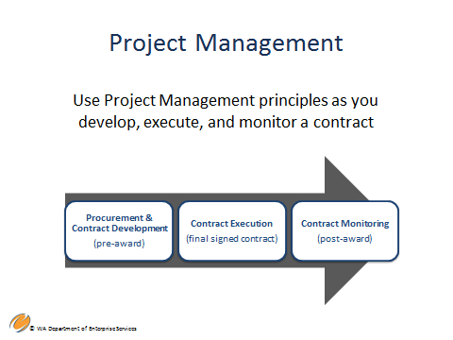

Use project management principles as you develop, execute, and monitor a contract.

The previous modules introduced the concepts shown here.

This module will discuss contract execution and will provide greater detail regarding the role of contract monitoring through the contract period of performance.

|  |  |
| --- | --- |
| Notes |  |

**Slide 8 – Elements of Contract Management**

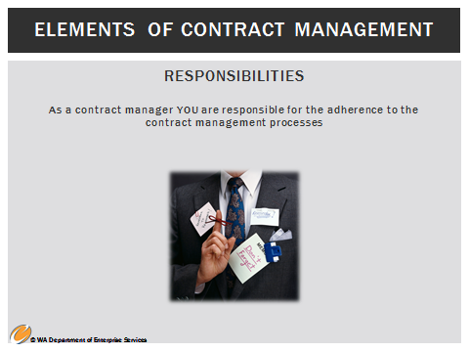

**Elements of contract management responsibilities**

Contract management responsibilities are certainly not limited to processes, however, they are a critical element of the proper management of a contract.

**Here are some examples of contract management processes**

* **Invoice approval -** In terms of invoicing, an invoice approval process should be established and communicated as part of the contract and should be discussed at your kick-off meeting. Sometimes this is also set forth in the competitive procurement document but it is a necessary part of the contract.
* **Deliverable approval** – In addition, deliverables should be tracked by the Contract Manager to ensure the agency provides appropriate approval in an efficient manner. Deliverable approval and tracking often involves coordination with the project/business owner. This process should be defined in the contract and discussed at your kick off meeting – the contractor should clearly understand the process so they know when to anticipate payment. Approval of deliverables should not be unreasonably withheld. If the deliverable is not satisfactory notify the contractor immediately so that they can make the necessary corrections or adjustments.
* **Change order control tracking** – Manage all change orders just as you would the statement of work and requirements. Make sure all change orders are mutually agreed upon. The change order process should be clearly defined in the contract and discussed at your kick-off meeting.

* **Status reporting -** Often status reports are listed as deliverables or pay points in the contract. However, don’t overburden your contractor with reporting. Reporting should be done using efficient methods that allow the contractor to complete their work while informing you of status. Coordinate all reporting requirements with your stakeholders and the contractor. Status reporting is important to discuss at your kick-off meeting to determine what works best for you and your contractor.

* **Monitoring the contract schedule –** Often the schedule is tied to deliverables or milestones. These are good indications of how the project is progressing. Another indicator asks how many tasks or how much work remains. Can work be completed on time? Keep contract progress on schedule, or communicate in order to understand and mitigate any delays.

* **Dispute management** - This is another process that should be defined early in the project. Work with your Procurement Professionals to know up front what you should do if issues arise. The formal dispute resolution process should be included in your contract.

**Note**: Do not attempt dispute management on your own! Include your Procurement Professionals right away when these issues arise.

|  |  |
| --- | --- |
| Notes |  |

Slide 11 – Elements of Contract Monitoring

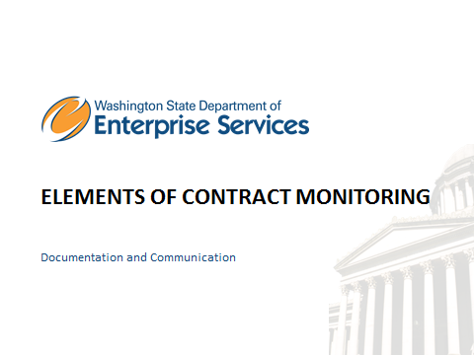

Section Two – Elements of Contract Monitoringwill cover the following topics:

* Documentation and Communication

Slide 12 - Elements of Contract Monitoring

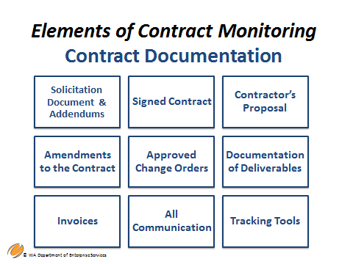

**Contract Documentation includes, but is not limited to, the following:**

* Solicitation document – This includes any addendums. Addendums are any written changes, additions, alterations, or corrections made to the solicitation document made during the proposal period. This also includes responses to bidder questions during the proposal period usually called “Q&A addendums.”
* Contractor’s proposal – The final proposal. In other words, if negotiations resulted in some changes to the proposal, the revised proposal would be considered the final proposal. The final proposal with all negotiated changes should be submitted by the awarded bidder. The agency should not revise a bidder’s proposal, but should review the submitted revised proposal to ensure all negotiated changes were incorporated and that nothing else was changed or modified.
* Signed Contract – The fully executed (signed) agreement between the agency and the awarded bidder.
* Amendments – Any changes or modifications to the contract.
* Approved Project Change orders – This is done only if a change order process was set up and defined in the contract. Otherwise, change orders do not apply.
* Deliverables and pay points – Make sure to document approval or rejection of deliverables. If a deliverable was rejected, document the reason(s) why, the action required of the contractor and proposed resolution date.
* Invoices – All approved invoices should be included in the file. It is recommended that you use a spreadsheet or some other tracking device/software to document invoices approved for payment order to track your expenditures and ensure you stay within budget.
* Communication (formal and informal) – This includes all reports, emails, telephone calls, notes to the file, etc. Telephone calls and other verbal communication should be memorialized in writing if they resulted in an agreement, decision or if other issues were discussed. If an agreement or decision was reached, consult with your Procurement Professional to determine if it should be memorialized in an amendment or numbered memorandum of understanding.
* Tracking tools – Reports or other tools that you use to monitor the contract. For example, a Statement of Work/Requirements Traceability log. Most contracts have specific requirements or deliverables listed within the statement of work. These “requirements” should be tracked throughout the life of the contract. Examples of traceability will be discussed in the next few slides.

If any contract issues arise, your contract documentation is first and foremost your most valuable reference. Contract records may be kept at different locations throughout individual agencies – for instance, original contract documents may be kept in either your contract unit or your fiscal unit. Regardless, be sure to have copies of all the documents in your contract management file. Some agencies may also include additional agency contract documentation requirements.

|  |  |
| --- | --- |
| Notes |  |

Slide 13 - Contract Documentation Examples

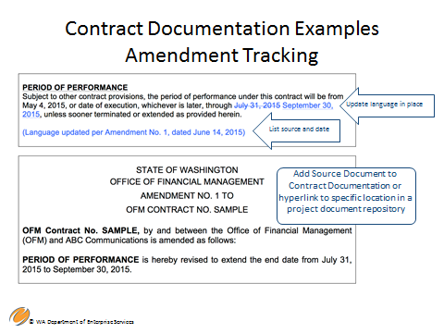

This is an example of a contract summary document used to track amendments. Some Contract Managers choose to use excel spreadsheets or other methods for tracking.

The document tracks amendments or changes to requirements over the period of performance of the contract and it includes the source of the change.

This allows for a streamlined way to find the origin of contractual modifications.

When incorporating addendums, amendments, and approved project change requests, the change to the contract language is made at the original location of the language. Simply copy and paste the original language from the contract document to the tracking document. Then copy and paste the amended language. This prevents the need to read through separate documents to find the most current requirement language.

Or, you can make a “tracking copy” of the original contract document and use track changes to insert the changes to the contract. This keeps all the language together to allow for the proper contextual framework while reading a clause.

Note: This is only an example and is not required. Consider this an example of a good practice.

|  |  |
| --- | --- |
| Notes |  |

Slide 16 - Contract Documentation Examples

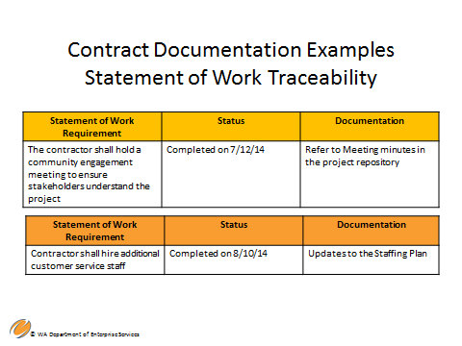

This example of a “Statement of Work Traceability Table” is another documentation tool you might consider using. The slide above identifies the statement of work requirements, the status of these requirements, and the documentation used to verify status.

These are critical elements to track through the life of the contract. This traceability table helps to ensure the contract is being completed in a way that satisfies the agency’s needs.

* This slide identifies an example of ways to document your contract requirements. Use whatever method best meets your needs and your management style. Also, check to see if your agency has any contract management processes and templates that you are required to use. Always follow your agency policies and processes.

In your workbook is a case study. At your convenience, please read the scenario and complete the example tracking tool also in your work book. Once again, this is just another example of tracking and traceability for you to consider.

Background  
  
In September of 2013, under a Convenience Contract for management consulting services a State Agency issued a 2nd Tier procurement to select a vendor to provide training program development services to the Agency.   
  
After evaluation of all bids a vendor was selected. ABC Training is the name of the vendor. The contract with ABC Training was executed on December 1st.  
  
Period of Performance  
  
The contract’s period of performance is for one year from December 1, 2013 through November 30, 2014. There is an option to extend the contract for up to 12 months.   
  
Statement of Work  
  
The original scope of work included these responsibilities that the contractor must perform:  
  
1. Conduct Project Planning   
   
Project Plan – due no later than 15 days after execution  
Communication Plan – due no later than 30 days after execution  
Status Reports – due monthly by the 5th of the month  
  
2. Define Training Program Requirements  
  
Draft Requirements – due January 25, 2014  
Draft Training Plan – due February 15, 2014  
Facilitated Requirements Review Session – TBD  
  
3. Provide Training Assistance  
  
Final Training Plan – due April 1, 2014  
Curriculum for 3 Designated Courses – Iterative delivery TBD  
Logistics Plan – due June 1, 2014  
  
Other Contract Facts  
  
Invoicing is based on fixed price per deliverable and is monthly for all deliverables submitted and accepted by the Agency that month.

|  |  |  |  |  |  |  |  |
| --- | --- | --- | --- | --- | --- | --- | --- |
| **Deliverable** | **Validation Source** | **Tied to Payment (Yes/No)** | **Target Submission Date** | **Actual Submission Date** | **Revision Date (if applicable)** | **Agency Acceptance** | **Comments** |
|  |  |  |  |  |  |  |  |
|  |  |  |  |  |  |  |  |
|  |  |  |  |  |  |  |  |
|  |  |  |  |  |  |  |  |
|  |  |  |  |  |  |  |  |
|  |  |  |  |  |  |  |  |

|  |  |
| --- | --- |
| Notes |  |

Slide 17 - Elements of Contract Monitoring

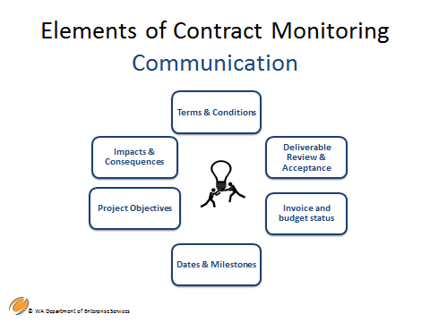

Be clear about who the point of contact is for communication and understand what it means to have your name in the contract as the Contract Manager. As the Contract Manager you must be “in the know” about all aspects of the contract or know when to seek guidance! Appropriate communication is one of your main responsibilities.

Establish communication structures and protocols early and be willing to adjust as necessary. This should be one of the first things on your kick-off meeting agenda.

Communication is an important aspect. Align your communication strategy with the communication model for the larger project, if applicable.

At no time should you give verbal approvals or disapprovals that affect the statement of work or other terms and conditions of the contract. All changes and amendments must be in writing and fully signed before work can commence.

Communication among the project manager, business owners, contractors, stakeholders, and possibly other vendors includes the following areas:

* Terms and conditions.
* Deliverables review and acceptance.
* Invoice and budget status.
* Dates and milestones.
* Project objectives.
* Impacts and consequences of not meeting contract terms and conditions.

Also, the project manager, business owners, and all others listed above must communicate with you through all aspects of contract management, especially if any of these people are working directly with the contractor. You need to be aware of all interactions and decisions made. It is recommended that you are copied in all written communication. You may have other strategies that allow you to track all communications.

Your contract might define a communication plan but the plan needs to be solidified with your team, including the contractor. You need to be proactive if the communication plan doesn’t work – be ready to modify if necessary.

|  |  |
| --- | --- |
| Notes |  |

Slide 18 - How to Implement Contract Management

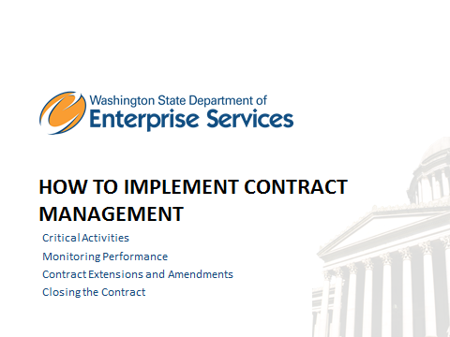

Section Three - How to implement Contract Management will cover the following topics:

* Critical Activities
* Monitoring Performance
* Contract Extensions and Amendments
* Closing the Contract

Slide 19- How to Implement Contract Management

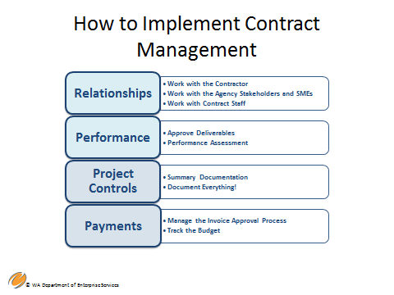

**Contract management includes the management of relationships, performance, project controls, and payments. This section of the training will describe “how” to conduct or implement sound contract management throughout the period of performance.**

**Manage relationships - Coordination and communication with agency and contractor team members who are involved in this contract is extremely important.**

* **Work closely with your contractor and be able to provide guidance and technical assistance when necessary.**
* **Work with the agency stakeholders, subject matter experts (SME’s) and management. Thoroughly understand agency business needs and be able to provide status updates and alleviate concerns.**
* **Have your Procurement Professional on speed dial! Your procurement staff is there to help you with any contract issues.**

**Performance - All work must be completed within the contract period of performance, including deliverables.**

* **Approve deliverables in a timely and efficient manner. Be sure your approval process is either defined in the contract or decided upon at your kick-off meeting – both you and the contractor should agree. The contractor should know the approval standards are, how to correct if necessary, and when to expect payment. Do not unreasonably withhold approval of payment.**
* **Proactive monitoring will help you keep track of contractor performance, responsiveness, and the ability to keep to stay on schedule and budget. If issues arise, contact your Procurement Professional. Work with them to act on issues immediately. Resolve issues before they become a bigger problem.**

**Project controls - help to achieve the desired result of the contract. Project control disciplines include strategy and planning to help you optimize the outcome of the contract.**

* **Establish summary documentation or other tracking tools as previously discussed.**
* **Document everything! Leave no part of your contract management and monitoring activities undocumented. A contract is a legal document. Therefore, in the case of contract disputes, resolution may actually result in legal action or litigation. Documentation is critical to protect the state!**

**Payments - Services should be performed or goods provided to the satisfaction of the Contract Manager before payment is approved. As noted, approval should not be unreasonably withheld.**

* **As the Contract Manager, you will most likely approve invoices. Be sure that what is billed is in accordance with the compensation terms of the contract. Do not approve payment for things that are not included in the contract.**
* **You are responsible to track the contract budget and ensure that the contract total is not exceeded.**

|  |  |
| --- | --- |
| Notes |  |

Slide 20 – Critical Activities of Contract Management

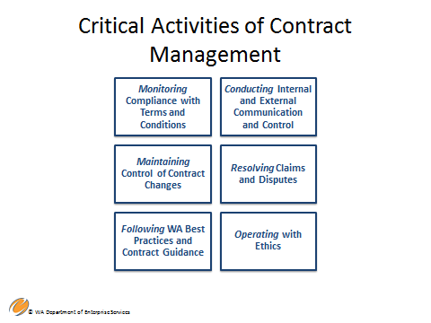

**The following are critical activities associated with the management and the monitoring of a contract:**

* Assuring compliance with special and general terms and conditions – This can be monitored through reports and periodic meetings, both formal and informal.
* Know early when contract changes are necessary. Through effective reporting and communication strategies you will be able to determine when change orders or amendments are appropriate and be able to have them completed in time so that the project is not delayed. Work with your procurement professional when amending. For change orders, follow the process set forth in your contract. Make sure all contract changes are tracked.

Follow Washington’s Best Practices and Contract Guidance. There are few state statutes or policies about contract management. See RCW 39.26.180. Use best practices as discussed in this training, provided by your Procurement Professionals and adhere to the language set forth in your contract. And follow your agency’s policies and guidelines.

* Have an effective plan for both internal and external communication and control as previously discussed.
* When you need to resolve contract claims and disputes always work with your Procurement Professional. If you don’t have a procurement professional, work with your assistant Attorney General (AAG). Don’t try to do this on your own. Poorly handled disputes can lead to larger legal problems.
* Manage your contract in an ethical manner. Procurement involves high ethical standards. Conflicts of interest and other ethical issues can arise. Educate yourself and be cautious. **Note:** You are required to take the “Ethics and Procurement” training. Check the DES training website or the Learning Management System (LMS) for available dates and times.

Examples of where ethical issues can arise:

* Lunch or dinner business meetings with contractors.
* Gifts from contractors.

|  |  |
| --- | --- |
| Notes |  |

Slide 21 - How to Implement Contract Management Relationships

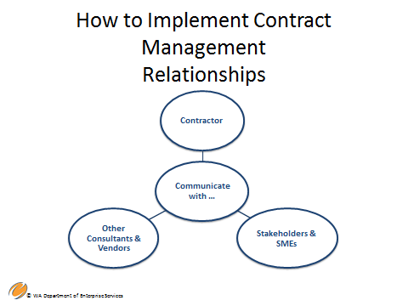

In order to maintain strong contract management relationships, effectively communicate with:

* **Contractors** – Always remember this is a business relationship do not treat the contractor as an employee. Establish a communication and coordination strategy that includes both formal and informal reporting and meetings or check-ins. Meetings and other periodic contact with the contractor to review progress will help facilitate continuous dialog and mitigates problems.

* **Stakeholders and SMEs** – These groups each need different information from you. Develop a strategy to understand what information they need, and how often reporting is required.

* **Other Consultants and Vendors** – If your project is complex, you may have multiple contractors who need to work together in a coordinated way. You will need to provide the coordination and communication process between the entire work team. A good business practice is to have periodic group meetings with the contractors and your team to determine how the work is progressing, if there are any obstacles, or any redundant work being done.

|  |  |
| --- | --- |
| Notes |  |

Slide 24 - How to Implement Contract Management

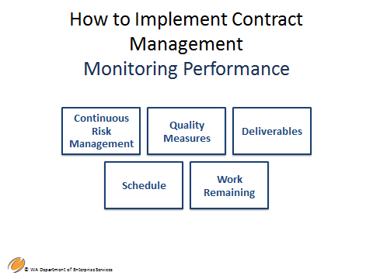

**Contract Management and Performance –**Contract Managers track a contractor’s performance and progress towards successful completion.

Performance monitoring can include,

* **Continuous risk management** – Risk assessments must be conducted throughout the period of performance because risk is dynamic; it changes! As risks change, your responsibility is to update your risk management plan.

* **Quality measures** – Measure the quality of service or the goods being provided by the contractor. Be sure your contractor knows and understands how they are being measured – provide them with constructive feedback.
* **Deliverables** – Measure the deliverables in accordance with your contract or as determined and agreed upon in your kick-off meeting and documented in an amendment. Be consistent and timely in your acceptance of deliverables and do not unreasonably withhold your approval. Do not require the deliverables to meet standards that have not been agreed upon.

* **Schedule** – Track the project schedule and make sure the contractor is adhering to it. Also, it is extremely important to track whether your agency is delaying the schedule and causing contractor delay. As contract managers we need to make sure that we and our agency are on schedule as well. The contractor should not be held responsible for agency delays. If delays are caused by the agency, you may need to consider an amendment to allow the contractor to finish the work.
* **Work remaining** – Keep track of work remaining throughout the period of performance and determine if the work can reasonably be completed in the time remaining. If it cannot be completed, brainstorm solutions.

|  |  |
| --- | --- |
| Notes |  |

Slide 25 - How to Implement Contract Management

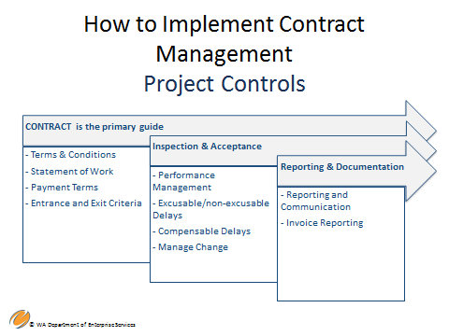

Project control is a project management term which is very important to good contract management. The term “control” is often equated to the concept of authority; however, in project management it has a completely different meaning. It means continually making course adjustments as necessary, with one main objective in mind – a successful outcome.

Project controls include the people, processes and tools used to plan, manage, and mitigate cost issues, schedule issues, and any risk that may impact the project or contract.

In order to set up effective project controls and make effective adjustments,

* Know the essential components of the contract. The contract will clear up most areas of misunderstanding if it is written well. The contract is the guide for understanding requirements relating to the following six elements.

**Special and general terms and conditions**

**Statement of work**

* Deliverables.
* Compensation.
* Performance specifications and expectations.
* Requirements.

**Payment Terms**

* Payment schedule and requirements for payment.

**Entrance and Exit Criteria**

* Project schedule.
* Deliverable review and approval process.
* Milestone completion – in other words, what does “done” look like?

**Inspection and Acceptance which includes;**

* Performance management - this involves monitoring vendor performance.
* Excusable and non-excusable delays – either by the contractor or the agency.
* Compensable delays – Delays that are not the fault of the contractor.
* Manage change –
  + Know when and how to manage project changes.
* **Reporting and Documentation:**
* Two quick reminders**,** 
  + Make sure your strategies and plans are working effectively.
* Make sure all invoices are accurate, and that all necessary approvals have been obtained.

|  |  |
| --- | --- |
| Notes |  |

Slide 26 - How to Implement Contract Management Payments

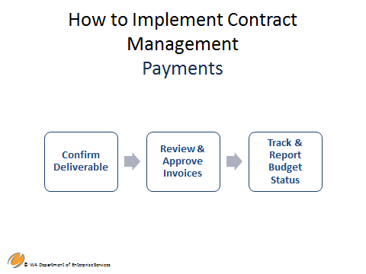

**To implement payment**

1. **Confirm deliverable or contract milestone completion –**The contractor must understand the standards they are expected to meet when developing and submitting deliverables or meeting milestones. Those standards must be agreed upon and consistent.
2. **Invoicing review and approval** – Do a thorough invoice review prior to signing and approving the invoice for payment.

1. **Cost reimbursement –** Review of cost reports and detailed breakdown of costs – You need a detailed report describing the work accomplished to validate line item amounts claimed.

Remember, the contract is your guide. Contract Managers compare billings/invoices with contract terms to ensure the costs being charged are accurate, consistent with the contract requirements, and within the compensation limits set by the contract. If the contract is paid through multiple funding sources, you may need to verifying that payments are tracked by fund to prevent over-payments of any fund source.

**Examples:**

* Your payment methodology is performance-based, based on defined deliverables. You receive the deliverable and it meets approval standards. You should check your contract for the agreed upon cost for that deliverable and make sure that is the amount requested on the invoice. If so, approve the invoice for payment.
* Your payment methodology is time and materials because your agency was unable to clearly identify the level of effort it would take to accomplish the work. You receive an invoice for 80 hours of work. You required a detailed report with the invoice that described and validated the work accomplished in those 80 hours and did not receive the report, you do not have enough information to approve the invoice.

Depending on the type of payment approach, the process of verifying invoices may be different. Here’s a guide for the different payment methodologies discussed in Module 1:

* **Fixed price –** Verify that the minimum standards for the fixed price breakdown is met (e.g., if monthly, what is the monthly reporting/service requirement?)

* **Performance based** – Review of performance standards and expectations from the contract, including deliverables by a certain date, number of services performed, or other measurements or outcomes.

* **Time and materials** - The state pays a fixed hourly rate, and for the costs of certain specified services or materials. You need a detailed report that adequately describes the work accomplished and the cost of the itemized materials.

* **Track and Report Budget Status -** Tracking / reporting on budget status to both internal stakeholders and the contractor

|  |  |
| --- | --- |
| Notes |  |

Slide 29 - How to Implement Contract Management Amendments & Extensions

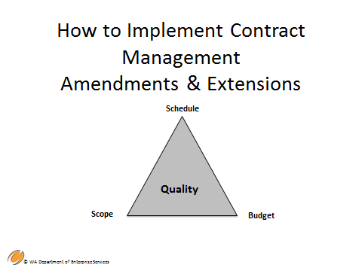

**Contract Amendments & Extensions**

As we begin to discuss contract amendments and extensions, it’s important for to understand the difference between the “scope of work” and the “statement of work.”

**SCOPE OF WORK -** A detailed, written description of the conceptual requirements for the project contained within a competitive solicitation document. The scope of work should establish a clear understanding of what is required by the vendor.

**STATEMENT OF WORK -** This is the response from the vendor that outlines very specifically how the vendor proposes to complete the work as stated in the scope of work. It is included in the contract and defines what will be done, by whom, when and for what price.

If there are changes to the contract resulting from the defined scope, such as statement of work, schedule, period of performance, or budget then it may be necessary to initiate a contract amendment.

|  |  |
| --- | --- |
| Notes |  |

Slide 30 - Steps to Amend a Contract

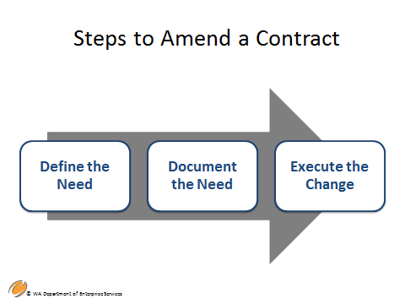

**Define the need for the amendment**

* Why is the contract change needed? Document the business need and reasons for the amendment and why it is essential to a successful outcome.
* Is the original scope being changed? If the answer to this is “yes” you should consider competitively procuring a new contract. By changing the scope you are changing the intent of the original procurement and circumventing the competitive process.
* Is more money added to the contract due to higher than expected volume of services or compensable delays? You will need to justify why you are adding more money to the contract. The addition of money should equate to the addition or continuation of work.

**Document the Need**

* With the assistance of your Procurement Professional, draft the contract amendment to define the required changes to the statement of work, the schedule or period of performance and cost or other necessary changes.
* Document approval for any budget impacts.

**Execute the Change**

* Make sure you have a signed amendment in place before any work covered by the amendment is started.
* Continue monitoring activities and contract management to include all the amended activities.

Also, at your convenience, please complete exercise #2 in your workbook.

|  |  |
| --- | --- |
| Notes |  |

Slide 31 - Substantial vs..Non-substantial Changes

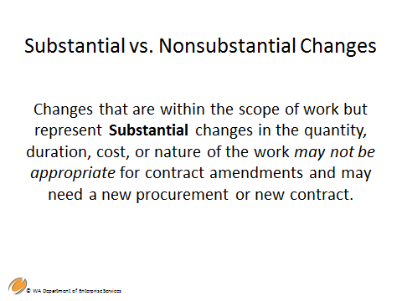

Substantial vs. non-substantial changes – How to determine if a contract amendment is appropriate or if a new contract should be procured.

It may become necessary to make changes to the contract in order to enhance or improve the deliverables or services. The main areas of contract changes that require amendments are:

* **Statement of Work –** Adding, modifying, or deleting tasks, services or deliverables, or revising specifications
* **Cost –** If the total amount of the contract is increased or decreased a contract amendment is required.
* **Period of Performance –** An extension to the end date of the contract

Changes to contracts may be awarded as amendments rather than as new contracts if the changes are within the general scope of work of the original contract**.**

However, changes that are within the scope of work but represent substantial changes in the quantity, duration, cost, or nature of the work *may not be* appropriate as a contract amendment. Consider whether or not these substantial changes might have changed the competition had they been included in the original procurement document.

* Would more bidders have submitted proposals if they knew these substantial changes were a possibility?
* Could your substantial changes to the contract be construed as a circumvention of competition?

Best practice is that when substantial changes are made they should have been intended in the original procurement document, such as options to renew. If your agency decides to make substantial changes within scope that were not initially intended, be sure to have compelling justification why it makes solid business sense.

Amendments that would result in changes to the general scope of work are not appropriate. You should conduct a new competition.

|  |  |
| --- | --- |
|  |  |

* **Exercise #1**: As you are starting up this contract, how would you begin documenting and tracking performance using the worksheet here?

.

**Contract Change Log \***

|  |  |  |  |  |  |  |
| --- | --- | --- | --- | --- | --- | --- |
| **Project Name:** | |  | | | | |
| **Contract Number:** | |  | | | | |
| **Contract Prepared By:** | |  | | | | |
| **Date Contract Prepared:** | |  | | | | |
| **Vendor/Contractor Name and Telephone:** | |  | | | | |
| **Change #** | **Description** | | **Request**  **Date** | **Approval Date** | **Effective Date** |
|  |  | |  |  |  |
|  |  | |  |  |  |
|  |  | |  |  |  |
| * *Adapted from materials in “World Class Contracting” by Gregory A. Garrett* | | | | | |

Current Contract Status  
  
The contractor has an outline for the draft Training Plan that has been approved by the Agency. It is now February 1, 2014 and the Agency is expecting the Draft Training Plan to be delivered in two weeks. However, the Agency realized they want the contractor to include an additional section on E-learning into the draft plan, and the contractor is requesting a time extension to deal with this additional section.   
  
*Which of the following scenarios represents the best course of action to address this change?.*  
1) The Agency should work out with the contractor a new date for delivery of the draft Training Plan, since it’s only a draft, and just document it in a memo to file and keep in the contracts file.   
  
  
2) The Agency should execute a contract amendment to update this date since the deliverable is listed with a due date in the original contract and the Agency is asking for additional content to be included in the deliverable that was not part of the outline. This is not really additional scope for the contractor, but does impact the deliverable that is part of the statement of work.   
  
  
3) The Agency should demand the deliverable on the same schedule and expect this additional section to be included. The Agency should reject the deliverable if it is not included.

.

|  |  |
| --- | --- |
| Notes |  |

**Step 34 - How to Implement Contract Management Closing the Contract**

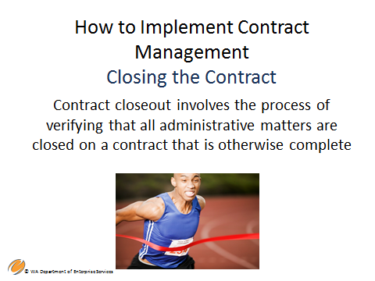

Contract closeout involves the process of verifying that all administrative matters are closed on a contract.

**Contract Closeout**

Contract Managers are responsible at a minimum to consider the following eight elements;

* Confirm that all services have been provided and contract objectives and outcomes have been met.
* Address any required audits, and make sure all audit issue are resolved.
* If issues arose during the period of performance, assure those issues are resolved.
* Complete all contract documentation, and follow the pertinent record retention schedules
* Ensure contractor has accounted for and returned any state property or equipment that was used during the contract engagement.
* Ensure all invoices have been received and authorized for final payment.
* Hold a close-out meeting with the contractor to discuss performance, lessons learned, and other topics that are important to the agency’s business needs.
* Determine the agency’s next steps based on the contractor’s work.

Please refer to the example of a contract closeout checklist in your workbook.

**Contract Closeout Checklist \***

|  |  |
| --- | --- |
| **Project Name** |  |

|  |  |
| --- | --- |
| **Contract Prepared By:** |  |
| **Date Contract Prepared:** |  |
| **Vendor/Contractor Name and Telephone:** |  |

|  |  |  |  |
| --- | --- | --- | --- |
| **Complete**  **(✓)** | **Activity** | **Planned Complete**  **Date** | **Actual Complete Date** |
|  | All contracted products, services, or deliverables were provided. |  |  |
|  | Documentation adequately shows receipt and formal acceptance of all contract items. |  |  |
|  | No claims or investigations are pending on this contract. |  |  |
|  | All actions related to contract price revisions and changes are concluded. |  |  |
|  | All outstanding subcontracting issues are settled. |  |  |
|  | If a partial or complete termination was involved, action is complete. |  |  |
|  | The final invoice has been submitted and payment has been made. |  |  |

* *Adapted from materials in “World Class Contracting” by Gregory A. Garrett*

**Slide 35 – Summary & Key Points**

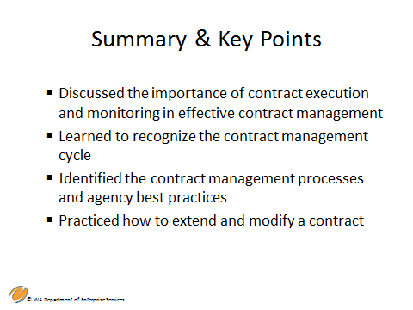

In this module, we covered,

* The importance of contract execution and monitoring in effective contract management
* The contract management cycle
* Contract management processes and agency best practices
* Practiced how to extend and modify a contract

Next steps Module 4 – Contract Changes, Disputes, and Appeals

|  |  |
| --- | --- |
| Notes |  |

**Slide 36 – Questions**



If you have questions after the training, please contact:

Cheryl A. Shaw

Contract and Legal Services Training Manager

Department of Enterprise Services

1500 Jefferson St SE

Olympia, WA 98504

(360) 407-9376

|  |  |
| --- | --- |
| Notes |  |

## Resources

DES Policies – Contracting & Purchasing Policies, Training, and Resources

<http://des.wa.gov/services/ContractingPurchasing/Pages/default.aspx>

RCW 39.26 – Procurement of Goods and Services

<http://app.leg.wa.gov/rcw/default.aspx?cite=39.26>

SAAM 16.20 – Client Service Contracts – Contract Award, Management, and Monitoring

<http://www.ofm.wa.gov/policy/16.20.htm>



Contact Us By Phone

For questions, feel free to contact us by phone at 360-407-2200.

Locations & Directions

Our headquarters office is at 1500 Jefferson, on the Capitol Campus in Olympia, Washington. DES operations are also located throughout the state.

[Enterprise Services headquarters at 1500 Jefferson Building](http://www.des.wa.gov/about/AboutDES/Pages/LocationsDirections.aspx#1500Jefferson)

[Other Enterprise Services locations](http://www.des.wa.gov/about/AboutDES/Pages/LocationsDirections.aspx#OtherLocations)

DES Headquarters at 1500 Jefferson Building

The headquarters of Enterprise Services is the 1500 Jefferson Building, which will also serve as the state’s new data center. The building is part of state government’s historic Capitol Campus and is the newest structure built on the grounds since 1992.

Mailing Address

Washington State Department of Enterprise Services PO Box 41401 Olympia, WA 98504-1401

Physical Location

1500 Jefferson Street SE Olympia, WA 98501 - [Map](http://www.des.wa.gov/SiteCollectionDocuments/campus-map.pdf)