## PCBs Preference in Procurement - Desk Aid

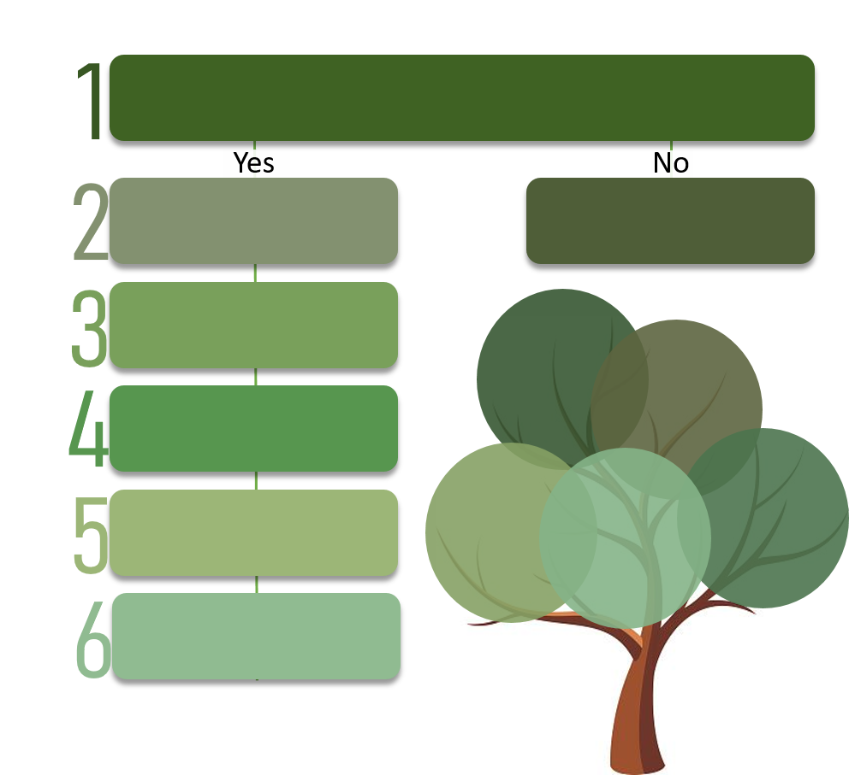

**[PCBs Risk Calculator](https://des.wa.gov/sites/default/files/public/documents/About/Procurement_reform/training/NonStateEmp/PCB/PCBsRiskCalculator/story_flash.html)**

**Sample Language**

[**Sample Bidder Certification**](https://des.wa.gov/sites/default/files/public/Bidder_Certification_Environmental_Preference.docx?=8f07d)

**[PCBs](https://youtu.be/EZOQdBr1dyc)**

**[Documentary](https://youtu.be/EZOQdBr1dyc)**

Include PCBs language in your solicitation and mark it in WEBS

**FAQs**

Plan how you will break down the preference during the evaluation.

Plan how the PCBs preference

will be applied.

Proceed in completing your procurement, and skip the other steps found in this desk aid.

Determine if the product you are purchasing needs testing for PCBs.

[Use this PCBs Risk Calculator](https://des.wa.gov/sites/default/files/public/documents/About/Procurement_reform/training/NonStateEmp/PCB/PCBsRiskCalculator/story_flash.html)

Include PCBs language

in your sample contract

Rank tests in order of amount of PCBs present in product.

[RCW 39.26.280](https://app.leg.wa.gov/rcw/default.aspx?cite=39.26.280) [POL-DES-280-00](https://des.wa.gov/sites/default/files/public/documents/About/Procurement_reform/Policies/DES-280-000PCB.pdf)

# Step 1. Determine whether the product you are purchasing should be tested for PCBs.

1. Use this [PCBs Risk Calculator](https://des.wa.gov/sites/default/files/public/documents/About/Procurement_reform/training/NonStateEmp/PCB/PCBsRiskCalculator/story_flash.html) to determine whether the product you are purchasing should be tested. If you have questions about this process, the Department of Ecology has provided a resource/subject matter expert: Contact Kari Trumbull, (360) 407-6093 or email [kari.trumbull@ecy.wa.gov](mailto:kari.trumbull@ecy.wa.gov).
2. A helpful hint to avoid the need to test for PCBs: If available, choose a transparent, non-pigmented metal, or unpainted wood version of the product, the product’s packaging, or both.

Note: You may have noticed that the last question on the calculator was regarding the products’ packaging or labeling. By requesting plain packaging from our manufacturers, we are educating them on the importance of reducing PCBs in both products and packaging.

# Step 2. Plan how the PCBs preference will be applied. There are Four considerations.

### Do you need to test one item or multiple items(s)?

* 1. One item: If the procurement is for a single item, and the bidder wishes to receive the PCBs preference, require the bidder to test the specific item.
  2. Multiple items: If the procurement is for numerous line items (e.g., office products, MRO, paint, clothing, food), specify within the solicitation that bidder must apply the test to a pre-determined line item or items within the bid.

For example, if the solicitation is for multiple office products, the agency could specify each bidder test specific items such as yellow sticky notes, blue tape, green paper, but not the items that most likely do not contain PCBs. Or, if the solicitation is for traffic marking paint and there are several items on the contract, such as shown in the example below, the agency could specify that only the yellow paint and the sealing solvent are tested.

Example of items included in procurement for traffic marking paint:

* Preformed Thermoplastic Pavement Markings, White
* Steel Transfer punch sets
* Airless line Striper Sprayer gun
* Steel ADA template Stencil
* Steel Alphabet template Stencil
* Steel Safety and Warning Stencil
* Sealing Solvent
* Yellow Paint

### Determine Frequency of PCBs Testing. Will you require the bidder to test the item(s) at other times throughout the term of the contract? If so, determine how many times. Include the predetermined frequency of testing needs to be established and identified in the solicitation and then again in the contract.

### Will you give the minimum 5% preference, or will you give a higher percentage?

### Will you give a cost preference or a non-cost preference?

1. If you give a cost preference, note in your solicitation that the preference is applied for evaluation purposes only. If awarded, the vendor’s pricing would be as bid. The preference won’t be paid to the vendor.
2. If you use a non-cost preference, determine the points available for preference out of the total available points.

Example: Your agency needs to purchase 200 (75 medium, 75 large and 50 x-large) yellow rain coats with your agency’s logo. Your agency will provide the vendor with the logo patches. On pages 5 and 6, you will see a sample of how you could use a **non-cost preference** of 10%. On page 7, you will see a sample of how you could use a **cost preference** of 5%. Remember, you can make your PCBs preference higher than 5%.

Step 2.3 (continued)

**Non-Cost Preference Example:**

Example of purchasing 200 yellow jackets is an example of a bid tab using a non-cost preference of 10%.

This example procurement uses the following evaluation criteria:

Non-cost (specifications) 40

Cost 60

PCBs Preference (10%) 10

Total Points 110

In this example, the PCBs Preference will be awarded as follows:

10 Points = Tested, and no PCBs were found

9 Points = Tested, lowest level of PCBs

8 Points = Tested, 2nd lowest level of PCBs

7 Points = Tested, 3rd lowest level of PCBs

6 Points = Tested, 4th lowest level of PCBs

5 Points = Tested, 5th lowest level of PCBs

4 Points = Tested, 6th lowest level of PCBs

3 Points = Tested, 7th lowest level of PCBs

2 Points = Tested, 8th lowest level of PCBs

1 Points = Tested, 9th lowest level of PCBs

0 Points = Not Tested

Note: If you are requiring PCBs testing on several items in your procurement, determine how you will award the PCBs Preference. Will each item that tests as having no PCBs receive points, or will you prorate the points across the items requiring PCBs testing?

See example bid tab on next page.

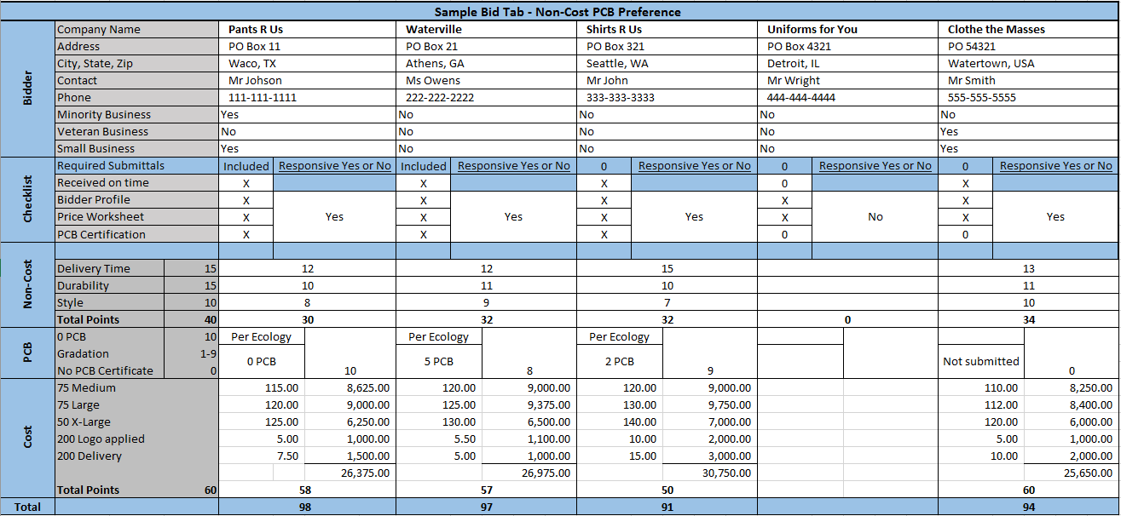

As you can see, the Apparent Successful Bidder in this case is a small and minority owned business that opted to test for PCBs and received the most points. Remember, you can always make the PCBs preference higher than the 5%.



Step 2.3 (continued)

**Cost Preference Example:**

Example of purchasing 200 yellow rain coats using a cost preference of 5%.

**Evaluation criteria: Maximum Points:**

Non-cost (specifications) 40

Cost 60

+ PCBs Preference (5%)

Total Points 100

PCBs Preference will be awarded as follows:

5% = Tested, no PCBs

0% = includes some PCBs or Not Tested

Note: If you are requiring PCBs testing on several items in your procurement, you will need to determine how to award the PCBs Preference. Will each item receive a 5% preference if it tests no PCBs, or will you prorate the 5% across the items requiring PCBs testing?

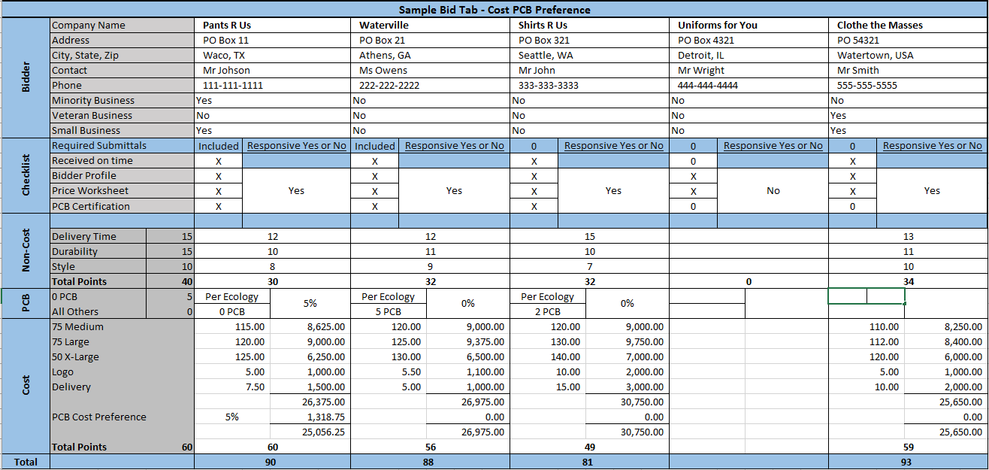

As you can see, the Apparent Successful Bidder in this case is a small and veteran owned business that opted NOT to test for PCBs and received the most points anyway. Remember, you can always make the PCBs preference higher than the 5%.

# Step 3: Plan how you will break down the preference during the evaluation.

### Let’s look at some samples, examples and scenarios:

In addition to the PCBs-free preference, agencies may design their specific procurements to meet agency, market, and other needs, which may include other factors (i.e., Human impacts and other environmental impacts). Using the PCBs preference product example, suppliers who have made product improvement efforts to reduce PCBs and have satisfactory evidence of that provided in the procurement process and in testing results, an appropriate evaluative basis evaluation model may be used. Below is an example of how you could complete this task:

* 1. First example of Gradation Evaluation Matrix: For this example, we have decided to give a 10% preference. We would use a gradation evaluation matrix as seen below.

|  |  |
| --- | --- |
| Evaluation Criteria | Maximum Points  Points |
| Price | 60 |
| Specifications | 40 |
| PCBs | 10 |
|  |  |
| Total | 110 |

Sample Gradation Evaluation Matrix:

10 Points = Tested, and found no PCBs

5 Points = Tested, lowest level of PCBs

4 Points = Tested, 2nd lowest level of PCBs

3 Points= Tested, 3rd lowest level of PCBs

2 Points = Tested, 4th lowest level of PCBs

1 Points = Tested, 5th lowest level of PCBs

0 Points = Not Tested

|  |  |  |
| --- | --- | --- |
| Bidders | PCBs | Points |
| 1 | 0 | 10 |
| 2 | 2 | 5 |
| 3 | 3 | 4 |
| 4 | 4 | 3 |
| 5 | 5 | 2 |
| 6 | 6 | 1 |
| 7 | Not Tested | 0 |

* Bidders may receive a partial preference for testing. (optional)
* According to RCW and Policy, maximum preference is reserved for no PCBs.
  1. Second example of Gradation Evaluation Matrix:

5 Points = Tested, no PCBs

1-4 Points = Tested, prorated based on PCBs levels – Lowest level receives 4 points, 1 point for highest level, with a graduation of points for all levels in between. Based on calculations (lowest level PCBs divided by bidders PCBs level times maximum points available)

0 Points = Not Tested

|  |  |  |  |
| --- | --- | --- | --- |
| Bidders | PCBs | Points | Calculation |
| 1 | 0 | 5 |  |
| 2 | 2 | 4 | 2 / 2 * 4 = 4 |
| 3 | 3 | 3 | 2 / 3 * 4 = 2.67 |
| 4 | 4 | 2 | 2 / 4 * 4 = 2 |
| 5 | 5 | 2 | 2 / 5 * 4 = 1.6 |
| 6 | 6 | 1 | 2 / 6 * 4 = 1.33 |
| 7 | 7 | 1 | 2 / 7 * 4 = 1.14 |
| 8 | 8 | 1 | 2 / 8 * 4 = 1 |
| 9 | 9 | 1 | 2 / 9 * 4 = .89 |
| 10 | Not Tested | 0 |  |

# Step 4: Include PCBs Preference in your Solicitation. This has four parts.

### Include a PCBs purpose statement regardless of whether the product you are purchasing has a low or high risk of containing PCBs.

**Sample PCBs Purpose Statement:**

Polychlorinated biphenyls, commonly known as PCBs, have adverse effects on human health and the environment. Accordingly, the State of Washington, through its procurements of goods, is trying to minimize the purchase of products with PCBs, and to incentivize vendors to sell products and products in packaging without PCBs.

### Include a statement that specifies how you will award the preference points during the evaluation.

Include any gradation evaluation matrix you will use (See Step 3). Also, two sample evaluation clauses follow.

**Sample Evaluation Clause 1:**

Pursuant to RCW [39.26.280](http://app.leg.wa.gov/rcw/default.aspx?cite=39.26.280), a preference of XX% (no less than 5%) will be given to any bidder who provides evidence as set forth herein, that the products and/or product packaging in Exhibit __ (cost worksheet), do not contain PCBs.  In the event products and/or product packaging are tested, and no products or product packaging contain zero PCBs, a preference of XX% (no less than 5%) will be given to bidders who provide evidence that the products and/or product packaging, identified for PCBs testing in Exhibit _, (title of exhibit) contain the least amount of PCBs. The method for testing products and/or packaging for PCBs must be per the U.S. Environmental Protection Agency (EPA) Analytical Method 1668c.

**Sample Evaluation Clause 2:**

Pursuant to RCW 39.26.280, a preference of XX% (no less than 5%) will be given to bidders who provide evidence that the products and/or product packaging, identified for PCBs testing in Exhibit _, (title of exhibit) pursuant to RCW 39.26.280 that do not contain PCBs.  In the event products and/or product packaging are tested, and no products or product packaging contain zero PCBs, a preference of XX% (no less than 5%) will be given to bidders who provide evidence that the products and/or product packaging, identified for PCBs testing in Exhibit _, (title of exhibit) contain the least amount of PCBs. The method for testing products and/or packaging for PCBs must be per the U.S. Environmental Protection Agency (EPA) Analytical Method 1668c.

### Include a requirement that states that the bidder must ensure the product or products still maintain the same levels of PCBs throughout the term of the contract.

When writing this requirement consider these questions:

* What are the consequences if the product that was given preference is found to now contain PCBs during the life of the contract?
* Will the item be removed from contract until corrected?
* Will the vendor be cured/suspended/terminated due to contract performance?

Determine this before issuing the solicitation, and include this information in the solicitation and in the awarded contract. WA State Department of Ecology recommends managing PCBs levels to a +/- 50% of original test results. While this may seem like a significant variance, it is industry standard for scientific testing in parts per billion.

### Include a requirement that the vendor must have the specified product/products tested if they want the PCBs preference.

1. Specify that the method for testing products or packaging for PCBs must be per U.S. Environmental Protection Agency (EPA) Analytical Method 1668c.
2. Specify that the above test usually takes 15 days to process and suggest that the contractor include that extra time in their timeline in order to meet the deadline.
3. Include a [**Sample Bidder Certification**](https://des.wa.gov/sites/default/files/public/Bidder_Certification_Environmental_Preference.docx?=8f07d).
4. Mark your preference on the Manage Solicitations screen in WEBS.

# Step 5: Include PCBs language in your sample contract.

### Include language regarding PCBs in your sample contract. An example follows:

**Sample contract warranty language:**

Contractor Preference – Product(s) Do Not Contain PCBs. Contractor represents and warrants that, during the term of this Contract, for any product(s) or product(s) in packaging for which Contractor sought and was awarded a purchasing preference pursuant to RCW 39.26.280 and Washington State Procurement Policy *****, such product(s) or product(s) in packaging shall meet or exceed the testing limitations that enabled Contractor to be awarded such preference. Notwithstanding any provision to the contrary, upon breach of warranty and Contractor’s failure to provide satisfactory evidence of compliance within thirty (30) days, Agency may suspend or terminate this Contract. The rights and remedies of the parties under this warranty are in addition to any other rights and remedies of the parties provided by law or equity, including, without limitation, actual damages, and, as applicable and awarded under the law, to a prevailing party, reasonable attorneys’ fees and costs.

### Include a purpose statement regardless of whether or not the product you are purchasing will be tested.

**Sample PCBs Purpose Statement:**

Polychlorinated biphenyls, commonly known as PCBs, have adverse effects on human health and the environment. Accordingly, the State of Washington, through its procurements of goods, is trying to minimize the purchase of products with PCBs and to incentivize its vendors to sell products and products in packaging without PCBs.

### If you have planned to require testing throughout the period of the contract, include a requirement that states that the bidder must ensure the product or products still maintain the same levels of PCBs throughout the period of the contract.

* + - 1. When writing this requirement consider these questions: What are the consequences if the product that was given preference is found to now contain PCBs during the life of the contract? I.e. will the item be removed from contract until corrected, or will the vendor be cured/suspended/terminated due to contract performance?
      2. As stated in Step 4, all of this needs to be determined before issuing the solicitation, and then included in the solicitation and then established in the awarded contract. Remember, WA State Department of Ecology recommends managing PCBs levels to a +/- 50% of original test results. While this may seem like a significant variance, it is industry standard for scientific testing in parts per billion.
      3. Specify that the method for testing products or packaging for PCBs must be per U.S. Environmental Protection Agency (EPA) Analytical Method 1668c.
      4. If you plan to require additional testing throughout the contract, include a requirement that the bidder must provide additional testing and the frequency of testing.

# Step 6: Rank tests in order of amount of PCBs.

### If the bidder tested the product/products, you will receive a Contractor Certification for PCBs Preference as well as the PCBs Analytical Method 1668c test with the bid. See Step 4.d.3 and the Samples section of this document.

### Often times, different labs present test 1668c in different formats, making it difficult for the average person to read the test results. If you would like Ecology staff to rate in ranking order the tests for you, you may send all test results together in one email to Kari Trumbull at [kari.trumbull@ecy.wa.gov](mailto:kari.trumbull@ecy.wa.gov). Ecology has estimated the turnaround time to be approximately two weeks. If you have questions about this process, Ecology has provided a resource/subject matter expert: Contact Kari Trumbull, (360) 407-6093 or email [kari.trumbull@ecy.wa.gov](mailto:kari.trumbull@ecy.wa.gov).

1. The agency shall evaluate and award based on best value in the event that no bids are received seeking a “PCBs preference” or in which none of the bids satisfy the test method for award of the preference.
2. Check the appropriate Preference/s box on the Solicitations Response screen in WEBS.

# Contacts and Resources

Contact Kari Trumbull, (360) 407-6093 or email [kari.trumbull@ecy.wa.gov](mailto:kari.trumbull@ecy.wa.gov).

* Questions about PCBs facts/risks
* Questions about PCBs test results
* Questions about whether a product should be tested for PCBs

Contact DES Customer Service, (360) 360-407-2210 or email [Contractingandpurchasing@des.wa.gov](mailto:Contractingandpurchasing@des.wa.gov).

* Questions about Providing the PCBs preference during procurement
* The testing of items for PCBs within Master Contracts

# Samples

[**Sample Bidder Certification**](https://des.wa.gov/sites/default/files/public/Bidder_Certification_Environmental_Preference.docx?=8f07d)**:** Select this link to access the updated sample.

**Sample PCBs Purpose Statement:**

Polychlorinated biphenyls, commonly known as PCBs, have adverse effects on human health and the environment. Accordingly, the State of Washington, through its procurements of goods, is trying to minimize the purchase of products with PCBs and to incentivize vendors to sell products and products in packaging without PCBs.

**Sample Evaluation Clause 1:**

Pursuant to with RCW [39.26.280](http://app.leg.wa.gov/rcw/default.aspx?cite=39.26.280), a preference of XX% (no less than 5%) will be given to any bidder who provides evidence as set forth herein, that the product(s) (including product packaging) specified in Exhibit __ (cost worksheet), do not contain PCBs. The method for testing products or packaging for PCBs must be per U.S. Environmental Protection Agency (EPA) Analytical Method 1668c.

**Sample Evaluation Clause 2:**

Pursuant to RCW 39.26.280, a preference of XX% (no less than 5%) will be given to bidders who provide evidence that the product(s), including product packaging, identified for PCBs testing in Exhibit _, (title of exhibit) pursuant to RCW 39.26.280 that do not contain PCBs. The method for testing products and/or packaging for PCBs must be per the U.S. Environmental Protection Agency (EPA) Analytical Method 1668c.

**Sample contract warranty language:**

Contractor Preference – Product(s) Do Not Contain PCBs. Contractor represents and warrants that, during the term of this Contract, for any product(s) or product(s) in packaging for which Contractor sought and was awarded a purchasing preference pursuant to RCW 39.26.280 and Washington State Procurement Policy *****, such product(s) or product(s) in packaging shall meet or exceed the testing limitations that enabled Contractor to be awarded such preference. Notwithstanding any provision to the contrary, upon breach of warranty and Contractor’s failure to provide satisfactory evidence of compliance within thirty (30) days, Agency may suspend or terminate this Contract. The rights and remedies of the parties under this warranty are in addition to any other rights and remedies of the parties provided by law or equity, including, without limitation, actual damages, and, as applicable and awarded under the law, to a prevailing party, reasonable attorneys’ fees and costs.

# FAQs.

**#1 - FAQ: What exactly does the law say?**

A: [RCW 39.26.280](https://app.leg.wa.gov/rcw/default.aspx?cite=39.26.280)

(1) The department shall establish purchasing and procurement policies that provide a preference for products and products in packaging that does not contain polychlorinated biphenyls.

(2) No agency may knowingly purchase products or products in packaging containing polychlorinated biphenyls above the practical quantification limit except when it is not cost-effective or technically feasible to do so.

(3) Nothing in this section requires the department or any other state agency to breach an existing contract or dispose of stock that has been ordered or is in the possession of the department or other state agency as of June 12, 2014.

### **#2 - FAQ: How time consuming is this going to be?**

A: That is a great question. If providing a preference for products and products in packaging that do not contain PCBs is a new process for you, it will require either two or six additional steps depending on the product you are purchasing. You may also need to add up to 2 more weeks in your solicitation time frame and 2 more weeks into your bidding award time frame. Don’t panic, we have provided you with tools to use and resources to contact in order to make it as easy as possible.

**#3 - FAQ: I heard that the a popular cereal box (bright yellow) tested really high for PCBs, so I tried using the risk calculator for that cereal, and it came back as green as if they are safe to buy without testing for PCBs. Why?**

A: This is a great question and brings up a good point that the risk calculator is just a guide, and your best tool is your own critical thinking. The risk calculator’s low score for the cereal happens because when you answered the questions on the risk calculator, you did not indicate *this product is a paper product*. Since the cereal itself is not paper, it isn’t at a high risk for containing PCBs. Although, the box it comes in, is at high risk. The PCBs from that box will eventually end up in our environment. What can you do? If you are knowingly purchasing a product that comes in packaging that looks like it has a lot of color, you could do one of the below three things, using the cereal as an example:

* + - 1. You could use the risk calculator on *just* the packaging without the cereal itself (the score will come back much higher than just the cereal), then specify that the cereal boxes, but not the cereal itself be tested for PCBs.
      2. You could bypass the calculator and trust your own critical thinking, and specify that the packaging, not the cereal, be tested for PCBs.
      3. You could just skip specifying the PCBs testing altogether and specify that the cereal need to come in plain packaging. *preferred method*

**#4 - FAQ: How much do these PCBs test cost?**

A: The cost for conducting the 1668c PCBs Test (which is cited and specified in policy) is to be at the bidder's cost. In 2017, the cost of the test was from $1,200 to $1,500 per item tested, each time.

**#5 - FAQ: How does the cost of PCBs testing not affect Washington’s goal to do business with small and diverse businesses?**

A: Due to the many variables in each individual purchase, it is hard to know whether PCBs testing will have a negative effect on small or diverse or veteran owned businesses. As you can see by the examples in this desk aid, this preference may not affect whether a small, diverse or veteran owned business becomes the successful bidder. If you think that the PCBs testing is going to negatively impact small, diverse, or veteran owned businesses on a specific solicitation that you are writing, contact your supervisor or the DES Contract and Procurement Diversity team for more guidance.

**#6 - FAQ: What labs can the bidders get the tests from?**

A: The lab does not need to be a WA State Department of Ecology Certified Lab; the only requirement is the lab must be able to conduct a 1668c test. Ecology has a list of some of the labs that offer this test, and you may locate that [list here on the Ecology](https://fortress.wa.gov/ecy/laboratorysearch/SearchMethod.aspx) [website](https://fortress.wa.gov/ecy/laboratorysearch/SearchMethod.aspx). When you get to the lab search page, you may enter 1668c in the search box as seen below. You are not required to specify the lab to be used to test for PCBs; however you may conduct your own search of labs available to perform this test.

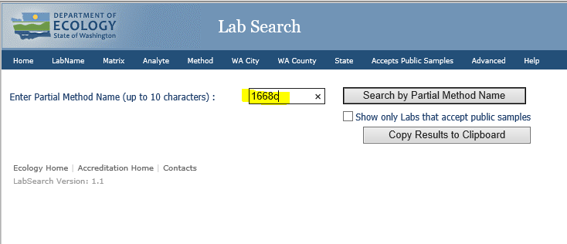

**#7 - FAQ: How do I calculate my preference percentage into preference points?**

A: Determine the number of points you will be awarding per the evaluation of the procurement. Once you know the total of points you will award, it’s just a simple calculation. Total number of awarded points times the percentage of preference. You decide to award 70 points for non-costs and 30 for costs for a total of 100 points. Your agency has chosen an 8% PCBS preference. 100 x .08 = 8 preference points.

Note: you do not need to calculate preference points if you have decided to use a cost preference.

**#8 - FAQ: Why would I want to give a higher preference?**

A: There are times when you may want to give a higher preference percentage. Best value criteria is addressed in the policy (#2) and RCW 39.26.160(3). You have the ability to design your specific procurements to meet your agency, market, environmental and other needs which may include other factors. Other factors like human impacts and other environmental impacts. Based on this information you may decide to give higher than a 5% preference. Example = yellow traffic marking paint line item on a paint bid, due to the high use, high dollar value of the contract, high safety importance, and high political impact (due to this item being considered a contributor to the PCBs in the Spokane River).

**#9 - FAQ: What is the difference between the Federal limits and Washington State’s limits regarding how many PCBs are allowed?**

A: In water, the presence of PCBs at levels below 50 parts per million is generally legal under the federal Toxic Substances Control Act. However, because of the threat to bioaccumulation that PCBs pose, Washington State water quality standards for surface waters are far lower than these standards for products. For example, the Washington State Department of Ecology sets limits for PCBs at levels as low as 170 parts per quadrillion – that’s 0.000000017 parts per million – in wastewater discharge permits.

**#10 – FAQ: Will a preference be applied to the whole bid (including all line items) if only specific line items were tested and found to be eligible for the preference?**

A: No. Unless specified otherwise in the solicitation, the preference is only to be applied to the line item(s) tested.

**#11 - FAQ: If I buy a product from a Master Contract, can I know that there are no PCBs in it?**

A: No. While the PCBs preference has been applied to Master Contracts during the solicitation process as outlined in RCW 39.26, there may still be items on that contract that contain PCBs. It is up to each individual/agency to ensure that they are making the best purchasing choices. For example, the office supply contract may still include many options for rulers. Some rulers may have pigments and dyes, and others may be made of unpainted wood. Those options remain as it is recognized that agencies have unique needs. It is up to each agency or purchaser to make the best choice that meets their purchasing needs. The law states, *No agency may knowingly purchase products or products in packaging containing polychlorinated biphenyls above the practical quantification limit except when it is not cost-effective or technically feasible to do so.* See Step 1 for assistance in making the best purchasing choices.

**#12 - FAQ: How will the Administrative Assistants, purchasing card holders, and other small purchasers in our agency know how to make the best purchasing choices?**

A: At this time, it is up to each agency or purchaser to make the best choice that meets their purchasing needs. There will be future trainings available for the small purchaser. The law states, *No agency may knowingly purchase products or products in packaging containing polychlorinated biphenyls above the practical quantification limit except when it is not cost-effective or technically feasible to do so.* See Step 1 for assistance in making the best purchasing choices.

**#13 - FAQ: Do I need to include the PCBs preference statement in ALL of my contracts, even my service contracts?**

A: No. The law, the policy, and this training are only for products and products in packaging. However, as you suggest in your question, the PCBs preference statement does need to be in ALL contracts for products and products in packaging. You may still consider including this statement in a service contract if that service comes with assumed products and products in packaging that may contain PCBs. For example, a janitorial contract. It is important that all vendors understand that “…the State of Washington through its procurements of goods is trying to minimize the purchase of products with PCBs…”

# Citations and Other Sources

Citations:

1. Source: US National Library of Medicine National Institutes of Health/[Fukuoka Igaku Zasshi.](https://www.ncbi.nlm.nih.gov/pubmed/19588843) 2009 May; 100(5):141-55. <https://www.ncbi.nlm.nih.gov/pubmed/19588843>
2. Source: US National Library of Medicine National Institutes of Health [Health status of Japanese and Taiwanese after exposure to contaminated rice oil.](https://www.ncbi.nlm.nih.gov/pmc/articles/PMC1568546/)
3. Source: EPA

<http://www.ecy.wa.gov/programs/wq/ruledev/wac173201A/comments/0060x.pdf>

1. Ecology Publication #16-04-014 September 2016. <https://fortress.wa.gov/ecy/publications/documents/1604014.pdf>
2. Source: EPA

<https://www.epa.gov/sites/production/files/documents/bioaccumulationbiomagnificationeffects.pdf>

Other Sources:

Ecology’s explanation of the PCBs testing – Publication 16-04-024

<https://fortress.wa.gov/ecy/publications/documents/1604024.pdf>

**This training was made in collaboration with the following partners to whom much thanks is owed:**

* Washington State Department of Ecology
* Senator Andy Billig, 3rd legislative district
* Washington State Department of Labor and Industries
* Spokane River Regional Toxics Task Force
* Green River College
* Washington State Department of Licensing
* Washington State Auditor’s Office
* Washington State Department of Social and Health Services
* Washington State Department of Revenue
* Washington State Patrol