# Clean Fuel Vehicles Environmental Preference (EP) Desk Aid

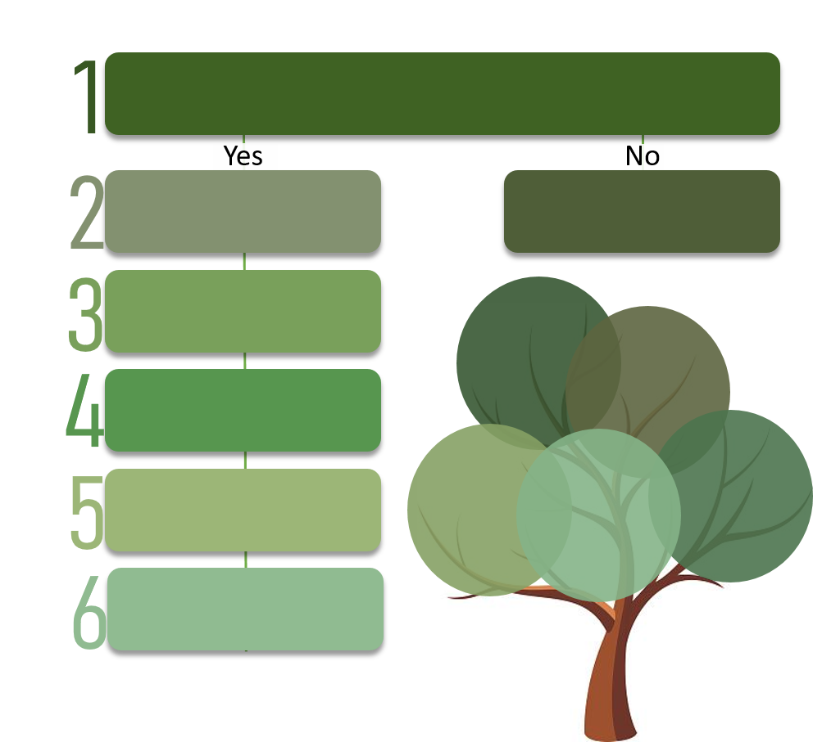

Proceed in completing your procurement, and skip the other steps found in this desk aid.

Consult with your agency vehicle person.

Plan how the preference will be applied.

Include the preference in your solicitation clause and mark it in WEBS.

Include the preference language in your sample contract.

Evaluate

Use the [Environmental Preference Calculator](https://360.articulate.com/review/content/38a719d6-ee93-4cae-8def-e58a2f3ab086/review) to determine whether your purchase has a Washington State Environmental Preference.

**Sample Language**

**FAQs**

[**Sample Bidder Certification**](https://des.wa.gov/sites/default/files/public/Bidder_Certification_Environmental_Preference.docx?=8f07d)

[**Environmental Calculator**](https://360.articulate.com/review/content/38a719d6-ee93-4cae-8def-e58a2f3ab086/review)

[**Documini**](https://youtu.be/3-oNkvKZgGI)

**Authorizing Sources:** [RCW 43.19.648](https://apps.leg.wa.gov/RCW/default.aspx?cite=43.19.648)|[RCW 43.01.250](https://apps.leg.wa.gov/rcw/default.aspx?cite=43.01.250) | [ePACT](https://www.energy.gov/eere/vehicles/epact-regulated-fleets) | [RCW 82.08.809](https://app.leg.wa.gov/RCW/default.aspx?cite=82.08.809) | [194-28 WAC](https://apps.leg.wa.gov/WAC/default.aspx?cite=194-28)

[Executive Order 20-01](https://www.governor.wa.gov/sites/default/files/exe_order/20-01%20SEEP%20Executive%20Order%20%28tmp%29.pdf)

*Save this link to your favorites. This document will be updated as needed and is best used online. Please avoid printing in color.*

# Step 1. Determine whether or not the product you are purchasing has an Environmental Preference.

Use this [Environmental Risk Calculator](https://360.articulate.com/review/content/38a719d6-ee93-4cae-8def-e58a2f3ab086/review) by selecting this link to determine whether the product you are purchasing is at risk of environmental concerns.

# Step 2. Consult with your Agency Clean Fuel Vehicles Fleet Contact or Other Vehicle Expert

* Contact your Agency Transportation Officer. Some of the larger agencies do not have a person listed. If this is true for your agency, send an email to your agency’s internal ‘fleet distribution list’. If you do send out communications to your agency’s ‘fleet distribution list’, also copy the [DES Fleet Account Representatives](mailto:mpmail@des.wa.gov) in your email.
* If your agency, board, commission, or higher education institution does not have a fleet representative, contact your DES Fleet Operations Customer Account Representative at (360) 664-9210 or send an email to [mpmail@des.wa.gov](mailto:mpmail@des.wa.gov). DES Fleet Operations And Agency Transportation Officers follow all required rules and laws regarding environmental preferences with state owned vehicles, including RCW [43.19.648](https://apps.leg.wa.gov/RCW/default.aspx?cite=43.19.648), [RCW 43.01.250](https://apps.leg.wa.gov/rcw/default.aspx?cite=43.01.250), [ePACT](https://www.energy.gov/eere/vehicles/epact-regulated-fleets), [RCW 82.08.809](https://app.leg.wa.gov/RCW/default.aspx?cite=82.08.809), [194-28 WAC](https://apps.leg.wa.gov/WAC/default.aspx?cite=194-28), and [Executive Order 20-01](https://www.governor.wa.gov/sites/default/files/exe_order/20-01%20SEEP%20Executive%20Order%20%28tmp%29.pdf). They also stay up to date on the changing federal political environment in regards to clean fuel vehicles.
* DES Fleet Operations can only provide vehicles to state agencies, boards, commissions, and state institutions of high education. If you are not at one of these entities, but still wish to use the Master Contract for vehicles, contact DES Customer Service, (360) 360-407-2210 or email [Contractingandpurchasing@des.wa.gov](mailto:Contractingandpurchasing@des.wa.gov)

***If you still need to write your own solicitation, proceed to Step 3.***

# 

# Step 3. Plan how the Clean Fuel Vehicles Environmental Preference will be applied.

1. In addition to the Environmental Preference, agencies may design their specific procurements to meet agency, market, environmental and other needs, which may include other factors (i.e., human impact and environmental impact).
2. Consult with DES Fleet Operations to ensure that you are including all environmental preferences and low emission requirements for the vehicles on your solicitation.

### Determine if you need to identify the environmental impact on multiple items.

Multiple items: If the procurement is for numerous line items (e.g., multiple types of vehicles), the agency should specify those items within the solicitation.

### Determine and identify in the solicitation if the bidder must provide notification of substitute products throughout the duration of the contract.

### Determine the percentage of a preference you will give. There is no statutory determined minimum or maximum.

# Step 4: Include a Clean Fuel Vehicles Environmental Preference in your Solicitation.

### 

### Include a *Clean Fuel Vehicle Products**Purpose Statement* regardless of whether the product you are purchasing will qualify for the Environmental Preference.

**Sample Clean Fuel Vehicles Purpose Statement:**

Improved technology has made new, clean-energy vehicles in many cases cheaper to own and operate over their life cycles than their traditional alternatives, shattering outdated notions of having to decide between doing what’s “right” and doing what is affordable. Cutting harmful pollution caused by the burning of fossil fuels in the state vehicles that state agencies purchase has a direct positive effect on human health. When purchasing or leasing vehicles and making other decisions that affect state government’s emissions of greenhouse gasses or other toxic substances, Washington State will explicitly consider the benefits and costs (including the social costs of carbon) of available options to avoid those emissions. Where cost-effective and workable solutions are available that will reduce or eliminate emissions, Washington State shall select the lower-emissions options.

### Include a statement that specifies how you will award the preference points during the evaluation.

**Sample Clean Fuel Vehicles Evaluation Clause:**

A preference of XX per product line item will be applied to any bidder that provides clean fuel vehicles as described in this solicitation. The preference shall only be applied when the vehicle meets or exceeds the specifications in this solicitation.

The preference will be applied at time of bid evaluation. When evaluating the bid price of qualifying bidders, a **XX% price reduction** will be applied to those bidder’s items that qualify for the clean fuel vehicles preference for price evaluation purposes. This preference is separate from and applied after any other preferences allowed by statue. In the event of a tie, the bidder with the larger post-consumer recovered content will break the tie and receive the award.

Accordingly, all bidders must certify whether they are seeking the statutory preference for clean fuel vehicles in this Competitive Solicitation. Bidders must make the certification on the certification form attached as Exhibit __ (Environmental Certifications).  Bidders who seek to obtain the XX% bid preference for clean fuel vehicles must, in regard to the products pertaining to this procurement, certify that the products specified in Exhibit __ (Cost Worksheet) meet or exceed the recommended clean fuel vehicle specifications in this solicitation.

1. Include any gradation matrix you will be using.

### Include a requirement that states that the bidder must ensure the product or products still maintain the same levels of clean fuel vehicles throughout the term of the contract. When writing this requirement consider these questions:

* What are the consequences if the product that was given preference is changed and no longer meets the agreed upon clean fuel vehicle specifications in this solicitation?
* Will the item be removed from contract until corrected?
* Will the vendor be cured/suspended/terminated due to contract performance?

1. Include an [Environmental Bidder Certification](https://des.wa.gov/sites/default/files/public/Bidder_Certification_Environmental_Preference.docx?=32fd9).

# Step 5: Include a Clean Fuel Vehicles Environmental Preference language in your sample contract.

### Consult DES Fleet Operations Customer Account Representative at (360) 664-9210 or send an email to [mpmail@des.wa.gov](mailto:mpmail@des.wa.gov) to ensure that you are including all environmental preferences and low emission requirements for the vehicles on your solicitation.

### Include language regarding Environmental Preference in your sample contract.

**Sample Clean Fuel Vehicles Environmental Preference contract warranty language:**

Contractor Preference – Clean Fuel Environmental Preference: Contractor represents and warrants that, during the term of this Contract, for any product(s) for which Contractor sought and was awarded an environmental purchasing preference pursuant to [RCW 43.19.648](https://apps.leg.wa.gov/RCW/default.aspx?cite=43.19.648), [RCW 43.01.250](https://apps.leg.wa.gov/rcw/default.aspx?cite=43.01.250), [RCW 82.08.809](https://app.leg.wa.gov/RCW/default.aspx?cite=82.08.809), [194-28 WAC](https://apps.leg.wa.gov/WAC/default.aspx?cite=194-28), and [Executive Order 20-01](https://www.governor.wa.gov/sites/default/files/exe_order/20-01%20SEEP%20Executive%20Order%20%28tmp%29.pdf) such product(s) shall exceed the minimum clean fuel vehicle specification that enabled Contractor to be awarded such preference. Notwithstanding any provision to the contrary, upon breach of warranty and Contractor’s failure to provide satisfactory evidence of compliance within thirty (30) days, Agency may suspend or terminate this Contract. The rights and remedies of the parties under this warranty are in addition to any other rights and remedies of the parties provided by law or equity, including, without limitation, actual damages, and, as applicable and awarded under the law, to a prevailing party, reasonable attorneys’ fees and costs.

1. Include *Clean Fuel Vehicles Environmental purpose statement* regardless of whether the product you are purchasing qualifies for the Environmental Preference.

**Sample Clean Fuel Vehicles purpose statement:**

Improved technology has made new, clean-energy vehicles in many cases cheaper to own and operate over their life cycles than their traditional alternatives, shattering outdated notions of having to decide between doing what’s “right” and doing what is affordable. Cutting harmful pollution caused by the burning of fossil fuels in the state vehicles that state agencies purchase has a direct positive effect on human health. When purchasing or leasing vehicles and making other decisions that affect state government’s emissions of greenhouse gasses or other toxic substances, Washington State will explicitly consider the benefits and costs (including the social costs of carbon) of available options to avoid those emissions. Where cost-effective and workable solutions are available that will reduce or eliminate emissions, Washington State shall select the lower-emissions options.

# Step 6: Evaluate

If the bidder wishes to receive the preference, you will receive a Bidder Certification for Environmental Preference.

In the event that no bids are received seeking an Environmental Preference, you shall evaluate and award based on best value.

Sample Language

# Select this link for the latest [Sample Environmental Preference Bidder Certification](https://des.wa.gov/sites/default/files/public/Bidder_Certification_Environmental_Preference.docx?=32fd9)

Sample Clean Fuel Vehicles Environmental Preference **purpose statement**:

Improved technology has made new, clean-energy vehicles in many cases cheaper to own and operate over their life cycles than their traditional alternatives, shattering outdated notions of having to decide between doing what’s “right” and doing what is affordable. Cutting harmful pollution caused by the burning of fossil fuels in the state vehicles that state agencies purchase has a direct positive effect on human health. When purchasing or leasing vehicles and other decisions that affect state government’s emissions of greenhouse gasses or other toxic substances, Washington State will explicitly consider the benefits and costs (including the social costs of carbon) of available options to avoid those emissions. Where cost-effective and workable solutions are available that will reduce or eliminate emissions, Washington State shall select the lower-emissions options.

Sample Clean Fuel Vehicles Environmental Preference **evaluation clause**:

A preference of XX per product line item will be applied to any bidder that provides clean fuel vehicles as described in this solicitation. The preference shall only be applied when the vehicle meets or exceeds the specifications in this solicitation.

The preference will be applied at time of bid evaluation. When evaluating the bid price of qualifying bidders, a **XX% price reduction** will be applied to those bidder’s items that qualify for the clean fuel vehicles preference for price evaluation purposes.

Accordingly, all bidders must certify whether they are seeking the statutory preference for clean fuel vehicles in this Competitive Solicitation. Bidders must make the certification on the certification form attached as Exhibit __ (Environmental Certifications).  Bidders who seek to obtain the XX% bid preference for clean fuel vehicles must, in regard to the products pertaining to this procurement, certify that the products specified in Exhibit __ (Cost Worksheet) meet or exceed the recommended clean fuel vehicle specifications in this solicitation.

Sample Clean Fuel Vehicles Environmental Preference **warranty language:**

Contractor Preference – Clean Fuel Environmental Preference: Contractor represents and warrants that, during the term of this Contract, for any product(s) for which Contractor sought and was awarded an environmental purchasing preference pursuant to [RCW 43.19.648](https://apps.leg.wa.gov/RCW/default.aspx?cite=43.19.648), [RCW 43.01.250](https://apps.leg.wa.gov/rcw/default.aspx?cite=43.01.250), [RCW 82.08.809](https://app.leg.wa.gov/RCW/default.aspx?cite=82.08.809), [194-28 WAC](https://apps.leg.wa.gov/WAC/default.aspx?cite=194-28), and [Executive Order 20-01](https://www.governor.wa.gov/sites/default/files/exe_order/20-01%20SEEP%20Executive%20Order%20%28tmp%29.pdf) such product(s) shall exceed the minimum clean fuel vehicle specification listed in Exhibit X (Environmental Certification) or Exhibit Y Specifications that enabled Contractor to be awarded such preference. Notwithstanding any provision to the contrary, upon breach of warranty and Contractor’s failure to provide satisfactory evidence of compliance within thirty (30) days, Agency may suspend or terminate this Contract. The rights and remedies of the parties under this warranty are in addition to any other rights and remedies of the parties provided by law or equity, including, without limitation, actual damages, and, as applicable and awarded under the law, to a prevailing party, reasonable attorneys’ fees and costs.

## FREQUENTLY ASKED QUESTIONS - Clean Fuel Vehicles Environmental Preference

**1. Is there a minimum or maximum preference that I have to use for clean fuel vehicles?**

**Answer:** No. There is no statutory pre-determined minimum or maximum for the preference.

**2. Do I include this specification as a special exhibit?**

**Answer:** There are multiple mechanisms of action for including the preference. The specifications can be listed as part of the bid documents or as a special exhibit and the bidder can sign a certification that they meet the specifications. Or the specifications can be included in the certification exhibit that the bidder is signing. Either way there must be a certification where the bidder promises under law that they meet the specifications. But this only applies to their bid. If they win we want to make them promise it applies for the contract.

The key for this is to have the contract representations and warranties tie to the environmental specifications. The representation and warranty is a promise from the Contractor that they currently and in the future will meet expectations. So we need to include in the contract language what we want them to promise.

We want them to promise that they currently meet specifications that gave them the preference and they will meet the specifications that gave them the preference for the life of the contract.

If we have listed those specifications in either a certification or specification document we want to call that out in the contract and include it as an exhibit to the contract.

If the specifications are part of the certification the language would say “shall exceed the minimum clean fuel vehicle specification as listed in Exhibit X Environmental Certification.” That certification would then be attached as Exhibit X to the master contract.

If the specifications are in their own document the language would say, “shall exceed the minimum clean fuel vehicle specification as listed in Exhibit Y Specifications.” That specification document would then be attached as Exhibit Y to the master contract.

**3. To whom does this law apply?**

**Answer:** Any state office or activity of the executive branch of state government, including state agencies, departments, offices, divisions, boards, commissions, institutions of higher education as defined in [RCW 28B.10.016](http://apps.leg.wa.gov/RCW/default.aspx?cite=28B.10.016), correctional and other types of institutions ([RCW 39.26.010(1)](https://apps.leg.wa.gov/rcw/default.aspx?Cite=39.26.010)) ([RCW 39.26.100](https://app.leg.wa.gov/RCW/default.aspx?cite=39.26.100)) ([RCW 39.26.102](https://app.leg.wa.gov/RCW/default.aspx?cite=39.26.102)).

**4. What are the Authorizing sources?**

**Answer:**

* [EO 20-01](https://www.governor.wa.gov/sites/default/files/exe_order/20-01%20SEEP%20Executive%20Order%20%28tmp%29.pdf)
* [RCW 43.19.648](https://apps.leg.wa.gov/RCW/default.aspx?cite=43.19.648)
* [RCW 43.01.250](https://apps.leg.wa.gov/rcw/default.aspx?cite=43.01.250)
* [ePACT](https://www.energy.gov/eere/vehicles/epact-regulated-fleets)
* [RCW 82.08.809](https://app.leg.wa.gov/RCW/default.aspx?cite=82.08.809)
* [194-28 WAC](https://apps.leg.wa.gov/WAC/default.aspx?cite=194-28)

**5. What is the effective date of the policy?**

**Answer:** Link to policy

**6. Question:** When do I have to complete the training?

**Answer:** Link to Chris Liu letter

# Contacts & Resources

Contact DES Customer Service, (360) 360-407-2210 or email [Contractingandpurchasing@des.wa.gov](mailto:Contractingandpurchasing@des.wa.gov).

* Questions about providing the Environmental Preference during procurement
* Clean Fuel Vehicles within Master Contracts