Small
Agency
Executive
Assistant’s
Manual
December 2020 (DRAFT)



Presented by

Contents
Chapter 1 – Support Networks 4
Department of Enterprise Services 5
Small Agency Financial Services 7
Small Agency HR Services 9
Mailing Services 10
Printing Services 11
Technology Leasing 12
Contracts & Procurement Training & Development 13
Washington Technology Solutions (WaTech) 14
Important Web Sites 16
Chapter 2 – Chart of Accounts 17
Chart of Accounts 18
Objects / Subobjects 19
Chapter 3 – Human Resources 23
Recruitment 24
New Hire Packet 25
Appointment Letter 26
Determining Medical Insurance Eligibility 27
Position Description (PD) 28
Position Action Form (PAF) 29
Performance Development Plan (PDP) 30
Personnel/Payroll Data Sheet (PPDS) 31
Personnel Files 35
Position File 38
Medical File 39
Supervisor File 40
Reasonable Accommodation 41
Family Medical Leave Act (FMLA) 42
Shared Leave 43
Employee Resignations 44
Employee Retirements 45
HR HRMS Report Requests 46
Investigations 47
HR Liaison Meetings 48
Quick Reference Guide – Where to Send HR and Payroll Documents 49
Chapter 4 – Payroll 50
Payroll Cutoff 51
Payroll Timesheet 52
MyPortal – Leave Tool 54
Leave Requests with MyPortal 55
Leave Request Slips 58
Overtime Request & Authorization 59
Payroll Journal 60
Payroll and Related Costs Report 61
Semi-Monthly Attendance Report Form 62
Attendance System Change Report 63
Exit Checklist 64
Exit Checklist (Continued) 65
Chapter 5 – Accounts Payable 66
Central Service Agencies 67
OFM – Statewide Payee Desk 68
Field Order – Form A17-A 69
Invoice Voucher – A19-1A 70
Chapter 6 – Travel 71
Quick Reference Guide - Travel Do’s and Don’ts 72
Quick Reference Guide – Internal Travel Policies and Related Issues 74
Travel and Expense Management System - TEMS 77
Travel Authorization – Form A40-A 79
Exceeding Maximum Per Diem Form 82
Travel Expense Voucher – Form A20-AE 84
Board Member Travel Record/Request for Payment 86
Questions to Ask When Preparing for a Meeting 88
Meeting Expense Authorization Form 89
Chapter 7 – Credit Cards 91
Types of Credit Cards 92
Purchasing Card 93
Purchasing Card Policy 95
Chapter 8 – Accounts Receivable 99
Internal Control for Cash Receipts 100
Invoicing 102
Agency Unique Receipt 103
State Treasurer Waiver 104
Cash Receipt – Form A8-A 105
Chapter 9 – Document Transmittal 106
Agency Transmittal – Form A45 107
Official Agency Payment Register 108
Chapter 10 – Audits 109
State Auditor’s Office 110

Executive Assistant’s Manual

Chapter 1 – Support Networks

Department of Enterprise Services

The Department of Enterprise Services manages many business and operational services that state agencies and municipal governments need to deliver public services. Our centralized services include facilities and lease management, accounting, human resources, risk management, contracting and printing. Enterprise Services also manages the Capitol Campus.
We bring together the policy, planning and oversight of such services and are constantly working to improve their value and effectiveness and reduce the overall cost of government operations. Services provided by Enterprise Services allow state agencies and municipal governments to focus on their core missions.
Enterprise Services is funded primarily by the revenues we receive from the agencies for which we provide services. We endeavor to use our unique position as a statewide service provider to integrate various support services and provide economies of scale to save the state money and seize opportunities for Washington. In many cases, agencies can either choose to use our services or get them elsewhere; however, some services we offer are mandatory under state law.
We focus on finding the best value for our customers. We do our best to take the time to understand our customers’ needs so they can continue to work on their core mission while we provide "what you need, how you need it and when you need it."
Services – What services does DES provided

Contracting & Purchasing

- Bid Opportunities
- Doing Business with the State
- Policies , Training & Resources
- Purchasing

Printing & Mail

- Mail Services
- Printing Services
- Print Online Ordering

Facilities & Leasing

- Capitol Campus
- Public Works Design & Construction
- Real Estate Services

Risk Management

- File a Claim
- Insurance for State Agencies
- Local Government Self-Insurance
- State Vehicles and Drivers
HR, Finance & Lean

- State Employee Services
- Small Agency Services
- Jobs

Surplus

- Buy Surplus
- Dispose of Surplus
- Online Auction
- Store Hours and Location

Training

- Training and Development
- Browse by Course Title
- Browse by Category
- Learning Management System
Travel, Cars & Parking

- Fleet Services
- Parking
- Reserve or Rent a Vehicle
- Travel on State Business

For more information, visit:
Department of Enterprise Services web site at http://www.des.wa.gov

Small Agency Financial Services

Small Agency Financial Services provides efficient, centrally located accounting, budgeting, and payroll services for over 40 small agencies. As a result, small agencies are better able to focus their limited resources on their missions, strategic plans, and most importantly, their customers.

Services Provided
Accounting
- Expenditure/Disbursements including vendor payments, employee and commissioner travel, and other state agency payments
- Revenue including invoicing, accounts receivable, and deposits/cash receipts
- Fixed Asset Accounting
- Bank Statement Reconciliations for Local Accounts
- Financial Reporting
- Federal Grant Reporting and Disclosure
- Miscellaneous Income (Federal Form 1099) and Excise Tax Reporting
- General Ledger Reconciliations
Budgeting
- Biennial & Supplemental Budget Development Assistance
- Fiscal Note Preparation & Coordination Assistance
- Allotment Preparation
- Financial Report Analysis and Monitoring
- Fiscal Year Close and Financial Disclosures
- Consultation on Policy Development
- Fiscal Year Projections

Payroll
- Enter information for employees
- Supply information on payroll changes to agencies
- Enter attendance
- Prepare semi-monthly payroll
- Process insurance and benefits information
- Prepare state and federal reports
- Reconcile the payroll funds, retirement and withholding

Service Objectives

- Partner with agency to maintain fiscal integrity and separation of duties
- Share information freely between the two agencies
- Serve as an advocate for small agencies
- Ensure compliance with state and federal laws and generally accepted accounting principles
- Send financial reports monthly
- Meet with agencies quarterly
- Attend Commission/Board meetings at agencies’ request

For More Information, Contact:
Gwen McClanahan, Manager at (360) 407-8132 or gwen.mcclanahan@des.wa.gov

Small Agency HR Services

Small Agency Human Resources (HR) Services provides personnel services, consultation, and technical support to agencies that do not have the staff or resources to assist their employees in the area of Human Resources.

Your agency selects an HR Liaison to work closely with the assigned DES HR Business Partner on all HR issues.
Services Provided
- Data Entry, Analysis, and Reporting – Enter and maintain data in the Human Resource Management System (HRMS), review and consult on employment actions to ensure compliance with rules and regulations, and create reports based on agency data.
- Enterprise and Industry Communication – Distribute information from enterprise meetings, share policy updates and agency-specific impacts.
- Investigative Support – Clarify employee concerns and recommend next steps and conduct investigations and provide reports.
- Labor and Employee Relations – Provide guidance and interpretation of contracts and rules, consult on performance development plans and corrective/disciplinary actions. Consult on the layoff process, including employee notices and determining options as well as support the agency through appeals and the grievance process.
- Leave and Accommodation Support – Review Shared Leave and Family Medical Leave Act (FMLA) paperwork and assess eligibility. Assess medical documentation for reasonable accommodations and facilitate the interactive reasonable accommodation process.
- Talent Acquisition – Services include recruitment planning and posting, targeted job announcements, in-depth application assessment, review of interview questions, participation on interview panels as able, guidance on reference checking and employment offers.
- Position Classification – Review and provide feedback on position descriptions and partner with OFM to establish or update exempt positions. Perform WMS banding and position allocation.
For More Information, visit or contact:
DES Web Site – https://des.wa.gov/services/hr-finance/small-agency-services
Haley Thompson, Manager at (360) 407-8268 or haley.thompson@des.wa.gov

Mailing Services

Consolidated Mail Services (CMS) delivers incoming Federal mail addressed to state agencies using the 98504 Zip Code. We provide service to State Agencies, Institutions, Community Colleges, Universities and Political Subdivisions and Non-Profit Organizations.

About Mail Services
- Contacts
- Customer contract (Contract number 01214)
- Map and directions to our facility
Mail pickup and delivery
- Delivery route map
- Look up a PO Box/Mail Stop or delivery schedule
- Mailing Instruction Form or 'Pink Slip'
- Sending and receiving mail
- Order mail supplies
- Certified Mail with Electronic Return Receipt (ERR)
Mailing tips and guidelines
- How to use the Mailing Instruction Form or 'pink slip'
- Postal regulations regarding window envelopes
- First Class Presort flats guidelines
- Mail guidelines
- State document and mailing standards
Inserting and mailing preparation

For More Information, visit:
DES Web Site – https://www.des.wa.gov/services/printing-mail/mail-services

Printing Services

The Printing & Imaging program main plant is located at 7580 New Market Street in Tumwater. We provide skilled, one-stop service to complete your job from design to distribution.
- Quick copies - up to 5,000 copies, in standard sizes
- Large volume and specialized printing
- Envelopes
- Posters, signs, mounting and laminating
- Fulfillment - production, storage, and on-demand shipping of finished items
Advice and estimates
- Customer support
- Request an estimate
- Resource center
- Become a prequalified vendor
Online ordering
DES Printing Services offers secure online shopping to give you fast, convenient access to our services any time, any place. These applications give you the power to create and manage a wide variety of printing tasks in one central location, from any computer with Internet access.
- Submit and manage print orders (myPrint)
- Order stationery and business cards (myPrint)
- Order from our store of products and publications (Fulfillment Services)

For More Information, visit:
DES Web Site – http://des.wa.gov/services/PrintingMail/printing/Pages/PrintingServices.aspx

Technology Leasing
Description
The DES Technology Leasing Program helps state agencies and public institutions of higher education avoid large cash outlays by spreading the costs associated with procuring desktop and laptop personal computers, monitors, printers, servers and IT infrastructure equipment across two or three biennial budgets.
While the Office of Financial Management sets standard life cycles for specific systems, industry analysts say effective leasing strategies can reduce technology costs by up to 15%.
With the DES leasing program, agencies have a cost-effective solution for obtaining new systems to meet new requirement and keeping computer equipment up to date.
This approach for replacing technology helps our customers meet state and local technology standards while reducing procurement costs.
Features:
- Larger pricing discounts due to DES’s centralized purchasing volume.
- State agencies can replace large up-front cash outlays with fixed operational expenses – making budgeting easier.
- Lease terms that match the useful life of the assets (according to SAAM) for equipment.
- Warranty services are provided by manufacturers or equipment vendors.
- DES transfers ownership to the leasing entity when the lease expires and is fully paid.
- DES Surplus Operations redistributes end-of-lease computers to Washington K-12 schools through the Computers for Kids program.

Darrell Damron - Technology Leasing Manager
(360) 581-7922
Vacant - Business Coordinator
(360) 407-8712
Master Lease Agreements
Vendor Quotes
Lease Quotes
Lease Renewals
Marsha Adams - Leasing Associate
(360) 407-8724
Purchase Order
Shipment Tracking
Asset Disposal
Steve Voigt - Data Analyst
(360) 407-8222
Statistical Analysis

Contracts & Procurement Training & Development
Description
In accordance with RCW 39.26.110, DES provides expertise and training on best practices for state procurement. State agencies must require agency employees responsible for developing, executing or managing procurement, to complete DES-approved training or certification programs. No agency employee may execute or manage contracts unless the employee has met the training or certification requirements.

Find information for:
- Contract & Procurement Professionals
- Contract Monitors & Managers
- Small Purchases
- Executives

See What’s New:
- Executive Order 18-03 Worker’s Rights
- Contract Management Training Program
- PCBs & Procurement Training

Check out Current Courses:
- Purchasing and Procurement Ethics Training
- Executive Management Purchasing and Procurement Training
- Wage Theft Training
- Purchasing and Procurement 101 Training
- Small Purchases Training
- Master Contracts Training
- WEBS Training

For More Information, visit:
DES Web Site – http://des.wa.gov/about/pi/ProcurementReform/Pages/PRTraining.aspx

Washington Technology Solutions (WaTech)

Washington Technology Solutions (WaTech) is "the consolidated technology services agency" (RCW 43.105.006) for Washington state, providing enterprise IT services, support, strategy and security for public agencies and municipalities.

WaTech operates the state’s core technology services - the central network and data center – and provides strategic and comprehensive information security to protect state networks from growing cyber threats.

Through the Office of the Chief Information Officer (OCIO), the agency leads the implementation of a strategic direction and enterprise architecture for information technology, and oversees the portfolio of major IT projects for state government. Within the OCIO, the Office of Privacy and Data Protection leads Washington’s effort to protect the state and citizens’ data and privacy through advocacy and education.

WaTech serves state agencies, county, city and tribal governments, and public-benefit nonprofits.

Mission
Advancing Washington's technology strategies and services.

Vision
Trusted leader and technology partner of choice.

Guiding Principles
People first
Customer focused
Service-driven
Deliver quality solutions
Lead with integrity

Products and Services

Cloud
Cloud highway services, VPN, enterprise shared tenant, mobile device management, server backup (Avamar), Washington state cloud.

Communications & Collaboration
Audio conferencing, audio/video conferencing services, Centrex services, private branch exchange, shared services – email, SharePoint, Skype for Business, WebEx video and Web conferencing.

Hosting
Reliable and quality hosting options including colocation, enterprise output and private cloud services backed by professional technical support.

Identity
Services include – active directory, SecureAccess Washington, strong authentication.

Legacy Services
Obtain space to store your organization's data, and a way to protect it against loss with electronic records vault, network attached storage (NAS), server backup (Avamar), SharePoint, storage area network.

Network
Establish connections to State Government Networks, the Enterprise Active Directory, and server hosting in the State Data Center.

Professional Services
Services include: small agency IT services, user experience, web accessibility, web services.

Security
Services include: CERT security assessment, domain naming services (DNS), logging and monitoring, managed firewall, secure file transfer, SecureAccess Washington, virtual private network (VPN), Web services gateway.

For more information, visit:
WaTech web site at https://watech.wa.gov/

Important Web Sites

Office of Financial Management
State Administrative and Accounting Manual (SAAM)
http://www.ofm.wa.gov/policy/default.asp

OFM/DES Training
http://www.ofm.wa.gov/training/default.asp

Administrative and Accounting Resources
http://www.ofm.wa.gov/resources/default.asp
Washington State Legislature
Revised Code of Washington (RCW)
http://apps.leg.wa.gov/rcw

Washington Administrative Code (WAC)
http://apps.leg.wa.gov/wac

Central Service Agencies
Dept. of Corrections Executive Ethics Board
http://www.doc.wa.gov http://www.ethics.wa.gov

Health Care Authority Office of Administrative Hearings
http://www.hca.wa.gov http://www.oah.wa.gov

Office of the Attorney General Office of the Secretary of the State
http://www.atg.wa.gov http://www.secstate.wa.gov

Dept. of Retirement Systems Office of the State Auditor
http://www.drs.wa.gov http://www.sao.wa.gov

Executive Assistant’s Manual

Chapter 2 – Chart of Accounts

Chart of Accounts
A chart of accounts is a coding system designed to track revenues and expenses. It provides information on the agency’s financial status to assist management in making good financial decisions. It should also provide information to meet your agency’s financial reporting needs. Some important elements in the chart of accounts are:
- Fund/Account Codes
- Expenditure Authority Codes
- Object Structure
- Program Structure
- Revenue Structure
Fund/Account Codes – These are a bit like your bank account number. It designates the pot of money the agency will use to pay expenses or where money the agency receives will be deposited. Refer to SAAM Section 75.30 for the authorized statewide fund/account codes.
Expenditure Authority Codes – The state uses these codes to identify the legislative or executive authorization to spend. The Office of Financial Management (OFM) assigns expenditure authority codes specifically for an agency each biennium.
Object Structure – These codes are used to classify expenses. Object structure has three levels. As of July 1, 2017, this structure is the same for all state agencies. Refer to SAAM Section 75.70 for the authorized statewide object/subobject/sub-subobject codes. Each level provides more detailed information on what was purchased.
Program Structure – This helps agencies to identify the cost of major activities or functions within the agency. Program structure has five possible levels of detail. Those levels are summarized in a single Program Index Code.
Revenue Structure - These codes are used to identify where revenue is derived. Revenue structure has three levels. The first two levels, Major Source and Source, are the same for all state agencies. Refer to SAAM Section 75.80 for the authorized statewide revenue source codes. The third level, called sub-source, is used to identify a particular revenue item within a Source. The lowest coding level is usually determined by agency need.
Project Structure - Used to identify tasks for which there are specific results. They can be used over multiple years and biennia to accumulate transaction results over time. For this reason, they are often used in tracking grant expenses. Project structure has three possible levels. Agency use of project codes is optional.
Master Index – A master index is a combination of the coding elements above used to assist us to consistently and accurately code expenses or revenue.

Objects / Subobjects

Descriptions of objects can be found in SAAM 75.70.20.
A- SALARIES
AA-SW01 State Classified
AA-A100 Salary Appropriation Transfers
AC-SW01 State Exempt
AE State Special
AL-SW15 Work Study
AR Elected Officials
AS Sick Leave Buyout
AT Terminal Leave
AU Overtime and Callback
B- BENEFITS
BA OASI
BA-A100 Benefit Appropriation Transfers
BB Retirement and Pensions
BC Medical Aid and Industrial Insurance
BD Health, Life, and Disability Insurance (includes FSA Admin fee)
BE Allowances
BE SW21 Commute Trip Reduction - Cash Incentive Program
BE SW22 Cellular Devices
BF Unemployment
BH Medicare
BT Shared Leave Provided – Sick Leave
BU Shared Leave Provided – Personal Holiday
BV Shared Leave Provided – Annual Leave
BW Shared Leave Received
BZ Other Employee Benefits – Annual DRS OASI Admin fee
C – PERSONAL SERVICE CONTRACTS
CA Management and Organizational Services
CB Legal Service and Expert Witnesses
CC-C020 Actuarial Services
CC-C030 Auditing Services
CD Computer and Information Services
CF Technical Research
CH Communications Services
CJ Employee Training Services
CZ Other Personal Service Contracts
E – GOODS AND SERVICES
EA General Office Supplies and Equipment less than $100
EA-A130 Supplies-Coffee and Light Refreshments
EA-A180 Supplies-Meals with Meetings (See SAAM 70.15)
EA-A400 Supplies-Inventory Adjustments
EA-A410 Supplies-Information Technology
EA-A450 Purchase Card Payment Suspense
EB-B010 Communications – Internet (Internet service, Routers, Modems, Conferencing over web)
EB-B020 Communications – Mobile Phone
EB-B030 Communications – State Provided Telecommunications (WaTech phone and SCAN charges)
EB-B040 Communications – Landline Phone Service (Not state provided)
EB-B050 Communications – Postage and Parcel (Pitney Bowes Rentals, PO Boxes, Postage, FedEx, UPS)
EC Utilities
ED-D010 Rentals and Leases – Office Space-Long Term (> 1 year)
ED-D030 State Agency Buildings (DES “Rent”– and from Other Agencies - Does not include DES owned On-campus buildings)
ED-D050 Rentals and Leases-Parking (not DES)
ED-D060 Rentals and Leases-Storage or Space
EE Repairs and Maintenance – non-IT
EE-E050 Repairs and Maintenance-IT Equipment (includes copiers, phone, voice and data line, owned multifunction devices)
EE-E110 Repairs and Maintenance-Maintenance Agreements-IT Equipment
EF Printing and Reproduction
EF-F030 Printing and Reproduction-Publications
EG General Training and Professional Development
EG-G010 Professional Development-Conferences
EG-G020 Professional Development-Dues/Membership Fees, Professional Certifications
EG-G030 Professional Development-Employee Recognition-Nontaxable
EH Rentals and Leases – Furnishings, water coolers
EH-H080 IT Hardware Leases – Computer rentals, DES Tech Leasing
EH-H090 Rentals and Leases – Other (Meeting Space)
EH-H160 Printers/Copiers – Leases Longer than a year
EJ Subscriptions (Matthew Bender, Lexus/Nexus, Newspapers)
EK-K020 DES Campus Mail
EK-K030 DES Facilities and Services/DES Utilities/Campus Rent
EK-K050 DES Other (Window Washing, Tenant Improvements, SAFS, Perry Street Daycare, Capital Project Surcharge)
EK-K060 DES Parking Services – Campus parking permits
EK-K080 DES Public and Historic Facilities
EK-K090 DES Real Estate Services
EL Data Processing Services – OFM Core Financials & OFM Data Processing
EL-L010 Data Processing Services – Computer Services (Mainframe, Email, Server Hosting, Storage Mgmt.)
EL-L020 Data Processing Services – Enterprise Security (Secure File Transfer, Security Gateways, Enterprise Security Infrastructure)
EL-L030 Data Processing Services – Enterprise Systems Rates
EL-L050 Data Processing Services – Office of the Chief Information Officer
EL-L060 Data Processing Services – Other CTS Services (Access WA Allocation, GIS, WAMAS Annual)
EL-L070 Data Processing Services – State Data Center
EL-L080 Data Processing Services – State Data Network
EL-L090 Data Processing – Warrant Charges
EM Attorney General Services
EN DES – Small Agency HR Services
EN-N010 OFM – Collective Bargaining Fee
EN-N020 DES/OFM – Personnel Fees
EP-P010 Insurance – Other (Fidelity Bonds, Private)
EP-P020 DES Risk Management - Self Insurance
EP-P030 DES Risk Management - Administrative Fees
ER Other Contractual Services - Security, Private Notary Fees, Press Clippings, Interpreter
ER-R100 Other Purchased Services – Court Reporter, Other Legal Services (Attorneys coded CB)
ER-R240 Other Purchased Services – Janitorial Service
ER-R180 Grounds Maintenance - Landscaping
ER-R230 IT Services – Technology services, IT Projects, WaTech Desktop Support Services
ER-R060 Other Purchased Services – Temporary Staff Services
ES Vehicle Maintenance and Operating Costs (Agency Vehicles Only)
ET Audit Services
EW Archives and Records Management Services
EV Administrative Hearings Services
EX OMWBE Services
EY Software Maintenance and Leases (useful life of 1 year or less), Subscription based Softwares
EZ Other Goods and Services (Advertising)
EZ-0024 Financial Fees – Late Fees
EZ-Z040 Credit Card Processing Fees
EZ-Z120 Purchase Card Rebates
G – TRAVEL
GA In-State Subsistence and Lodging
GA-A040 In-State Subsistence (Taxable Meals for Boards & Commissioners)
GA-SW41 In-State Subsistence (Taxable Meals)
GB In-State Air Transportation
GC Private Auto Mileage
GD Other Travel Expenses (Ferry, Bus, Parking, Tolls, Telephone, interviewing charges, Car Rental)
GF Out-of-State Subsistence and Lodging
GG Out-of-State Air Transportation
GN Motor Pool Services
J – CAPITAL OUTLAYS
JA-A010 IT Equipment (Printers, PCs, Copiers, Other Equipment Between $100 and $5,000 each, Items under $100 charge to EA)
JA-A020 Office Furniture and Equipment under $5,000 each
JB Software (Under $5,000 each), 2 year or more software leases, Apps for tablet & phone
JC-C020 IT Equipment (Printers, Copiers, Over $5,000 each)
JC-C030 Office Furniture and Equipment over $5,000 each
JQ Software (Over $1 million)
N – GRANTS AND BENEFITS
NZ Other Grants and Benefits
NZ SW91 Taxable employee recognition awards
S – INTERAGENCY REIMBURSEMENT
SA-* Salaries and Wages
SB-* Benefits
SC-* Personal Service Contracts
SE-* Goods and Services
SG-* Travel
SJ-* Equipment
SN-* Grants
*Use the paying agency’s three-digit number for the sub-sub-object.
T – INTRA-AGENCY REIMBURSEMENTS
TA Salaries and Wages
TB Employee Benefits
TE Goods and Other Services

For detailed listing and definitions, visit:
Office of Financial Management’s web site at http://www.ofm.wa.gov/policy/75.70.htm

Executive Assistant’s Manual

Chapter 3 – Human Resources

Recruitment

Description

The Human Resource Recruitment Team is here to help. DES Recruitment has a dedicated staff to coordinate and provide guidance and support throughout the hiring process. Recruiters work with hiring managers and provide expert consultation, practical tools and customized services to help you recruit the best talent.

Hiring a New Employee into an Existing Position:

Review the established Position Description Form (PDF) to ensure it is up to date and is an accurate reflection of the duties and actual work that will be performed, making sure the essential functions of the position are clearly stated and underlined. Email a completed Recruitment Request Form and the PDF to your assigned Human Resource Business Partner.

Establishing a New Position for Recruitment:

Write the position description on the appropriate PDF. If the new position is an exempt position, it may need to go to the State HR Director’s Office for the quarterly Director’s meeting. If the new position is a classified general service position or a new WMS position, agencies should work with their assigned HR Business Partner to determine the proper allocation determination. Once the allocation has been approved, email a completed Recruitment Request Form and the PDF to your assigned Human Resource Business Partner.

Recruitment Process:

Once your recruitment request has been received, a DES recruiter will work with you to create a recruitment plan (optional) and a position posting, which may include a scored supplemental questionnaire. DES uses an online recruitment system called NEOGOV to post all positions. We can also help you to identify outreach and advertising resources you may want to consider when hiring for hard to fill or unique positions. For classified positions, once your internal layoff list and the Statewide layoff list have been vetted and the posting has been released, the recruiter will work with you as outlined in the plan, for screening the applicants or sending to an identified subject matter expert (SME) for review. Once the qualified applicants have been determined, a referral will be created and notices will be sent to the hiring manager via NEOGOV. Once you have selected those individuals you would like to interview for your position, let the recruiter know or send a copy of the interview schedule. After a job offer has been made and accepted, let the recruiter know so they may close the recruitment in NEOGOV. DES Recruitment will send out notices to any additional applicants not interviewed. You will be responsible for notifying the candidates interviewed but not ultimately chosen for the position. Don’t forget to visit the Small Agency HR Toolkit for additional tools and resources for screening applicants, conducting reference checks, and interview planning!

New Hire Packet
Description
The new hire packet contains information for new employees and required forms necessary to get a newly hired employed paid and enrolled in the state’s benefits programs. The packet contains the following:
- Health Insurance, Life Insurance, Long-Term Disability, and Retirement forms and booklets (if employee is eligible) – to DES Payroll
- Direct deposit form – To DES Payroll
- Employment eligibility verification form (I-9)
- W-4 Form (Federal Withholding Tax form) – Send original to DES Payroll
- Retirement Status form – Send to DES Payroll
- PEBB Worksheet to determine insurance eligibility – Send to DES Payroll
- Emergency Contact Information – Keep at agency
- Employee Letter – Send to DES HR
- Collective Bargaining Agreement (if union represented)
- Employee Questionnaire – Send to DES HR

Please visit the Employee Toolkit/Insurance Information for links to these forms. Rehires, new hires, and transfers have different forms.
Agency Responsibilities
- Notify DES budget analyst when thinking of hiring new or additional staff to ensure it is incorporated into the budget plan.
- Work with DES HR to recruit new employees into your agency.
- Notify DES HR each time the agency hires a new employee with a PPDS.
- Have the new employee complete each form in the package that pertains to them.
- Confirm that each form is completed accurately.
- Send the completed new hire packet forms, with the exception of the I-9 and emergency contact form to DES IMMEDIATELY, once you have received the forms from the employee. Keep the I-9 and emergency contact forms separate from the personnel file.

Payroll: Email DESPayroll@des.wa.gov HR: Email SAA@des.wa.gov
Fax (360) 586-0021 Fax (360) 507-9249 Attn: DES HR
Attn: DES / Payroll Analyst Name
Mail to DES / Payroll Analyst Name Mail to DES HR
PO Box 41465 PO Box 41407 / Mailstop 41407
Olympia, WA 98504-1465 Olympia, WA 98504

Appointment Letter
Description
An appointment letter is written to inform an employee of the terms of employment, salary, benefits eligibility, effective date, union representation, and other important information about the appointment change.

The Department of Enterprise Services (DES) Small Agency Assistance (SAA) encourages the use of a formal appointment letter as a follow-up to a job offered by phone or in-person. SAA has developed appointment letter templates that can be used to inform employees of their new position, salary increase, or new appointment status.

If you are missing information to complete the appointment letter, need assistance determining what type of letter should be used, or if you need a different type of letter, contact the Small Agency Assistance Team.

Determining Medical Insurance Eligibility
Description
It is the HR Liaisons responsibility to determine insurance eligibility for all new appointments into your agency. Insurance eligibility is determined from the employee’s appointment, not the employee themselves.

To determine if an employee is insurance eligible, please visit the HR Toolkit under Forms for a step by step guidance.

Position Description (PD)
Description
The Position Description (PD) is a document that explains what the major duties, responsibilities, and organizational relationships of a job are. The PD is used to make many other personnel decisions such as determining overtime eligibility, developing recruitment plans, identifying training and development needs, developing workforce plans, setting performance expectations, making reasonable accommodations, and determining position requirements in the layoff process.
There are five (5) different types of PD’s. The four (4) most common are exempt management service (EMS), IT Professional Structure (ITPS), Washington General Service (WGS), and Washington Management Service (WMS). Guidance on how to complete PD’s for each of these types can be located on the DES HR Toolkit under classification and compensation.
A PD should be completed for each position at your agency and stored in the position file.

Position Action Form (PAF)
Description
The Position Action Form is used to create a new position, reallocate a position, or to update any information related to a position. Updates to a position can include:
- Cost coding changes
- Duty station changes
- Change in the position’s eligibility of telework/flex work/compressed workweek
- Change to the overtime designation of a position
- Changing in the working title of a position
- Changing in the JVAC score of a WMS or Exempt position

For detailed instructions on how to complete the PAF please refer to the HR Toolkit/PAF Guidance.

Important: There are some cases when both a PPDS and a PAF are required. If a position is filled and a reallocation is occurring, this is reallocating both an employee and a position, so both a PPDS and PAF are required.
Agency Responsibilities
- Complete a PAF each time there is a change or update to a position in the agency.
- Review the form for completeness and accuracy before submitting to DES HR.
- Have the Agency Director or Designee electronically sign the form.
- Send the completed PAF and supporting documentation to DES. The form must be completed in in Microsoft Word format.
  - Email to SAA@des.wa.gov
- Place the returned PAF from DES HR into the position file

Performance Development Plan (PDP)
Description
The Performance and Development Plan (PDP) is a tool for facilitating communication between a supervisor and an employee about:
- The linkage between the employee's expected results and the organization's goals and performance measures.
- The employee's standards and expectations.
- The organization's commitments for training and development.
- The employee's progress, accomplishments, and needs for growth.
The PDP is designed to facilitate both performance planning and feedback for a specific performance period. Each new employee should have a PDP when they begin.

For instructions on how a supervisor should complete a PDP along with the statewide PDP form please visit the DES HR Toolkit under Performance Management.

Personnel/Payroll Data Sheet (PPDS)
Description
The Personnel/Payroll Data Sheet (PPDS) form should be used whenever you are hiring a new employee or changing the status of or separating a current employee. The PPDS form covers everything from appointment and status changes to separations. Before filling a position with a new employee, or an existing employee, verify with budget that you have adequate funding. The completed PPDS or any questions related to filling out the form should be sent to Small Agency Assistance (SAA@des.wa.gov). For detailed instructions on how to complete the PPDS, please refer to the HR Toolkit/PPDS Guidance.
Agency Responsibilities
- Complete the PPDS each time there is a change in an employee’s personnel or payroll status.
- Review for completeness and accuracy before submitting to DES.
- Have the Agency Director or Designee electronically sign the form.
- Send the completed PPDS and applicable documentation, such as appointment letter, once completed. This form must be completed in Microsoft Word format. This form is due before Payroll cutoff.
  - Email the completed PPDS and applicable documentation to SAA@des.wa.gov.

PPDS Definitions
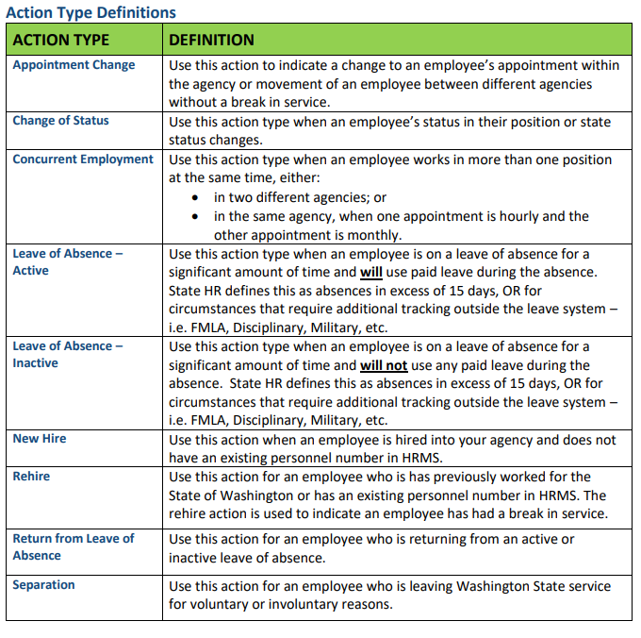

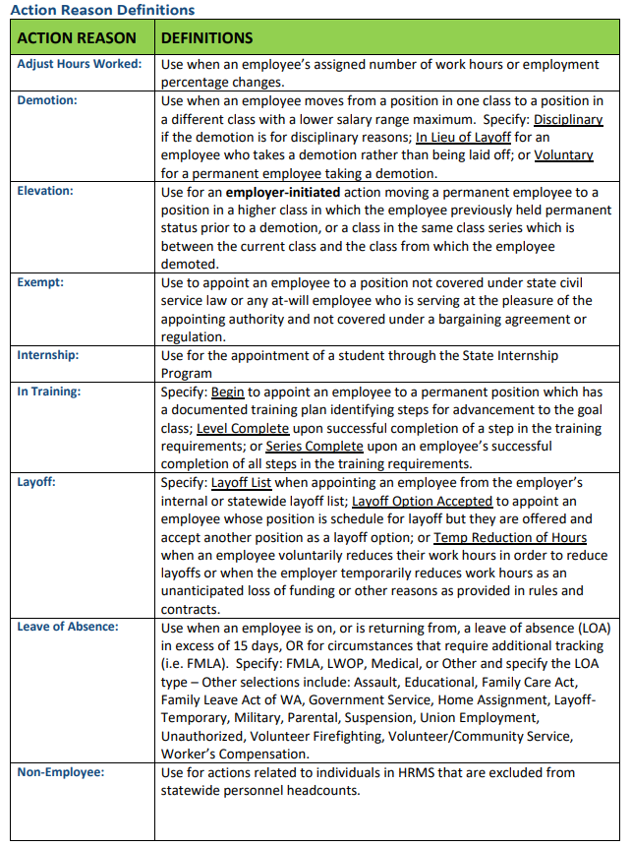
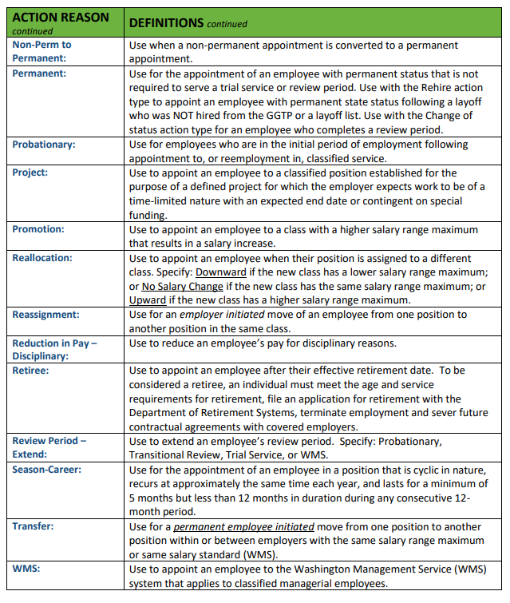

Personnel Files
Description
An employer must maintain an official file of each employee showing a record of employment. It should follow the employee through his/her tenure of state employment. Nothing regarding the employee’s performance or discipline can be placed in the personnel file without the employee’s knowledge.
All state agencies are required to organize any new personnel files according to the Standard Personnel File Sections. Agencies with collective bargaining agreements (CBAs) that require a different organization of personnel files are expected to comply with the Standard Personnel File Sections to the fullest extent possible.

It is the HR Liaisons responsibility to place completed PPDS and appointment letters into the personnel file. You will receive a completed PPDS and PAF from DES HR once it has been entered into the HRMS system.
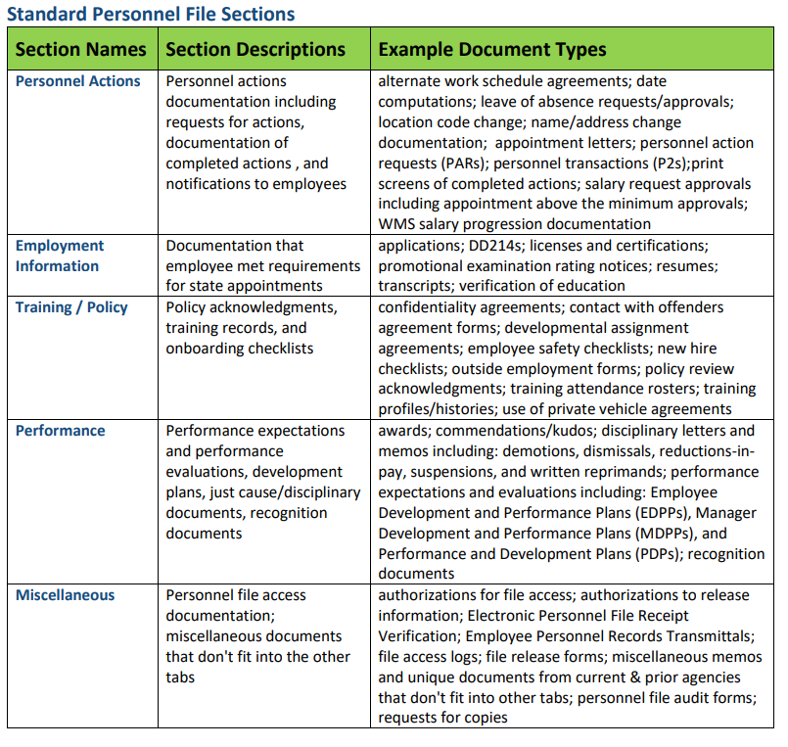

Documentation that SHOULD NOT be in a personnel file:
There are certain documents that should not be found in an employee personnel file. See below for guidance on where these types of documents should be found.

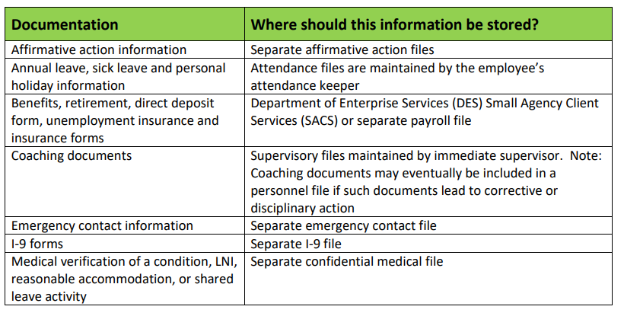

Employee Personnel Records Transmittal

When an employee accepts an appointment with a different employer, the most recent former employer must provide employee information to the new employer. When an employee transfers out of your agency, send a completed Employee Personnel Records Transmittal along with the personnel file to their new state agency. It is recommended that you keep a copy of the transmittal form for your agency’s records.

Position File
Description
All paperwork pertaining to a position, including PAFs, position descriptions, overtime eligibility forms, retirement eligibility forms, and risk class code forms should be kept in a separate position file. It is the HR Liaison’s responsibility to place the position information that DES HR provides to you into the appropriate position file.

Medical File
Description
All paperwork that has any type of medical information on it, including FMLA paperwork and emergency contact information card/paperwork should be kept in a separate medical file. It is the HR Liaison’s responsibility to place the medical information that DES HR provides to you into the medical file. It is to remain confidential, locked up, and separate from the personnel and supervisory file.

Supervisor File
Description
The supervisory file is a twelve-month working file maintained by the supervisor. The only items placed in the supervisory file are documents relevant to the performance of the employee during their twelve-month evaluation period. Once the annual PDP has been completed, the documents in the file should be destroyed and a new twelve-month file begins. The only time you would retain information beyond the 12 month time period is if there are current performance issues being addressed. If you have any questions about this, please consult your assigned Human Resource Business Partner.
What should NOT be kept in the supervisory file?
- Medical information or accident reports
- Criminal History information
- Copies of social security cards
- Direct deposit information
- Information regarding immigration status (copies of green cards or immigration papers)

Reasonable Accommodation
Description
Reasonable accommodation is any change in the work environment or the way a job is performed that enables a person with a disability to enjoy equal employment opportunities. This can be adjustments or changes to a job, work environment, policy, practice, or procedure.

Requests can happen during the application process, after a job offer, or any time during employment. The request can come from the individuals themselves or by the individual’s representative (ex: spouse). You may ask, but cannot require, the individual to submit the request in writing.

The reasonable accommodation process is administered through DES HR and/or your assigned AAG. Please reach out to your assigned Human Resources Business Partner if an employee has asked for a reasonable accommodation or may be in need of a reasonable accommodation.

Family Medical Leave Act (FMLA)
Description
The Family and Medical Leave Act (FMLA) is a federal law that provides eligible employees the right to take up to twelve work weeks or 480 hours of unpaid, job-protected leave for qualifying family or medical reasons. The leave may be approved either on a continuous basis or an intermittent basis.

The FMLA process is administered through DES HR. Please reach out to your assigned Human Resources Business Partner if an employee has asked for FMLA or may be in need of FMLA.

Shared Leave
Description
The state leave sharing program enables state employees to come to the aid of another state employee who meet the criteria to be eligible to request shared leave donations. Employees may donate accrued leave (WAC 357-31-425) to a fellow state employee who is suffering from or has a relative or household member suffering from an extraordinary or severe illness or impairment, which may cause the employee to take leave without pay or terminate employment. The employee who is eligible for shared leave must use their own leave in accordance with WAC 357-31-425 before using shared leave.

The Shared Leave process is administered through DES HR. Please reach out to your assigned Human Resources Business Partner if an employee has asked for Shared Leave or may be in need of Shared Leave.

Employee Resignations
Description
When an employee leaves the agency, certain actions must be taken by the supervisor, by the employee, and by support units throughout the agency. Leaving the state agency can mean resignation, transfer to another state agency or going to work for higher education. It is the HR Liaison’s responsibility to notify DES HR prior to the employee’s last day to avoid any over payments that potentially could be incurred.

For instructions on what forms to complete when certain resignations happen please visit the DES HR Toolkit under Employment Separation.

Employee Retirements
Description
When an employee retires from state government, certain actions must be taken to ensure all necessary steps are completed properly. It is the HR Liaison’s responsibility to notify DES HR prior to the employee’s last day to avoid any over payments that potentially could be incurred.

For instructions on what forms to complete when an employee retires please visit the DES HR Toolkit under Employment Separation.

HR HRMS Report Requests
Description
Much of the data about your agency’s employees and positions is stored within HRMS and can be pulled from either HRMS or Washington Workforce Analytics (WWA). Common requests include:

- Affirmative action information
- Vacancy report
- Current position list
- Current employee information, such as:
  - job class
  - salary, range, and step
  - appointment status
  - seniority dates
  - position numbers
  - periodic increment dates
- Cost coding information
- Telework/flextime/compressed workweek information

If you are seeking information or reports about your staff or your positions, please send the request to SAA@des.wa.gov and someone from the HR team will assist you.

Investigations
Description
Washington State, as an employer of choice, promotes a workplace where all employees, volunteers, interns, and those we interface with experience an environment that fosters mutual respect and professionalism. We are all responsible for contributing to such an environment and are expected to treat others with courtesy, dignity, and respect. If you witness or hear about a potential violation of policy, law, and other concerns it is you and the Department of Enterprises (DES) Human Resources (HR) that have a role.

Individuals may reach out to a trusted supervisor, manager, or colleague to discuss circumstances of an incident they observed or experienced. While it will depend on the circumstances surrounding such an event, this may allow for an informal response. Certain instances will require a formal investigation to be opened by DES HR. Such events may include but are not limited to claims of sexual harassment, discrimination, workplace violence, and illegal activity.

In your role as the agency's HR Liaison to DES HR, employees may approach you with information that leads you to believe there is a concern with discrimination, harassment and other workplace issues. We encourage you to perform an intake using the established Personnel Incident Form. Once the intake form has been completed and submitted, DES HR will be in contact for next steps.
If the employee feels uncomfortable reporting to their HR Liaison it is then encouraged they report to the agency's Appointing Authority or directly to their assigned HR Business Partner.
For more information about investigations, please visit the DES HR Toolkit under Performance Management.

HR Liaison Meetings
Description
The Small Agency HR Liaison meetings are hosted by the Department of Enterprise Services Small Agency HR team.
Held in informal settings, these meetings are used to provide timely HR information to small agency HR professionals or liaisons. They also provide a forum where we can discuss HR related topics, collaborate, interact, partner, and share information.
The Small Agency HR Liaison meetings are held quarterly at the Department of Enterprise Services. To learn more about these meetings please contact your assigned HR Business Partner.

Quick Reference Guide – Where to Send HR and Payroll Documents

Human Resources (HR)  Fax: (360) 507-9247  Email: SAA@des.wa.gov |  | Payroll  Fax: (360) 586-0021  Email: DESPayroll@des.wa.gov
PPDS  - New hires  - Transfers  - Appointment changes  - Review period extensions  - Separations  - Pay changes  - Org key changes  PAF  - Position reallocations  - Position establishments  - Position title changes  - Cost coding changes  - Delimiting positions  Employee address changes  Employee name changes  Family Medical Leave (FMLA)  Shared Leave  Paid Family and Medical Leave  Recruitment requests  Position allocation requests  HR HRMS report requests  WAC/RCW/CBA guidance  Investigation requests  Reasonable accommodation requests  Performance management questions |  | (Items listed in green can be submitted electronically)  W-4 form - mail original  EFT (Direct Deposit)  Insurance forms  - Medical/dental enrollment  - LTD enrollment  - PEBB worksheet  - FSA (special enrollment)  Retirement forms  - Enrollment  - Beneficiary designation  - Status form  Timesheets/Overtime requests  Leave requests/Attendance reports  Schedule Changes  Extra pay  Event/Incentive pay  Commission/Board pay  Shared leave donation forms  Verification of employment  Sick leave buyout  Commute trip reduction  VEBA enrollment forms  Cell phone stipends  AFLAC
Send Directly to Vendor
Deferred compensation
Union Dues
Charity deductions
Life Insurance Enrollment (MetLife)

Executive Assistant’s Manual

Chapter 4 – Payroll

Payroll Cutoff
Description
It is important to follow the deadlines for pay period cutoffs when turning in PPDS forms in order to insure there are no underpayments or overpayments for your employees. There are HRMS Payroll Calendars that can be printed from the OFM website that show when payroll processing days and payroll cutoff is.

Curious what the days mean?
Processing payroll takes four days. A payroll simulation is ran overnight on Days 0, 1, and 2. Errors are posted and payroll reaches out to our team with corrections needed. An additional simulation is ran at noon on Day 3 in order to provide agencies with one more check before payroll begins processing. At the request of OFM, agencies are encouraged to input HR, payroll and time entries on a daily basis rather than wait until payroll processing days. Day 3 should be reserved for corrections only. Final payroll processing begins after 8:00 p.m. on Day 3. HRMS is locked at that point to protect data as payroll runs. Here is an example of what the schedule looks like:
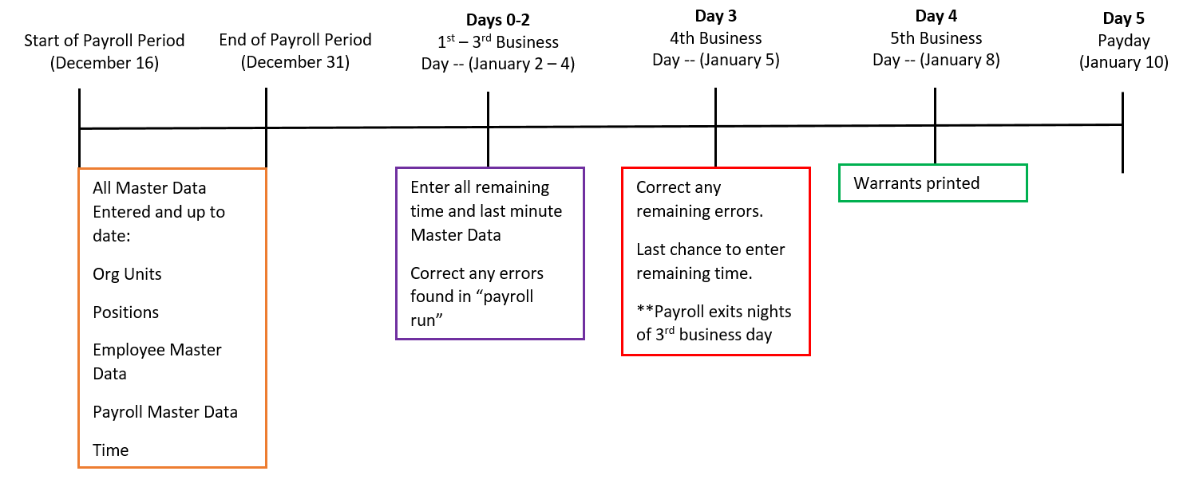

What does this mean?
Action forms should be turned in as soon as possible. In order to make cutoff for a certain pay period, actions must be entered by the end of Day 3. If possible, Day 3 should be used for corrections only; however, if an emergent situation arises, we can enter actions on this day.

For detailed listing and definitions, visit:
Office of Financial Management’s web site at https://support.hrms.wa.gov/resources/payroll-calendars

Payroll Timesheet
DESCRIPTION
Forms used to show the number of hours an employee works in a pay period. Timesheets are required for all overtime eligible employees
AGENCY RESPONSIBILITIES
    - The employee must:
  - Complete the form daily to show the number of paid hours worked that day.
  - Sign the form at the end of the pay period, or employment, whichever is first.
  - Give to the supervisor for approval.
    - The supervisor must:
  - Review the form for accuracy and completeness.
  - Discuss any discrepancies with the employees.
  - Indicate their approval of the Timesheet by signing the form.
  - Send the timesheet to DES for processing at the end of each pay period.
    - The supervisor or designee must:
  - Review the timesheet for the employee and supervisor signatures.
  - Send the timesheet to DES by 10:00 a.m. on the first business day following the pay period.
  - Email to DESPayroll@des.wa.gov
  - Fax to (360) 586-0021
Attn: DES/Payroll Analyst Name
  - Mail to:
DES/Payroll Analyst Name
PO Box 41465
Olympia, WA 98504-1465

For Work Study Timesheets Only:
    - The payroll analyst must:
  - Complete the pay and tax information for the employee.
  - Send the timesheet back with the paycheck to the agency.
    - The supervisor or designee must:
  - Send the timesheet to the employee’s school

STATE OF WASHINGTON

ANY AGENCY

123 Any Street, PO Box 56789  Olympia, Washington 98504  (360) 123-4567

May 1, 2011

To: SAFS Payroll
From: Agency Director
Subject: Commissioner Salaries

Please pay the Commissioners as follows:

Commissioner A 4/21/11 $ 50 Travel Day (5 hours)
4/22/11 $100 Regular Commission Meeting (8 hours)
$150

Commissioner B 4/21/11 $ 50 Travel Day (1 hour) 4/22/11 $100 Regular Commission Meeting (8 hours)
$150

Commissioner C 4/18/11 $ 50 Travel Day (2 hours)
4/19/11 $100 Briefings (1 hour)
4/21/11 $ 50 Travel Day (2 hours)
4/22/11 $100 Regular Commission Meeting (8 hours)
$300

Commissioner D 4/22/11 $100 Regular Commission Meeting (8 hours)
$100

Commissioner E 4/22/11 $100 Regular Commission Meeting (8 hours)
$100

Please call Agency Contact at (360) 123-4567 with any questions.
Thank you for your assistance.

MyPortal – Leave Tool

The MyPortal leave request tool available to state agencies. This application provides employees the ability to request leave and managers the ability to approve leave online, through the Employee Self Service portal.
Both employees and supervisors find the leave tool intuitive and easy to use. It can significantly reduce paperwork and shorten the turn-around time for leave approval. It also increases efficiency. The Payroll offices have reported up to a 67% reduction in the time needed to enter leave into the HRMS payroll system.

Employees
- Employees access the leave tool through MyPortal
- Employees can see real time leave balances
- Employees cannot submit a leave request if it exceeds their available leave balance
- If an employee submits a leave request that spans a range of dates, the leave request tool automatically populates the leave hours requested with the employee’s daily scheduled hours, therefore, partial day requests must be entered on a day-to-day basis
- When an employee submits a leave request, it is automatically routed to his/her supervisor for approval, and an email is generated notifying the supervisor that a leave request has been submitted. EMPLOYEES MUST HAVE ALL LEAVE ENTERED BEFORE THE END OF THE PAY PERIOD (The 15th or EOM).
Supervisors
- Supervisors also access the leave request tool throughMyPortal
- A supervisor can go to a work list to select and approve or reject leave requests
- When a supervisor approves or rejects a leave request, an email notification is automatically sent to the employee
- Supervisors and managers can submit/approve leave requests on behalf of their employees
- Approved leave requests are automatically posted directly into HRMS (no need for manual entry) SUPERVISORS MUST PROCESS ALL LEAVE BEFORE THE END OF THE PAY PERIOD (The 15th or EOM).

For more information, contact:
Louisa Wilkes, Payroll Manager at (360) 407-8445 or louisa.wilkes@des.wa.gov

Leave Requests with MyPortal

Read the following scenarios to determine how to submit a leave request. These examples are based on a work schedule of M-F, 8 am to 5 pm.

Consecutive full shifts: John is taking three days of leave (24 hours). Since the timeframe covers his entire work schedule over the three days, John will submit one leave request. Hourly employees must submit leave by the day.

Multiple partial shifts: John left work at 4pm on Wednesday and returned to work at 9am on Thursday. The total amount of leave taken is two hours. Since the time crosses over two days, but is not for the entire shift, John will need to submit two leave requests.

Scheduled work hours: John is taking two hours of sick leave and using two hours of compensatory time on the same date. Since John is using two different types of leave he will need to submit two leave requests. ESS will provide an error message if the combined time of the leave slips exceed John’s scheduled work hours for that day.

Submitting Leave Procedure

  - Log into MyPortal.
  - Click on the My Leave Requests box.
  - Click on the Create Request in the bottom right corner.
  - Complete the following fields on the Leave Request Page.
    - Leave Type – type of leave you are requesting
    - Select either “more than 1 day” or “One day or less”
    - Start/End Date – enter the dates for which leave begins and ends.
      - If consecutive full days enter date range
      - If one day enter the same stat/end date
    - Enter shift Start Time and End Time
    - Input Hours - Enter the number of hours or partial hours of leave taken. Partial hours may only be input in tenths of an hour

Minutes | Tenths
1-6 | .1
7-12 | .2
13-18 | .3
19-24 | .4
25-30 | .5
31-36 | .6
37-42 | .7
43-48 | .8
49-54 | .9
55-60 | 1.0

  - Approver – your approver will automatically be populated in this field. You cannot change the entry.
  - New Note – additional text the approver may require, this field is not required.
  - Click on the Save button.

After your leave request has been approved it will be posted to HRMS and you will receive notification via email.

Changing a Leave Request

A leave request can be changed at any time. Once leave requested has been approved you will need to edit it and the supervisor will need to approve the request.

  - Log into MyPortal.
  - Click on the Request Overview tab.
  - Click on the Pencil Icon.
  - Make the needed changes.
  - Click on either the Save button. If you are deleting the request make sure the correct leave was selected, hit delete then move on to step10.
  - Completed.

After your request has been approved it will be posted to HRMS and you will receive notification via email.

Deleting a Leave Request

You can delete a request without supervisor approval until it is in Approved status. Once leave has been approved you will need to request a deletion and the supervisor will need to approve the request.

  - Log into MyPortal.
  - Click on the Request Overview tab.
  - Click on the X button on the end of the line of leave.
  - Click OK to confirm deletion request.
  - Completed.

Leave Request Slips
Description
If your agency does not utilize the MyPortal, this form is used to report employees’ leave usage.
Agency Responsibilities
- The employee:
  - Complete the form each time leave is taken.
  - Sign the form and submit to their supervisor.

    - The supervisor:
  - Review the form for accuracy and completeness.
  - Determine appropriate type of leave is being taken.
  - Indicate their approval of the Leave Request by signing the form.
  - File the original in a tickler file until the pay period ends.

- The attendance keeper:
  - At the end of the month, transfer all information on the leave slips onto the Monthly Attendance Report. (This includes all leave without pay slips.)

Overtime Request & Authorization
Description
The form used to report employees’ overtime requests and actual overtime hours worked.
Agency Responsibilities
- The employee must:
  - Complete the form each time overtime is being requested.
  - Sign the form and submit to their supervisor.

    - The supervisor must:
  - Review the form for accuracy and completeness.
  - Indicate their approval of the Overtime Request by signing the form.
  - File the original in a tickler file until the pay period ends.
  - At the end of the pay period, send a copy of each overtime slip to DES Payroll.

Payroll Journal
Description
A report that shows what each employee was paid. The report lists the warrant or ACH number, detail of earnings, mandatory deductions, total dollar amount of voluntary deductions, allowances, reimbursements, and net pay.
Agency Responsibilities
- Ensure that each employee in the agency entitled to a paycheck is listed on the report.
- Check the salary rate for salaried employees, and the number of hours worked for hourly employees to make sure it is correct.
- Confirm that only employees of the agency are paid.
- Certify that the Payroll Journal is correct by signing the certification at the end of the report.
- Return the signed payroll journal to DES.
Example

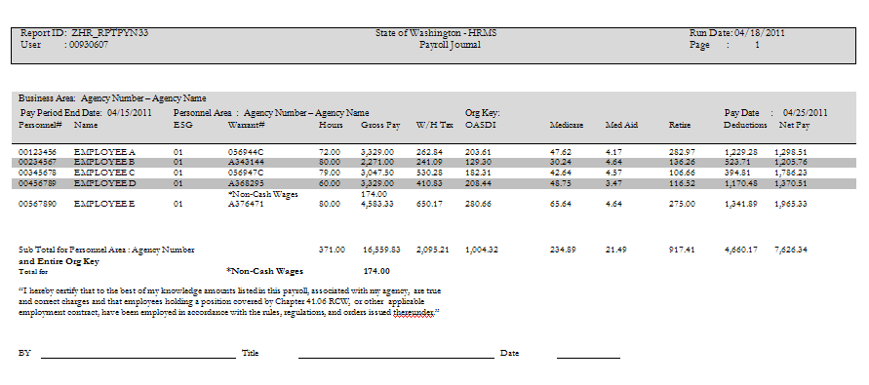

Payroll and Related Costs Report
Description
The report shows the account coding each employee was charged to and the associated employer costs. Examples are available upon request.
Agency Responsibilities
- Ensure that each employee in the agency entitled to a paycheck is listed on the report.
- Verify that the account coding for each employee is correct, and that the percentage of time being charged to each account code is correct.
- Contact DES for discrepancies in the account coding.
- File the report if everything is correct.

Semi-Monthly Attendance Report Form
Description
The Semi-Monthly Attendance Report is used to record employees’ leave activity for the each pay period
Agency Responsibilities
- Verify that each employee in the agency is listed on the report.
- Use the individual leave slips submitted by employees to enter the number of hours and type of leave taken for each day in the month. This includes any leave without pay.
- Email the report to DES in accordance with the payroll cutoff email to DESPayroll@des.wa.gov
- The report must show leave activity for the 1st-15th or the 16th-30th/31st.
- Send a separate report with the corrections box checked for corrections to a prior pay period. To make it to identify changes, we ask that the corrected reports show the corrections only.

Attendance System Change Report
Description
The Attendance System Change Report shows all employees who had attendance activity during the current report period.
Agency Responsibilities
- Verify that the information shown on the Attendance System Change Report is correct by:
  - Reviewing the previous month’s attendance report and attendance system change report to ensure that data submitted to DES was keyed correctly.
  - Confirming that the accrual rates are correct. Employees’ accrual rates may change when they complete another year of state service.
Time in Service | HRMS Monthly Accrual Rates
During 1st year | 9.33333
During 2nd year | 9.33333
During 3rd year | 10.0
During 4th year | 10.66667
During 5th & 6th years | 11.33333
During 7th, 8th, 9th years | 12.0
During 10th, 11th, 12th, 13th & 14th years | 13.33333
During 15th, 16th, 17th, 18th & 19th years | 14.66667
During 20th, 21st, 22nd, 23rd & 24th years | 16.0
During 25th year & thereafter | 16.66667

Exit Checklist

The following action items need to be completed prior to the departure of the employee:

- Letter of resignation: Ensure the letter references the effective date the employee will go off the agency’s payroll, the last working day if different from the effective date and the new agency the employee is going to, if applicable.
- Personnel Payroll Data Sheet (PPDS)
- PEBB Worksheet C-8

Exit Checklist (Continued)
It is the responsibility of the supervisor to ensure that the separation steps outlined below are reviewed and taken when an employee is leaving or transferring to another agency. This form should be completed by the supervisor and employee. Sign and date the form to confirm your review of the checklist with the employee.
Employee Name: _________________________ Personnel ID Number: _________________
Title: ___________________________________
Department: ____________________________ Last Day of Work (in paid status): ________
Supervisor: ______________________________
Voluntary Separation
Ask the employee for a letter of resignation.
Ask the employee to complete the Employee Exit Survey.
Involuntary Separation – CONTACT DES Primary Consultant IN ADVANCE
Confirm last day of employment (in paid status).
Determine the appropriate process for removal of the employee’s contents from office or workspace and secure computer networks and files.
Before Employee’s Last Day – Complete these forms or initiate these processes.
PPDS/Include the Exit Checklist and send to SAA@DES.wa.gov
Final Time Sheet (if applicable) Update current address for Payroll W-2
Outstanding travel vouchers Fiscal reimbursements
Last pay date: __________ Direct Deposit (check one): Yes No
Retrieve, cancel, or secure the following items:
Staff Identification Card Office and/or desk keys Pager, Laptop and/or cell phone Parking hang tag Telephone calling card Purchasing Card and/or Credit Cards Department network/e-mail account & Electronic files Voice mail password Other Agency property _______________

______________________________________ _____________________
Supervisor Date

NOTE: Place a signed copy in the employee’s personnel file.

Executive Assistant’s Manual

Chapter 5 – Accounts Payable

Central Service Agencies

Agency Name | Services Provided
Department of Corrections (DOC) | Furniture and signs.
Department of Enterprise Services (DES) | Office space, janitorial services, utilities, buildings and grounds maintenance, campus delivery and mail service, parking, motor pool, and procurement.
Department of Enterprise Services (DES) | Personnel services for classified employees.
Department of Enterprise Services (DES) | Printing and reproduction.
 | Small Agency Finance and HR, Risk Management.
Department of Retirement Systems (DRS) | Administers seven public employee retirement systems as well as the Deferred Compensation and Dependent Care Assistance programs.
Health Care Authority (HCA) | Administer and oversee the health care programs.
Office of Administrative Hearings (OAH) | Administrative hearings examiner services.
Office of the Attorney General (ATG) | Legal services.
Office of Minority and Women’s Business Enterprises (OMWBE) | Certification of minority business enterprises, socially and economically disadvantaged business enterprises, and women's business enterprises statewide.
Office of the Secretary of State (SEC) | Archives, records storage, and microfilm services.
Office of the State Auditor (SAO) | Auditing services and the Whistleblower Program.
Washington Technology Solutions (WaTech) | Computer and telecommunication services.  System support, IT contracts, Enterprise Reporting, eLearning, Usability Lab, and OCIO policies and initiatives.

OFM – Statewide Payee Desk

The Office of Financial Management maintains a central vendor file for Washington State agencies to use for processing vendor payments. This allows you, as a vendor, to receive payments from all participating state agencies by direct deposit, the state's preferred method of payment.
Information on registering as a Statewide Vendor
- FAQs
- Direct deposits
- Payee registration process
- Security of your information
Links
- Payee Registration Form and W-9 Form
- Statewide vendor number lookup
Questions
- Email the PayeeRegistration@ofm.wa.gov
- Call the Statewide Payee Desk at (360) 407-8180
Agency Responsibilities
- Have each NEW vendor complete a Statewide Payee Registration form and W-9 form.
- Check to be sure that the form is complete. Forms with errors will be returned to the vendor for resubmission.

Send directly to the Statewide Payee Desk at:

Statewide Payee Registration
PO Box 41450
Olympia, WA 98504-1450
Fax: (360) 664-3363

Field Order – Form A17-A
Description
Also known as a purchase order, a field order is a document used by agencies internally to order, encumber, liquidate, and authorize payment for purchases. Agency policy must still followed when requesting and obtaining approval for goods and/or services.
Field Order A17-A Instructions

- Date Ordered – Enter the month, day, and year the order was placed with the vendor.

- Field Order Number – Enter the next number in sequential order assigned by SAFS.

- From – Enter the agency’s official name.

- Ship To – Enter the agency’s name and address the order item(s) will need to be mailed.

- To – Enter the vendor’s name and address.

- Mail Invoice To – Enter the address the invoice will need to be mailed.

- Item Number – Starting with the number one, assign a number for each item order.

- Commodity Code – Enter the commodity code for each item ordered.

- Description – Enter a description for each item order.

- Quantity – Enter the quantity for each item ordered.

- Unit – Enter the unit of measure for each item ordered.

- Unit Price – Enter the price per unit for each item ordered.

- Total Cost – Enter the total cost for each item ordered.

- Total – Enter the total cost for all items ordered.

- Prepared By – Enter the name of the person preparing the field order.

- Telephone Number – Enter the phone number of the person preparing the field order.

- Date – Enter the date the field order was created.

- Agency Approval – Signature of the individual approving the acquisition.

- Date – Enter the date the field order was approved.

Invoice Voucher – A19-1A
Description
The form is used to substantiate and authorize payment when a vendor or claimant does not provide their own invoice. The vendor or claimant is required to comply with all agency and state purchasing regulations.

Invoice Voucher A19-1A Instructions

- Vendor or Claimant – Enter the name and address of the organization or person to whom payment is to be made. The agency will use the information provided to prepare the warrant.

- Vendor’s Certificate – The organization representative or person requesting reimbursement must sign the A19-1A in ink. The person signing must include their position title and date of signing. The Vendor’s Certificate indicates that they have provided the services in the amount invoiced.

- Federal ID Number – Enter the organization or the person’s federal identification number, if applicable.

- Description – Enter a description of the billable item(s). Enter the month and other pertinent information that describes the reimbursement.

- Amount – Enter the amount billable to the agency for any goods or services.

Agency Responsibilities

- The vendor or claimant must:
  - Complete the form.
  - Attach all required documentation including receipts.
  - Sign the form in ink.
  - Give to the agency contact or supervisor for review and approval.

- The agency contact or supervisor must:
  - Review the form for accuracy.
  - Discuss the discrepancies with the vendor or claimant.
  - Add expenditure coding to form.
  - Indicate their approval of the Invoice Voucher by signing and dating the form.

Email the signed original attached to an A-45 to payments.safs@des.wa.gov or campus mail to MS 41465 for processing.

Executive Assistant’s Manual

Chapter 6 – Travel

Quick Reference Guide - Travel Do’s and Don’ts
The following rules are high level summaries. For further details see the State Administrative & Accounting Manual (SAAM) reference. (http://www.ofm.wa.gov/policy/10.htm)
General: | SAAM
- All state agencies must comply with SAAM | 1.10.30
- All state employees, volunteers, and contractors must comply with SAAM | 10.10.05
- Use most economical travel alternatives unless Health/Safety issue | 10.10.20
- Get agency head approval in advance to travel out of state | 10.10.50
- Get approval from Governor or Board to travel out of U.S. or British Columbia | 10.10.50
- Do not reimburse for unnecessary travel costs such as alcoholic beverages | 10.20.20
- Combined business & personal travel must not result in additional cost to the state | 10.20.40
- Follow special travel rules and travel restrictions for Board, Commission or Committee members | 10.70
Meetings:
- State gatherings must be held in government facilities unless properly justified | 10.10.55
Lodging:
- Reimburse actual lodging expenses up to limits used in the Continental USA  and Non Continental USA schedules  except under special circumstances | 10.90.10  10.30.20
- Do not reimburse lodging expenses incurred at official station or residence | 10.30.40
- Do not reimburse lodging expenses within 50 miles of official station or residence | 10.30.30
Meals/Coffee and Light Refreshments:
- Reimburse meals on an allowance basis at rates used in the Continental USA and Non Continental schedules  On overnight assignments and in travel status for the entire meal period  On non-overnight assignments when the traveler has been in travel status for at least eleven hours and travels during the entire meal period | 10.90.10  10.40.50  10.40.50
- Do not reimburse for meal expenses incurred at official station or residence  exception for meals with meetings | 10.40.40  70.15
- Serve coffee and light refreshments only in accordance with agency policy and compliant with Executive Order 13-06 | 70.10
Transportation:
- Reimburse privately owned vehicle business miles at rate shown on the Reimbursement Rates for Lodging, Meals and Private Vehicle Mileage schedule | 10.90.20
- Do not reimburse for commuting miles between official residence and station | 10.20.20
- Agencies may purchase airline and other common carrier tickets in advance | 10.50.40
- Use a DES qualified travel provider when making air travel arrangements | 10.50.45
- Do not use state contract rental vehicles for personal business | 10.50.35
Moving:
- Contact DES Traffic Manager and follow all DES Moving Guide Rules | 60.10
Reimbursements
- Submit original receipts for reimbursements of travel expenses except meals | 10.80.40
- Account for travel expense advances monthly | 10.80.60

Note: Some travel reimbursements may be subject to federal income taxes. If you have questions relating to travel, contact us at (360) 407-8183 or email at travel.safs@des.wa.gov.

Quick Reference Guide – Internal Travel Policies and Related Issues
The State Administrative and Accounting Manual (SAAM) requires agencies to have their own written internal policies and procedures for travel, transportation, and related policies.
Travel Policies |  |  |  | SAAM
- Agencies are to have written internal policies and procedures to cover the items required in Chapter 10. |  | 10.10.10.a.3
- The agency head must specify in its internal policies and procedures the delegated approval level in the agency’s management structure (authorized designee) for control over travel expenses. |  | 10.10.10.a.3
- Agencies, as part of its positive system of management and control over travel are to periodically review purchases of airline tickets to ensure compliance with state travel regulations and terms of airline contracts. |  | 10.10.10.a.3
- The agency’s internal policies and procedures must also identify the amount of time required for advance approval of meals, coffee, and light refreshments at meetings, conferences, conventions, and training sessions. |  | 10.10.10.a.3
- Agencies may adopt internal travel policies and reimbursement allowances that are more restrictive than in Chapter 10. |  | 10.10.10.b
- Agencies are to develop and implement alternatives to travel, as well as less expensive means of travel (list of methods to be included are provided in this section). |  | 10.10.25
- Agencies employing airline pilots are to develop internal policies and procedures related to obtaining commercial lodging for flight crews during prolonged standby periods  - Agencies are to define business telephone calls as part of its positive system of management and control over travel. |  | 10.10.35  10.20.20.3
- Before requiring an employee to pay for service calls caused by negligence, agencies may wish to define negligence of the traveler to apply this rule in a fair manner. |  | 10.20.20.3
- The agency, as part of its positive system of internal control, is to develop policies and procedures when travelers are reimbursed for expenses by a person or outside entity. Reimbursement should be limited to actual expenses except for subsistence, which may be paid at the allowances contained in Section 10.90. |  | 10.20.60
- Agency policies may allow for non-original receipts. The policy needs to ensure that there are adequate controls in place that reduce the risk of duplicate or improper payments to travelers.  - Agencies that choose to reimburse travelers for the actual cost of subsistence are to adopt written policies and procedures. | 10.30.10  10.40.20.a
- Agencies must establish agency meal periods to determine if meal costs can be paid for overnight travel assignments. |  | 10.40.50.a
- Agencies must establish agency meal periods to determine if meal costs can be paid for when on non-overnight travel assignments.  - When authorizing employees to travel in their privately owned vehicle rather than in a state owned vehicle or via public transportation, agencies, as a part of their required, positive system of internal control over travel, may adopt and use other guidelines for satisfying what is considered advantageous or economical to the state. |  | 10.40.50.b  10.50.20.a
- Because of the potential misuse of POV reimbursement, internal agency policies and procedures are to be established to ensure that all claims for personal vehicle mileage is both critical and necessary for state business. |  | 10.50.25.b
- Agencies are to establish written internal policies to require the traveler to repay the state whenever a state contract vehicle is used for occasional incidental personal use. |  | 10.50.35.e
- Agencies may adopt written internal policies that allow for use of privately-owned vessels when commercial non-air common carriers are not available or economical. Agency policy must require prior authorization and limit reimbursement to actual costs, such as fuel and moorage, as evidenced by receipts |  | 10.50.65
- Agencies are to define when charges for transportation of equipment and materials are required to perform state business and the expense is reimbursable as a miscellaneous travel expense. |  | 10.60.10
- The agency, as part of its positive system of internal control, is to establish the maximum reimbursement for the cost of personal care assistants for disabled employees. |  | 10.60.30
- Agencies are required to define circumstances under which they will reimburse travelers for various fees on international flights. |  | 10.60.40
- Agencies are to have written internal policies when option 1 is selected for meal and lodging reimbursement for members serving in an advisory, coordinating, or planning capacity. |  | 10.70.20.b
- Agencies are to have written internal policies when option 1 is selected for meal and lodging reimbursement for members serving in a rule-making capacity. |  | 10.70.30.b
- Agencies are required to institute procedures ensuring that direct payments made to vendors are reasonable, accurate, and necessary for the conduct of the agency’s business. |  | 10.80.55
- Agencies are to establish written polices prescribing a reasonable amount for travel advances. |  | 10.80.60.b.7
Related Policies
- The agency head or authorized designee approves payment for the meals in advance of the meeting by defining in the agency internal policies and procedures. Executive Cabinet agencies are required, and all other agencies are strongly encouraged, to comply with Executive Order 13-06. |  |  | 70.15.10
- Coffee and light refreshments at meeting and training sessions are not allowed unless the agency has formally adopted written internal policies and procedures. Executive Cabinet agencies are required, and all other agencies are strongly encouraged, to comply with Executive Order 13-06. |  |  | 70.10.10

Travel and Expense Management System - TEMS

Description
The “Travel and Expense Management System” (TEMS) supports and manages requests for reimbursements to state employees and other individuals for personal expenses incurred while conducting state business. TEMS supports the complete business process from preauthorization to reimbursement. Individuals, including those with disabilities, have access to the system; and administrators have the tools to support agency operations. TEMS contains a repository of data on the daily travel and expense activities for each customer, allowing management, activity, and budgetary reporting. TEMS reduces redundancy and errors, streamlines processes, and saves time.

Reference Guide for Travel and Expense Management System (TEMS)
Access TEMS
The addresses to access the TEMS web sites are:

https://tems.ofm.wa.gov (Intranet)
https://fortress.wa.gov/ofm/tems (Internet)
Per Diem Rates
Travel rates set by the Office of Financial Management (OFM) establish reimbursement rates for state business travel within Washington State, the continental USA, the non-continental USA and foreign locations. OFM travel rates are derived from federal government rates.
Rate information can be obtained from the following state or federal web sites:

- Washington State Per Diem Rate Maps
- City/County Locator - National Association of Counties (NACo) search engine. Identifies the county a city is located in.
- OFM Travel Rates - State Administrative and Accounting Manual (SAAM) providing In-State and Out-of-State Per Diem Rates.

FAQ and Other Help
- TEMS - Requesting Reimbursement Quick Tips - all you need to know to request reimbursement in one condensed page
- TEMS - Approver Quick Tips - all you need to know review and approve reimbursement requests
- TEMS - Query Help
- TEMS - Training Video
- TEMS - Frequently Asked Questions
Contact information
TEMS assistance (TEMS Help Desk)
Phone: (360) 407-8183
E-mail: travel.safs@des.wa.gov

Travel Authorization – Form A40-A
Description
Travel advances are received money in advance of travel for the purpose of defraying some costs that the traveler may incur while traveling on official state business away from their official workstation or residence. Travel advances may be made by utilizing the TEMS. If the agency does not utilize TEMS, this form is used to request travel advances.

A40-a TRAVEL AUTHORIZATION INSTRUCTIONS

- Agency Name – Enter the agency name.
- Agency Number – Enter the three-digit agency number.
- Employee Telephone Number – Enter the phone number of the person requesting the travel authorization.
- Travel Authorization Number – Enter the agency assigned number to track travel authorizations.
- Travel Authorization Date – Enter the month and day of the travel authorization request.
- Division Or Department – Enter the name of the division or department within your agency the traveler belongs.
- Employee Name And Title – Enter the traveler’s name and title.
- Driver’s License Number – Leave blank.
- State Issuing Driver’s License – Leave blank.
- Purpose Of Trip – Provide a brief description of the purpose of the trip/business that will be conducted.
- Date – Enter the month and day(s) of travel.
- From – Enter the city where the trip begins.
- To – Enter the destination city.
- Mode Code – Choose the mode code from the options given in the box located to the right of this field.
- Subsistence & Lodging Days In-State – Enter the number of travel days for travel inside Washington State.
- Subsistence & Lodging Days Out-Of-State – Enter the number of travel days for travel outside Washington State.
- Estimated Travel Expense – Enter the estimated dollar amount for subsistence and lodging during the travel period.
- Advance Requested – Enter the dollar amount needed in advance to cover subsistence and lodging during the travel period. Follow agency policy for limitations.
- Transportation: Motor Vehicle – Enter the type of motor vehicle transportation for the trip.
- Estimated Miles – Enter the estimated driven roundtrip mileage for the trip.
- Estimated Travel Expense – Enter the estimated dollar amount for mileage during the travel period.
- Other – Enter the type of transportation used other than motor vehicle, such as train, bus, or ferry.
- Mode Code – Enter the mode code for other (box 22), using the key located next to box 14.
- Estimated Travel Expense – Enter the estimated dollar amount for other transportation during the travel period.
- Advance Requested – Enter the dollar amount needed in advance for other transportation during the travel period. Follow agency policy for limitations.
- Requestor’s Signature – The traveler must sign his/her name.
- Date – Enter the date the traveler signed the travel authorization.
- Other Expense – List any expenses expected to incur during the travel period, such as shuttle, taxi, airplane fare, parking fees, etc.
- Estimated Travel Expense – Enter the estimated dollar amount for other expenses during the travel period.
- Advance Requested – Enter the dollar amount needed in advance for other expenses during the travel period. Follow agency policy for limitations.
- Authorizing Signature – The signature of the person authorized to approve payment of these travel expenses.
- Date – Enter the date the authorizing person signed the travel authorization.
- Estimated Travel Expense – Enter the total estimated dollar amount for all estimated travel expenses during the travel period.
- Advance Requested – Enter the dollar amount needed in advance for other expenses during the travel period. Follow agency policy for limitations.
Agency Responsibilities (SAAM 10.80.60)
- The employee must:
- Complete the form.
- Sign the form in ink.
- Give to the supervisor for review and approval.
- Submit a fully itemized travel expense voucher on or before the tenth day following each month in which a travel advance was furnished.
- The supervisor must:
- Review the form for accuracy.
- Discuss discrepancies with the employee.
- Indicate their approval of the Travel Advance or Travel Authorization by signing and dating the form.
- Ensure that the signed, original is sent to DES for processing at least one week prior to departure when a travel advance is being requested.

Exceeding Maximum Per Diem Form
Description
The form is used to request an exception to the maximum per diem amounts for lodging.

Exceeding Maximum Per Diem Instructions

- Employee Name – Enter the name of the traveler.
- Date – Enter the month and day of the request.
- Conference/Training/Class – Enter the name of the conference, training, or class.
- Conference/Training/Class Date – Enter the date(s) of the conference, training, or class.
- Payment Of Lodging Exceeding Per Diem Amounts But Less Than 150% – Check this box if the traveler seeks approval to exceed the maximum lodging rate, but is less than 150% of the maximum rate. If the lodging exceeds 150% of the maximum per diem rate, skip to box 13.
- X – Check the box of the exception that applies to the situation to exceed per diem.
- Per Diem – Enter the maximum per diem amount for the location of the conference, training, or class.
- Actual Cost – Enter the actual dollar amount for the location of the conference, training, or class.
- Employee Signature – The traveler must sign his/her name.
- Date – Enter the date the traveler signed the form.
- Agency Director/Designee Signature – The signature of the person authorized to approve the exception.
- Date – Enter the date the authorizing person approved the exception.
- Payment Of Lodging Exceeding 150% Of The Maximum Per Diem Amount – Check this box if the traveler is seeking approval to exceed the maximum lodging rate in excess of the 150% maximum rate.
- X – Check the box of the exception that applies to the situation to exceed per diem. Note: All conditions must apply.
- Per Diem – Enter the maximum per diem amount for the location of the conference, training, or class.
- Actual Cost – Enter the actual dollar amount for the location of the conference, training, or class.
- Employee Signature – The traveler must sign his/her name.
- Date – Enter the date the traveler signed the form.
- Agency Director/Designee Signature – The signature of the person authorized to approve.
- Date – Enter the date the authorizing person approved the exception.

Agency Responsibilities
- The employee must:
  - Complete the form and give to the supervisor prior to travel.
  - Sign the form in ink.
  - Give to the supervisor for review and approval.
  - Attach the signed original form to a Travel Expense Voucher after the travel is completed.
- The supervisor must:
- Review the form for accuracy.
- Discuss discrepancies with the employee.
- Indicate their approval of the exception by signing the form.
- Return to the traveler to attach to their Travel Expense Voucher when they return.

Travel Expense Voucher – Form A20-AE
Description
If TEMS is not used, this form is used to document the approval of travel related expenses for all travel and authorize reimbursement to the traveler. The traveler is required to comply with all agency and state travel regulations.
Travel Expense Voucher Instructions
- Agency Name – Enter the agency name.
- Agency Number – Enter the three-digit agency number.
- Name and Address of Claimant – Enter the employee’s name and address to send payment.
- Month/Year – Enter the month and year travel occurred.
- Work Phone Number – Enter the employee’s work phone number.
- Social Security Number – Leave blank.
- Regularly Scheduled Work Hours – Enter the employee’s regularly scheduled work hours.
- Official Station – Enter the employee’s official station.
- Official Residence – Enter the employee’s city of official residence.
- Trip Information:
  - Date – Enter the month and day of travel.
  - From – Enter the city where the trip begins.
  - To – Enter the destination city.
  - Trip Time – Enter the departure time.
  - Trip Time – Enter the return time.
- Per Diem:
  - Per meal entitlement – Enter the reimbursable meal allowance amounts for breakfast, lunch, and dinner per SAAM Chapter 10, subsection 10.90.20.
  - Subsistence Subtotal – Add all meal amounts: breakfast, lunch and dinner.
  - Lodging Costs – Enter actual lodging costs not to exceed the maximum reimbursable lodging amount. Attach original receipts.
  - Total Per Diem – Add the subsistence subtotal and lodging costs.

- Motor Vehicle:
  - Miles driven – point-to-point – Enter the point-to-point miles as shown on an official state highway map or per the vehicle’s odometer.
  - Miles driven - vicinity – Enter the miles driven that exceed the point-to-point miles.
  - Reimbursement rate – Enter the allowable reimbursement rate for the vehicle driven.
  - Mileage allowance – Add point-to-point and vicinity miles multiplied by the reimbursement rate.
- Other Per Detail – Other reimbursable expense amounts transferred from the “Detail of other Expenses” section of the form (see line 18 instructions).
- Grand Total – Total reimbursable expenses.
- Amount Subject to Payroll Taxes – Enter the amount for non-overnight reimbursable meals. These reimbursements are reported to the Internal Revenue Service as taxable fringe benefit income. Federal income and payroll taxes are collected on the amount reported.
- Purpose of Trip– Provide a brief description of the purpose of the trip/business conducted.
- Detail of Other Expenses – Provide the date, payee description, and dollar amount of other expenses. Other expenses include, but are not limited to phone calls, ferry tickets, taxi fare and parking fees. This section provides the detail for amounts listed in the “Other Per Detail” column (see line 13 instructions).
- Signature, Date –The traveler must sign and date in ink.
- Initials – Travelers that choose not to be reimbursed for all allowable travel expenses must initial this box.
- Approved By – The signature of the person authorized to approve payment of these travel expenses.
Agency Responsibilities
- The traveler must:
  - Complete the form at the end of each trip or at least once a month.
  - Attach all required documentation including receipts.
  - Sign the form in ink.
  - Give to the supervisor for review and approval.
- The supervisor must:
  - Review the form for accuracy.
  - Discuss discrepancies with the employee.
  - Indicate their approval of the Travel Voucher by signing the form.
  - Ensure that the signed, original is sent to DES for processing

Board Member Travel Record/Request for Payment
Description
If TEMS is not used, this form is used to document the approval of travel related expenses for all travel and authorize reimbursement to the board member. The board member is required to comply with all agency and state travel regulations.
Board Member Travel Record Instructions

- Name and Address – Enter the traveler’s name and address. The agency will use the information provided to prepare a travel voucher.
- Location and Purpose of Meeting – Enter the specific location of the meeting. Briefly, describe the purpose of the meeting as it relates to official state business.
- Departure Date and Time and Return Date and Time – Enter the date and time of the traveler’s departure and return.
- Mode of Travel:
  - Mode of travel – Check the box next to the mode of transportation used to arrive at the traveler destination.
  - Fare for travel – Enter the cost the traveler paid for transportation. If only a private car was used leave this line blank.
  - Parking charge – Enter the cost the traveler paid for parking.
  - From – Enter the city where the trip begins.
  - To – Enter the destination city.
  - Mileage (Roundtrip) –Enter the sum of point-to-point and vicinity miles.
  - Point to point – Enter the point-to-point miles driven as shown on an official state highway map or per the vehicle’s odometer.
  - Vicinity – Enter the miles driven that exceed the point-to-point miles.
- Lodging Expenses – Check the box if the traveler paid lodging expenses, and attach the receipt(s).
- Signature of Traveler and Date – The traveler must sign the Board Member Travel Record/Request for Payment form in ink and include date of signing. The agency cannot make payment unless the Board Member Travel Record/Request for Payment form is signed in ink.
- Approval Signature and Date – The person authorized to approve the traveler’s request must sign the Board Member Travel Record/Request for Payment form in ink and include date of signing
Agency Responsibilities

- The Board Member must:
  - Complete the form at the end of each trip.
  - Attach all required documentation including receipts.
  - Sign the form in ink.
  - Give to the supervisor for review and approval.
- The Supervisor must:
  - Review the form for accuracy.
  - Discuss discrepancies with the board member.
  - Indicate their approval of the Board Member Travel Record/Request for Payment by signing the form.
  - Send the signed, original to DES for processing.

Questions to Ask When Preparing for a Meeting
General
- What is the purpose of the meeting?
- Can the agency absorb all costs associated with the event?
- Do you have a written Coffee and Light Refreshments policy?
- Do you have a written Meals with Meetings policy?
- Is the event provided by another state agency at a lower cost?
Location
- What city?
- Are there state facilities available? If so, who do I contact, and when?
- If no state facilities are available, will the hotel where the attendees are staying give the agency a free or reduced rate on a conference room?
Attendees
- Who? (Agency staff, commissioners, presenters, public)
- How many?
- Will they require overnight lodging?
- What is the maximum amount allowable per person per night?
- How will they get there? (Airplane, personal vehicle, or rental car)
- Will guest speakers be present?
- Will the agency have to pay the guest speaker(s)?
- Will you need to prepare a contract for the guest speaker(s)?
Food
- Can the agency pay for all of the attendees’ meals?
- What is the maximum amount allowable per person per meal?
- How many meals are being provided?
- Who will receive these meals?
- Are you planning to serve light refreshments to all attendees?
- Will the agency staff be eligible for the meal?
- Did you document the request and prior approval for coffee/light refreshments and/or meals?

Meeting Expense Authorization Form
Description
The form is used to document the request and approval for refreshments and/or meals with a meeting.

Meeting Expense Authorization Form Instructions

- Purpose of meeting – Enter a brief description of the event. Then check the box next to the type of event.
- Estimated cost of meeting – Enter the total estimated dollar cost for the meeting.
- Actual cost– Leave blank until receipt of all invoices.
- Place of meeting – Enter the location and city of the meeting.
- Date(s) of meeting – Enter the month and day(s) of the meeting.
- Beverages – Check the box next to the items, which will be provided at the meeting.
- Refreshments – Check the box next to the items, which will be provided at the meeting.
- Will meals be provided? – Check the box next to the answer yes or no. If the answer is no, skip to box 18. If the answer is yes, proceed to box 9.
- Breakfast number – Enter the number of people that will be provided with breakfast.
- Dates – Enter the month and day breakfast will be provided.
- Lunch number – Enter the number of people that will be provided with lunch.
- Dates– Enter the month and day lunch will be provided.
- Dinner number – Enter the number of people that will be provided with dinner.
- Dates – Enter the month and day dinner will be provided.
- Meals – Enter the name of the person or vendor providing meals.
- Estimated cost – Enter the estimated amount for the cost of meals.
- Amount paid – Enter the actual amount invoiced by the person or vendor for the cost of meals.
- Equipment rental – Enter the name of the person or vendor providing equipment.
- Estimated cost – Enter the estimated amount for the cost of equipment.
- Amount paid – Enter the actual amount invoiced by the person or vendor for the cost of equipment.
- Meeting room rental – Enter the name of the person or vendor providing the meeting room.
- Estimated cost – Enter the estimated amount for the cost of the meeting room.
- Amount paid – Enter the actual amount invoiced by the person or vendor for the cost of the meeting room.
- Coffee/light refreshments – Enter the name of person or vendor providing the coffee and/or light refreshments.
- Estimated cost – Enter the estimated amount for the cost of coffee and/or light refreshments.
- Amount paid – Enter the actual amount invoiced by the person or vendor for the cost of coffee and/or light refreshments.
- Participants will be claiming – Check the travel box and/or the per diem box if the agency will be reimbursing the traveler(s) these types of expenses.
- Name – Enter the name of each participant.
- Organization/agency – Enter the name of the organization or agency the participant is representing.
- Mode of transportation – Enter the type of transportation the traveler will be using.
- Requested by – Signature of the requesting staff member.
- Date – Enter the date of the requestor signature.
- Approved by – Signature of the authorizing designee.
- Date – Enter the date of the authorizing designee signature.

Agency Responsibilities
- The requester must:
  - Complete the form and give to the supervisor prior to the meeting
  - Sign the form in ink.
  - Give to the supervisor for review and approval.
  - Attach the signed, original form to the vendor’s invoice

- The supervisor must:
  - Review the form for accuracy.
  - Discuss discrepancies with the employee.
  - Indicate their approval for the refreshments and/or meal by signing the form.
  - Return to the requester to attach to the vendor’s invoice when they are submitted.

Executive Assistant’s Manual

Chapter 7 – Credit Cards

Types of Credit Cards

Corporate (Travel) Card
        - Each agency head or authorized designee may authorize the use of or approve the issuance of the corporate travel card to those travelers whose work requires them to travel on official state business. When a state employee uses the corporate travel card they are billed directly, are responsible to pay all charges, and must apply for travel reimbursement through their agency. It may be used to purchase all airline and train tickets.
Central (Travel) Card
        - The CTA is a ghost account. No actual card is issued. The agency is responsible for charges against the CTA. It may be used to purchase all airline and train tickets.
P-card (Purchasing) Card
  - Purchase goods and services under applicable laws, rules, and regulations governing the purchase.
One Card (Combination Travel & Purchasing Card)
  - Purchase goods and services under applicable laws, rules, and regulations governing the purchase.
  - Purchase lodging, car rental, meals, commuter rail fare, parking fee, bus fares, travel ferries, and other business related travel expenses.

For more information,
Review contract number 00612 available on the DES website www.des.wa.gov

Purchasing Card
Description
To provide a tool for rapid purchases and to reduce the amount of paperwork required when making certain types of purchases. The card is intended to promote purchasing efficiency, flexibility, and convenience.
Limitations
The use of the purchasing card includes the following:
- Goods and services for official state purposes purchased in person, by mail, by phone, or over the internet.
- Purchases complying with all applicable state statutes, rules, policies, and procedures.
- Purchases within spending and other limits established on the card, as established by the agency within the pre-determined agency aggregate limit.
- Purchases between Washington State agencies, but only when:
  - The paying and/or receiving account is a local account (not a treasury, treasury trust, nor petty cash account); and,
  - The receiving agency agrees to accept the inter-agency purchase card payments. Receiving agencies have the right to refuse acceptance of purchase card payments from other state agencies.
The purchasing card may not be used for:
- Cash advances.
- Purchases in excess of the limits authorized for the card.
- Gifts/donations.
- Splitting purchases to circumvent the daily or monthly purchase limits on a card, or to avoid competitive bidding limits or purchasing authority limits.
- Purchases between internal departments within an agency, unless prior written approval is received from the Office of Financial Management (OFM) based on the requirements in Subsection 40.40.10.
- Except as noted below, purchases between state agencies. For interagency payments, the preferred payment method is Inter-Agency Payment (IAP). Journal vouchers may also be used to transfer funds between state agencies. Refer to Subsection 85.36.20. Exceptions to this are as follows:
  - When prior written approval is received from OFM based on the requirements in Subsection 40.40.10; or,
  - When the paying and/or receiving account is a local account and the receiving agency has agreed to accept the inter-agency purchase card payments.
- Prepayments, unless otherwise authorized by statute or rule.
- Purchases from any merchant, product, or service normally considered to be inappropriate use of state funds, including, but not limited to:
  - Items for personal use.
  - Materials or services from any member of the card user’s immediate family.
  - Equipment, materials, services, or supplies restricted by state statutes, rules, policies, procedures, guidelines or contractual agreements.
  - Alcoholic beverages or liquor licenses, unless permitted by statute or rule.
Agency Responsibilities
Agency responsibilities include:
- Administration of their agency’s purchasing card program.
- Developing agency specific policies and procedures in accordance with state policies.
- Designating an “Agency Program Administrator” who shall manage the program within the agency. If an agency is using the contract administered by the Department of Enterprise Services (DES), they should notify DES of any change in the administrator.
- Determining whether the agency will issue individually assigned cards or department cards.
- Determining card limits, including determining and managing the agency aggregate limit.
- Establishing a system for responsibility, control, and distribution of purchase cards within the agency.
- Educating cardholders, card custodians, and designated card users on use of the card, sales and use tax issues, and 1099 reportable merchants.
- Determining who within the agency will be responsible for following up with the merchant to resolve disputes and arranging for returns, credits, delivery problems, etc.
- Performing routine reconciliation of card transactions to the issuing bank's online purchase card transaction data to monitor purchases made for proper use of the card.
- Keeping up to date of program updates from DES, if using the state contract.
- Designating appropriate records to be maintained. If using the state contract, such records shall be available for review by DES. The following information should be maintained at a minimum:
  - The number of cards used.
  - The type of cards used.
  - The amount of purchases made by card within a stated period.
  - Reports of any problems encountered with the use of the purchase cards.

Purchasing Card Policy

The proper usage and control of a purchasing card is the responsibility of the agency director. To aid in the reasonable assurance that a purchasing card is used properly and effectively, each agency must adhere to the following policy.
General Guidelines
1. Each agency must clearly document and assign the responsibility for disbursement procedures to specific personnel in the agency.
2. Each agency may use the card to procure goods and services for small dollar amounts only. There is an individual transaction purchase authorization limit of $XXX.
3. The purchasing card limit for the agency is $XXX.
4. Use of the purchasing card is to be handled in such a manner to:
- Ensure they are used only for authorized purposes; and,
- Follow applicable laws, rules, and regulations governing the disbursement.
5. The card must not be used to:
- Obtain cash advances from financial institutions.
- Make personal purchases.
- Purchase airfare unless prior written approval is obtained from Department of Enterprise Services.
- Purchase equipment, material or supplies restricted by policies, guidelines, or contractual agreements.
- Purchase materials or services from any member of the card custodian’s immediate family.
6. All potential users of the card must have familiarity with these procedures, and knowledge of the location of a written reference copy of these procedures.
7. US Bank, the card provider, shall send each Card Custodian a statement that displays detailed transactions made during the current billing cycle.
8. Agencies must report lost or stolen purchasing cards immediately after the loss is discovered by calling US Bank’s customer service center.
- In addition to this policy, holders of purchasing cards must adhere to all state rules and regulations.

Purchasing Card Usage
1. Employee duties in the handling of disbursements, including purchasing card use, are to be separated to the extent possible with regard to the:
- Initiating of purchase requests.
- Safeguarding and use of the card.
- Monitoring and approval of purchases and statements.
2. To the extent possible, employee duties in this area are to be complementary to or checked by another employee.
3. The agency director or designee must be the Agency Program Administrator. The Agency Program Administrator is responsible for management and oversight of the purchase card program within the agency, and is responsible for the following:
- Managing the purchase card program within the agency.
- Developing and enforcing agency policies and procedures for using the purchase card, including disciplinary procedures related to unauthorized use of cards and card renewal procedures. The agency policies and procedures should meet the minimum requirements of the statewide policies and procedures contained in this chapter. State ethics laws should also be considered when developing agency policies.
- Establishing and maintaining the purchase card reporting structure/hierarchy for the agency and ensuring proper separation of duties. For example, a card user may not be the reviewer or approving official for their own transactions.
- Reviewing purchase card applications and determining who within the agency should receive a card. For agencies utilizing department cards, this also includes designating card custodians.
- Ensuring that a card user agreement form has been signed by both the card user and appropriate approving official before issuing the card, and maintaining copies of the signed agreements in the agency’s files.
- Maintaining a list of current cardholders, card custodians, and designated card users that are authorized to use cards.
- Obtaining cards from the issuing bank and distributing new and reissued cards to agency employees.
- Providing training to approving officials, cardholders, card custodians, and designated card users in the management, security, and use of the card.
- Reviewing the agency purchase card program at least annually to ensure that proper procedures are being followed.
- Ensuring card users satisfy documentation requirements for purchases.
- Closing card accounts as necessary, and collecting and destroying cards upon employee reassignment or termination.
4. Each agency must assign one person to be the Card Custodian. The Card Custodian administers and controls the use of department cards by authorized designated card users within the card custodian’s workgroup and is responsible for the following
- Complying with all state, agency, and purchasing statutes, rules, policies, and procedures.
- Maintaining a current list of designated card users who are authorized to use the department card.
- Training designated card users on the use of the card.
- Maintaining a department card log for designated card users to check out and check in a purchase card for use and record the business purpose for each use of the card.
- Tracking and verifying designated card user transactions.
- Ensuring that designated card users obtain and submit valid supporting documentation for each purchase made.
- Maintaining a purchase card transaction log for all transactions made according to agency procedures.
- Safeguarding card security at all times. The card shall be kept in a secured (locked) location while not in use. The only people authorized to use the department card are the card custodian and/or the designated card user(s).
- Reporting lost or stolen cards immediately following agency procedures.
- Reconciling the card statement to the purchase card transaction log and supporting documentation, at least monthly, and submitting to the approving official for approval.
5. Cards must be kept in a secure place with limited access.
6. Each agency must establish and maintain a purchasing card transaction log. This log must contain the following information:
- Purchase date.
- Vendor’s name.
- Item(s) purchased.
- Purchaser’s name.
- Total amount of the purchase.
- The initials of the person reconciling the log to the purchasing card statement.
- Any other information the Agency Program Administrator may specify.

Payment Process
1. Each agency must prepare and submit an A45 Transmittal to DES.
2. Each agency must attach the following items to the original invoice:
a) A copy of the purchasing card transaction log.
b) The original statement from US Bank with original receipts attached.
3. Each agency must submit payment vouchers to DES timely to avoid interest and/or late charges. (Please note, US Bank offers rebates for payments made within 14 days.)

Executive Assistant’s Manual

Chapter 8 – Accounts Receivable

Internal Control for Cash Receipts

The proper control of cash receipts is the responsibility of the agency director. This resource intends to aid an agency in understanding its risks and identifying applicable controls to minimize those risks.
General Guidelines
- Segregation of duties in the handling of cash is one of the most effective ways to gain control over this asset. No individual is to have complete control in the handling of cash. Specifically, no one individual’s duties should include the actual handling of money, recording receipt of money, and the reconciliation of bank accounts or with the state treasurer. Employees handling cash are to be assigned duties that are complementary to or checked by another employee.
- Incoming cash must be made a matter of record as soon as possible.
- Two persons should open the mail when they expect cash or checks in the mail. One person needs to create a cash list another person should review the cash list with the receipts. A copy of the cash list is then forwarded to the DES Finance Cashier with receipts. A second copy of the cash list is used for accounting controls. A weekly comparison of the cash list and Cash Receipt Report received via email should be completed.
- Amounts of currency contained in each item of mail are verified. Documents enclosed with the currency received are machine date stamped or dated and initialed by the employee opening the mail.
- A secure area is needed for the safeguarding and processing of cash received. Access to the secured area is restricted to authorized personnel only. The secured area is locked when not occupied.
- Cash is protected by the use of registers, safes, or locks, and kept in areas of limited access.
- Collections made over the counter or in the field are documented by the issuance of sequentially pre-numbered official receipts or through cash registers or automated cashiering systems. All such receipts are to be strictly accounted for and the reason for any missing documents determined and documented. Blank form receipts are not used. Receipts indicate mode of payment, such as cash, check, etc. The total dollar amount recorded on cash receipt forms, by mode of payment, is balanced daily to total cash, checks, etc. collected.
- The cash receiving function of an agency is centralized to the extent possible.

- When cash is received in branch offices, it is to be transmitted to the central office through the banking system. Branch office personnel are restricted to making cash deposits and central office personnel make any cash withdrawals and reconcile bank accounts.
- A balance and summary of all cash receipts is prepared daily. Any shortages or overages are carefully investigated and, to the extent possible, corrected.
- Receipts are deposited intact on a daily basis. When a deposit slip is prepared, the cashier must get signed approval from a supervisor before making the bank deposit.
- Authenticated, duplicate deposit slips are retained and compared with amounts recorded in cash receipts records.
- Moneys are picked up or delivered to appropriate authorities on a scheduled basis.
- Adequate records are maintained to ensure the correct handling and final disposition of items held in suspense. Suspense accounting is eliminated whenever possible by the direct deposit of the item to the correct fund and account. However, deposits are not to be delayed because the account distribution cannot be immediately determined.
- Cash receipts retained on the premises overnight are minimized and locked up in a secure place, such as a safe.
- Cashiers are prohibited from cashing personal checks or notes of personal indebtedness.
- Written procedures on all cashiering and cash control procedures are maintained by each agency.

Invoicing

DES provides automated invoicing using the Agency Billing System (ABS) in Agency Financial Reporting System (AFRS).
DES manages aged outstanding receivables.

Agency Unique Receipt
Description
The form used to account for collection of checks, cash, warrants, or money orders. The form must have the agency’s name, be sequentially pre-numbered, in duplicate form, containing fields to indicate the date, person the money is collected from, total dollar amount, person who received the money, and mode of payment.
Agency Responsibilities
- Complete the form for all money received at the office.
- Provide the person giving you the money the original receipt.
- Safeguard the money at all times.
- Submit all money received to DES in a timely manner to ensure it is deposited within 24 hours of receipt.
- Attach a copy of the receipt to the A45.

Prepare and submit a separate A45 for deposits. Other types of documents sent to DES must be on a different A45.

Example
DES - SMALL AGENCY FINANCIAL SERVICES |  |  |  |  | RECEIPT |  |  | 91863
P. O. BOX 41465, OLYMPIA, WA 98504-1465
PHONE: 360-407-8183 -- FAX: 360-586-0055
 |  |  |  |  |  | DATE: | June 30, 2011
RECEIVED FROM: |  | Happy Agency Staff Person
AMOUNT: |  | $650.54
AGENCY NAME: |  | Agency A, #123 |  |  |  |  | HOW PAID | AMOUNT
A45 #: |  | 05-0045 |  |  |  |  | CASH | $50.54
RECEIVED BY: |  | Support Staff |  |  |  |  | CHECK [ 4 ] | $600.00
VERIFIED BY: |  | Support Analyst |  | DATE | March 10, 2005 |  | OTHER
White Copy: Agency |  | Yellow Copy: Attach to A45 |  |  | Pink Copy: Retain in receipt book

State Treasurer Waiver

SAAM 85.50.10 requires that cash receipts be deposited intact each day for the collections of the preceding day. Small Agency Financial Services retains a waiver each biennium for client agencies from having to send over cash receipts daily. Agencies served by DES may safe keep deposits under $500 and send to DES once a week. If receipts reach over $500 they must be delivered to DES for deposit within 24 hours.

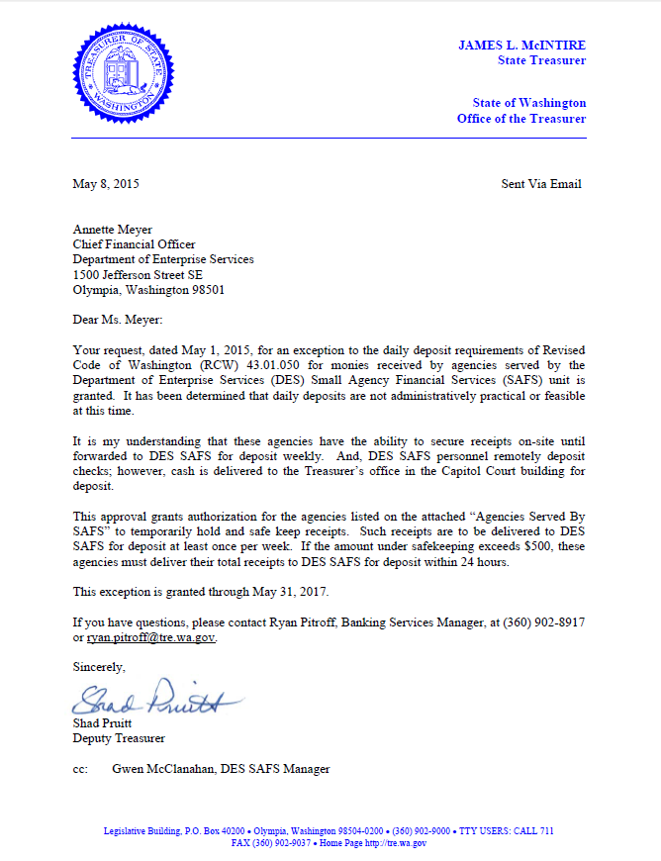

Cash Receipt – Form A8-A

Description
An A8 form is used to deposit any moneys (e.g., checks, cash, warrants, or electronic funds transfers) received by the state with the Office of the State Treasurer. DES will generate the A8 for all deposits and handle all communication with the Treasurer’s Office, unless otherwise specified in your agreement.

Executive Assistant’s Manual

Chapter 9 – Document Transmittal

Agency Transmittal – Form A45
Description
The form identifies the type and provides a brief description of the documents being sent to DES. All documents sent to DES must be accompanied with an A45. Instructions for filling out the A45.
Agency Responsibilities
- Complete an A45 when sending documents to DES. Send A45s as follows:
  - Deposits – within 24 hours (see cash deposits section)
  - Payments – at least once a week
  - Payroll/Personnel – within established timeframes.
- Ensure all documents listed are attached, and all documents attached are listed.
- Sign or initial the form.
- Send to DES.
DESSmallAgencyAP@des.wa.gov

Or

DES – Small Agency Financial Services
PO Box 41465
Olympia, WA 98504-1465

Official Agency Payment Register
Description
The register shows the amount paid to each vendor or claimant, the method of payment, and the account coding. The register also shows the current document number and total dollar amount paid. The method of payment includes warrants, regular and inserted, interagency payables (IAP), and electronic funds transfers (EFT). The account coding shows the funds, programs, appropriations, and object of expenditures.
Agency Responsibilities
- Ensure that each vendor on the A45 is listed on the report.
- Check the amount paid to each vendor to make sure it is correct.
- Confirm that only the listed vendors on the A45 are being paid.
- Confirm that the accounting codes are correct.

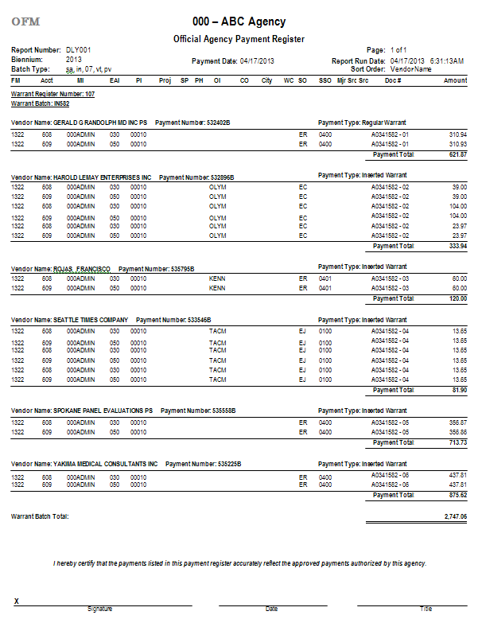
Example

Executive Assistant’s Manual

Chapter 10 – Audits

State Auditor’s Office
Description
The State Auditor’s Office (SAO) is responsible for performing audits at the state government level. They conduct a range of audits form financial audits, accountability audits, performance audits, and whistleblower investigations.

The most common audit that an agency will experience is an accountability audit. The audits are on a 3-4 year cycle.
Who to Contact
Once contacted by SAO about an upcoming audit, contact your assigned DES budget analyst. Since DES maintains a lot of your agency’s financial records, we will work closely with the auditor and provide requested documentation for review. We will also attend the audit entrance meeting and audit exit meeting if requested.

