How to locate/complete class evaluations Updated 3/24/23
Log into the system using the following link: WA-State Learning Center using either your active directory sign on or if you’re an extended user outside of the state directory, using your SAW account email address. Direct link: Learning Activity Evaluations - SumTotal
Please note that some screen shots may look slightly different based on roles assigned.
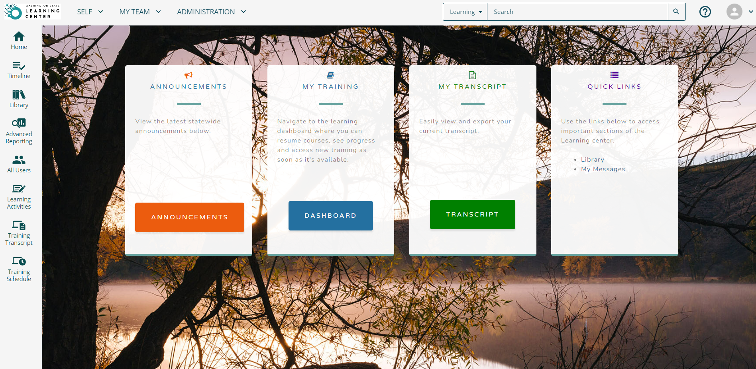

To find the Evaluation you will click on the word – SELF, Learning, Learning Activity Evaluations
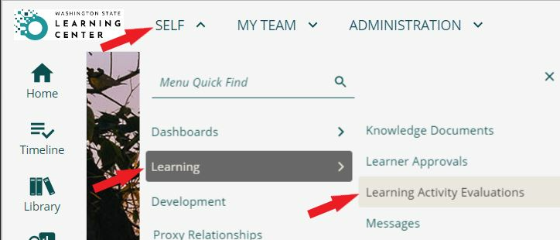
Any pending evaluations will be located here. Your evaluation is assigned the final day of class and expires after 10 days. Please complete it as soon as possible after the training.

