- 

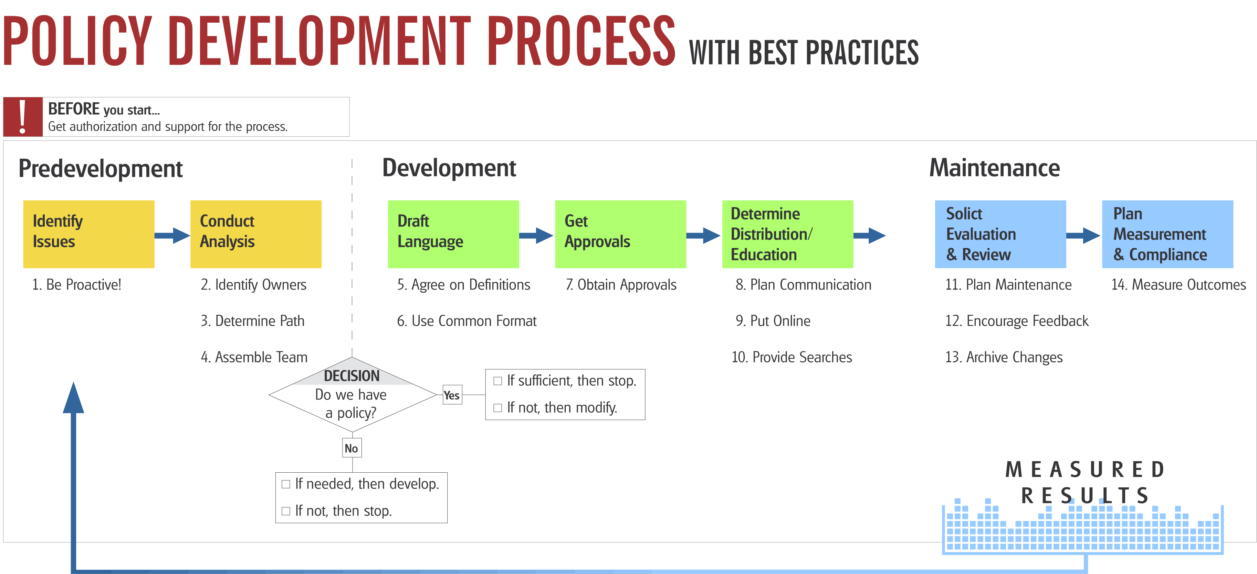
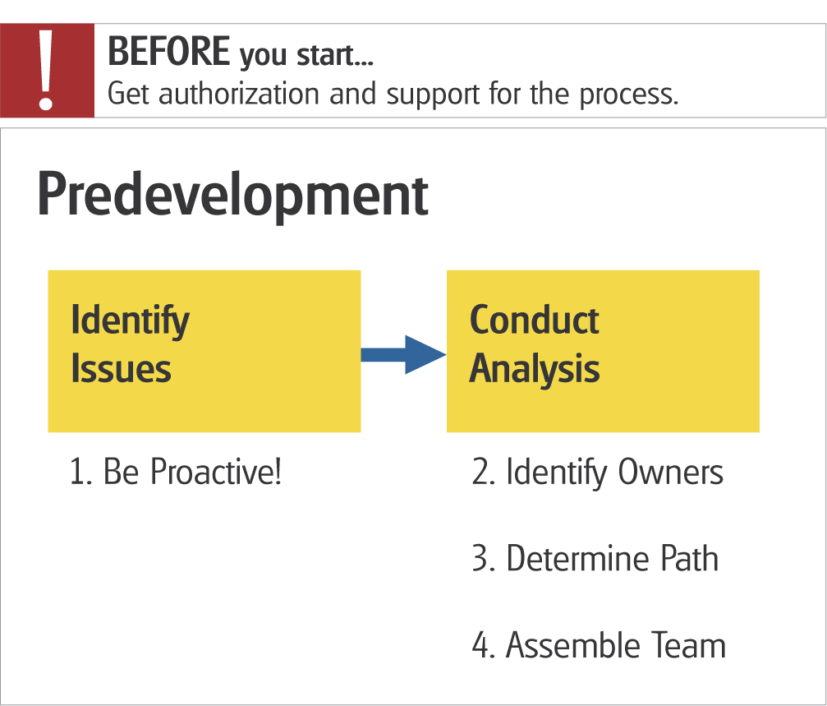

- Be Proactive in Issue Identification
It is usually better to anticipate a problem than to be surprised. This may especially be true for policy development because the timeframe from the start to the finish can be long. The more you are able to identify issues that will affect your agency, the less time will be spent in emergency mode. This is especially true for important policies that are enterprise wide in scope, involve budget changes or training efforts.

- Identify an Owner for Each Policy
A specific individual needs to have responsibility for the content and accuracy of information within the policy. Different offices can own pieces of the policy or procedures, but one individual should be designated with the overall responsibility to create and maintain the information. The owner should push and track policy development. If disputes arise, this individual is the one who ultimately decides the outcome or the process that will be used for resolution. Consider publishing the names and addresses of the policy owners in a table with their policies and procedures.

- Determine the Best “Policy Path”
Often, determining the owner of a policy will dictate the development path for the policy. However, that is not always the case. Agency-wide policies can be formulated by many different authorities including the legislation, executive management, senior management team, divisions or programs. Determining the best level can be more art than science. When choosing - consider topic significance, internal and external reactions, number of approvals necessary and ongoing maintenance.

- Assemble a Team to Develop Policy
Policies and procedures will often be used by a wide variety of groups. To develop accurate and complete documents, consider the expertise needed to develop a well informed policy. Depending on the issue, consider involving staff from human resources, financial, executive management, auditor, information technology and legal officers. Including representatives from groups that will use the policy and be affected by it will greatly improve the quality and may assist with buy-in.

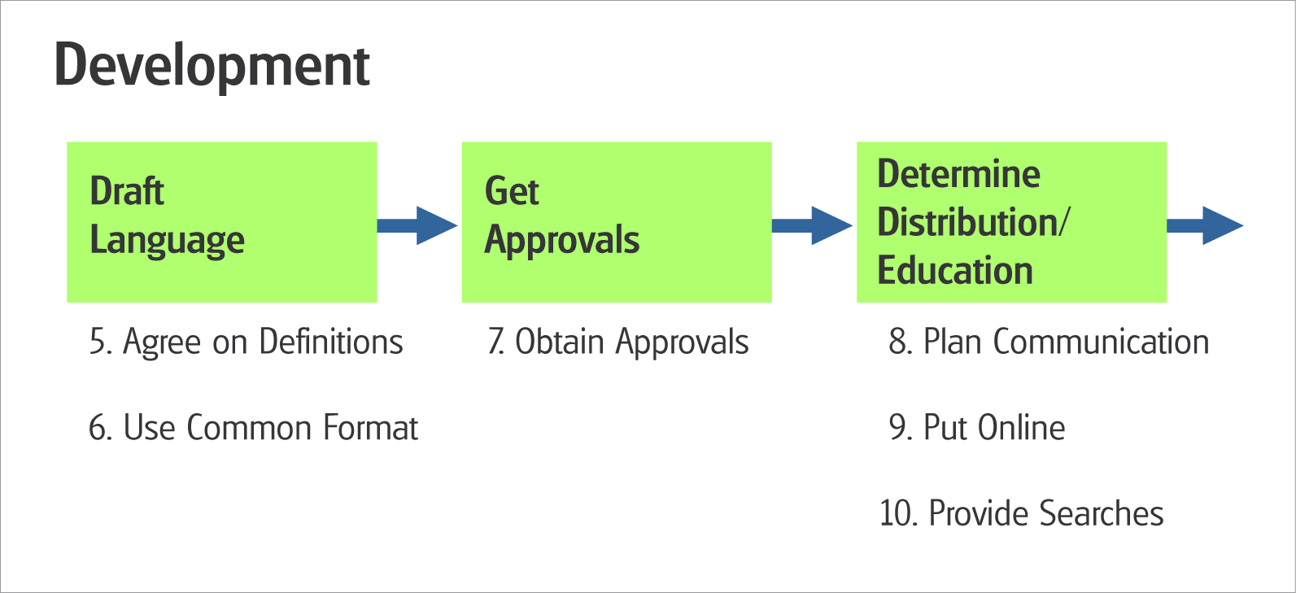

- Agree on Common Definitions and Terms
This seems simple but truly important. Not everyone will agree on what constitutes a policy or procedure. Throw in terms like rules, regulations, standards, guidelines, laws, recommendations and the picture gets even cloudier. This is not an easy task but it will provide a great deal of clarity during the policy process. These definitions should be readily available to those preparing policies.

- Use a Common Format
Coordination by those who manage and produce policies is needed to establish a common format. The payoff will be easier to find information for those accessing information but it will also help those creating policies be consistent. When developing policy, the common format speeds development and will often force questions to be answered that might not ordinarily come to light. The format helps to break up policies into digestible chunks. Consider having a "Contacts" section for policy interpretation and or an associated FAQ to capture the answers.

- Obtain Approval at Owner and Senior Levels
Throughout the process there should be periodic reviews and agreement with those who must ultimately approve the new policy. Before the process begins there must be agreement on the overall purpose and the outcome of the work.
A review of draft policy statements through the process can be critical to avoid misunderstandings about scope, timing, responsibilities and ownership. Consider periodic updates for stakeholders. A comment period may be appropriate in some circumstance. Finally, be sure all approvals are secured before publication.

- Plan Communication, Publicity, and Education
When policies are approved communicate results to those needing the information. This can vary widely. Determine various core interest groups and devise practical communication options. Include new and revised policy information in existing publications. Some issues may require special mailings and or training efforts. Establish a regular communication channel for all policies and institute special communication plans for those that are critical, complicated or time-sensitive. For critical issues, the importance of being proactive cannot be overstated.

- Put Information Online and Accessible From One Location
Having information online is the most effective way to make the information available. Getting all policy information in one location may be more difficult. Different offices often own policies and procedures. Coordination between these different groups is necessary if the end users are to achieve easy access. Creating one unified site will also assure your community that the policy list is complete. Consider setting up information in a database to facilitate search and sort capabilities. Active server pages enable fast updating of data on the web site.

- Provide Search Capability
People look for information in different ways. Some will remember it is a Human Resources policy while others the title. Others still recall a key word or the form name associated with the policy. The search tools should provide as many options as possible. When your users can do a full text search on all polices and procedures, you will know you have arrived at the highest level of policy accessibility.

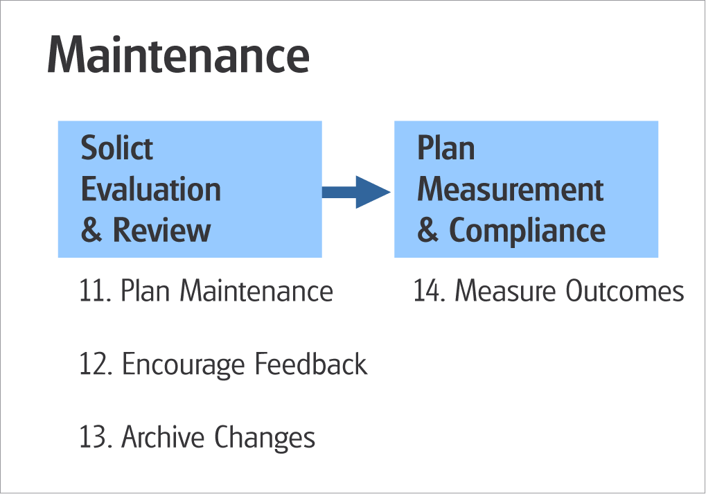

- Develop a Plan for Active Maintenance and Review
Owners of policy may not have the time or inclination to keep the information current. A methodology and training process needs to be in place to assist them. New developments in document management software can help in this area. Audits can often identify information that needs updating. There is no quicker way to lose the confidence of your users than to have information that is obsolete and no longer applicable.

- Encourage Users to Provide Feedback
The people who use the policies can help keep them accurate. Users are often the first to notice that information is outdated. Having an easy and visible way to invite feedback will assist in the maintenance process. User involvement will also help communicate the message to users that their help is welcomed and that they have an opportunity and perhaps even an obligation to keep information current. Users know what works and what doesn't. They can often offer suggestions for improvement.

- Archive Changes and Date New Releases with an “Effective Date”
Members of your community need to know what's new. However, there are times when it is important to know and be able to retrieve the "old information". For legal and administrative purposes it is critically important to provide access to a historical file of the texts of older policies that accurately reflects the dates when changes were made, the changes that were made to the wording, and who authorized the changes. Consider making policies "effective" at a future date if you are not ready for implementation.

- Measure Outcomes by Monitoring or Testing
Why have policies that no one follows? There are many factors that encourage people use a policy such as proper training and it being easy to read, find and understand. Making sure policies are accurate and up-to-date will increase confidence and use. Consider developing a measure to quantify the usefulness of the policies, such as the number of hits on the web site or logging phone calls on questions or suggestions for improvement. For critical issues, an internal or external audit may provide feedback on the extent of compliance with the policy or procedures.

