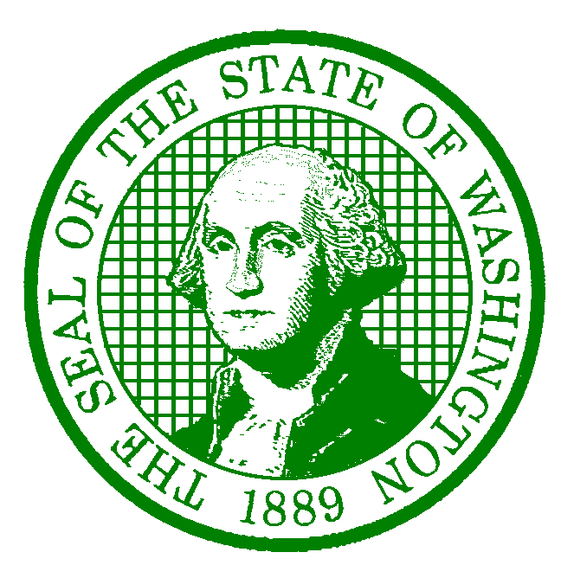**AGENCY LETTERHEAD**

December 20, 2022

Employee Name

Employee Address

City, State Zip-Code

Dear Employee Name:

This is to inform you that your project appointment has been extended in accordance with Washington Federation of State Employees (WFSE) Collective Bargaining Agreement (CBA) Article 4.5. Your employment in the project will terminate on date unless you are notified otherwise.

I want to thank you for your continued hard work. In the event you have questions concerning this extension, please feel free to contact Name at Phone # or Email Address.

Sincerely,

Supervisor/Appointing Authority/HR Liaison

Title

cc: Supervisor Name, Supervisor

saa@des.wa.gov

Personnel File