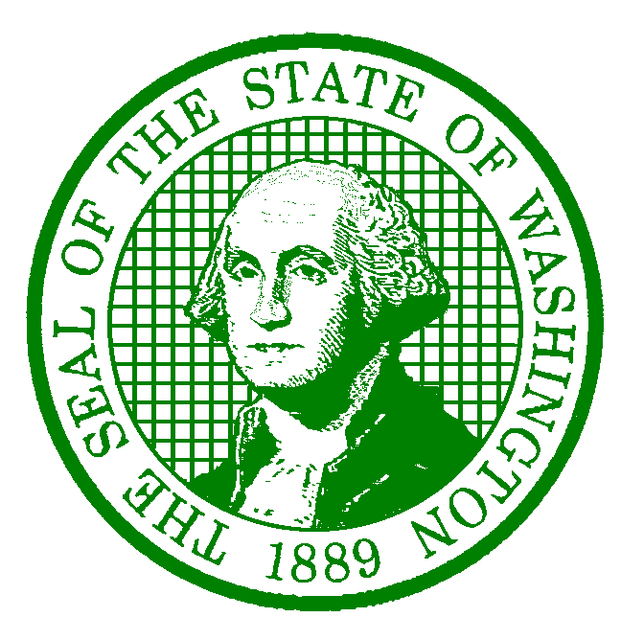**AGENCY LETTERHEAD**

December 20, 2022

Employee Name

Employee Address

City, State Zip-Code

Dear Employee Name:

This letter is confirmation of your approved salary increase. Effective Effective Date, your salary will increase to $Monthly OR Hourly Wage per month OR hour, RangeRange, Step Step**,** in accordance with the WAC 357-28-090.

In the event you have questions concerning your salary increase, please feel free to contact Name at Phone # or Email Address.

Sincerely,

Supervisor/Appointing Authority/HR Liaison

Title

cc: Supervisor Name, Supervisor

saa@des.wa.gov

Personnel File