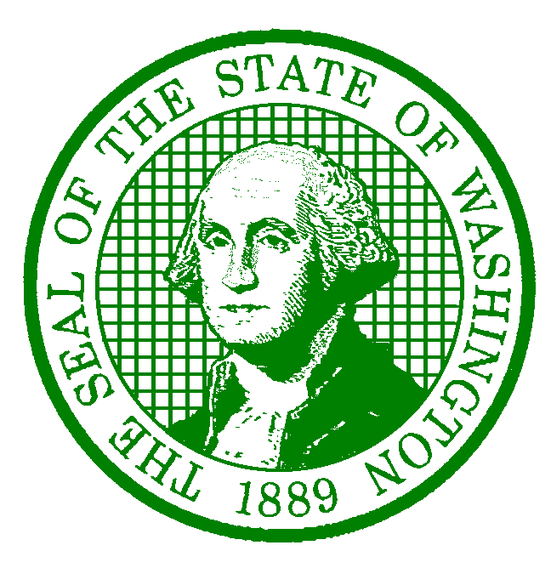**AGENCY LETTERHEAD**

December 22, 2022

Employee Name

Employee Address

City, State Zip-Code

Dear Employee Name:

This is official notice that your duty station will be changing from Current Duty Station to New Duty Station effective Effective Date.

Please let me know if you have any questions.

Sincerely,

Supervisor/Appointing Authority/HR Liaison

Title

cc: Supervisor Name, Supervisor

[saa@des.wa.gov](mailto:saa@des.wa.gov)

Samantha Costanti, DES Labor Relations Advisor

Personnel File