Guided Buying in the Washington State Amazon Business Environment
Amazon Business has a feature providing agency or group-level management of preferences and restrictions for product categories. This is known as category curation.
Be sure your organization has made full use of procurement training for state or non-state employees. Ensure your procurement policies, procedures and signature authorities are up-to-date and your staff have reviewed these documents.
Remember: Washington State Amazon Business Environment does not replace the requirement to use state master contracts for state agencies, and may not meet the competitive bidding or policy requirements of other entities.
Guided Buying allows you to add restrictive pop-up messaging to entire product categories. However, not all of the items in product category may be available on master contract. For product categories that already have master contracts, a well-informed administrator may want to create a pop-up message that says, “Some items found in this category may be available on master contract and those contracts must be used first before making a purchase through Amazon Business.” You can build pop-up messages once and apply it to multiple categories.

Instructions for creating a pop-up message
- Open Amazon Business.
- Hover over the dropdown arrow to the right of your account name in the upper right-hand corner.
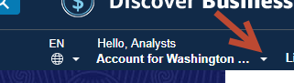

- If you have administrator permissions, you will see the selection to “Business Settings.” Click on “Business Settings” and sign in using your email and password.
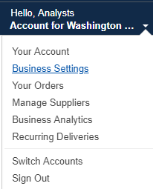
- Under “Buying Policies” you will see “Guided Buying” as one of the available options. Select “Guided Buying”.
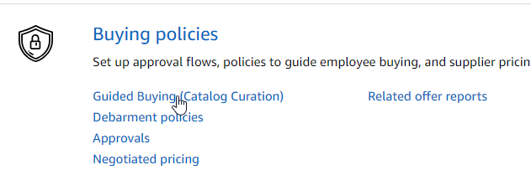
- A new screen will open. Click on “Manage Guided Buying”.
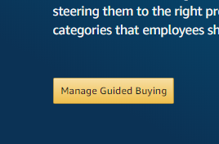
- Selected “Manage” under “Restricted policies”.
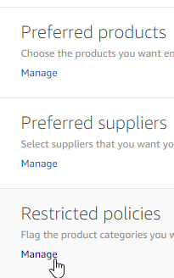
- In the next screen, select “Add Policy”.
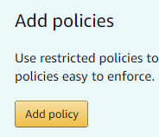
- A pop up box will open. Select “Restrict categories”. Enter the “Policy name”, a message for buyers. You may also enter an optional message for admins.
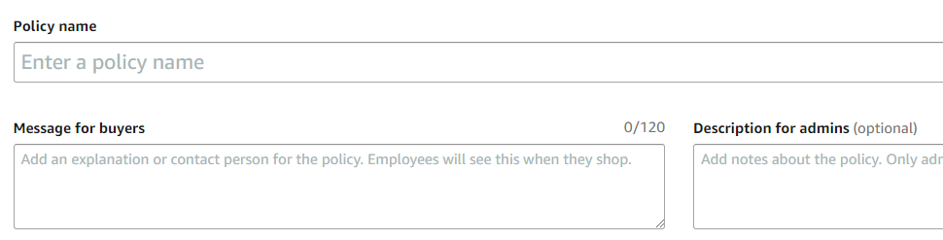
- Next, choose and select a category buy scrolling through the list or searching by category name.
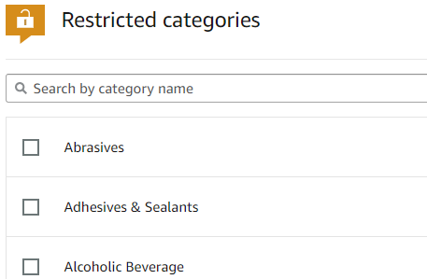
- Select “Save policy” in the bottom right corner.
You can copy and paste the message into as many categories as you like.
Managers and administrators can monitor transactions to determine if a requisitioner or unit requires additional procurement training or if a category is problematic.
If you want to prevent the ability of staff to purchase from a specific category without pre-approval, this must be done in the “Approvals” menu. Be sure to create a restricted category in the “Guided Buying” area before using the instructions for “Approvals.”
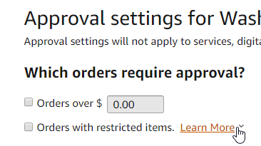

You can also view a “Set up Workflows” tutorial video on the Amazon Business Video Tutorial webpage.

If you have additional questions, please contact Contracts and Procurement Business Operations at cprmanalytics@des.wa.gov or (360) 407-2214.

User Tip
Firefox and Chrome have been the most effective browsers with Amazon Business videos and system functions. Users of Internet Explorer continually report experiencing challenges.
If you have trouble with your browser, please try an alternative such as Firefox or Chrome. Please provide feedback on your issues to Amazon via their feedback tool.

