**CMS Mailpiece Design Tips for Flats**

**Flats**

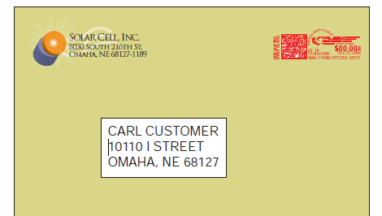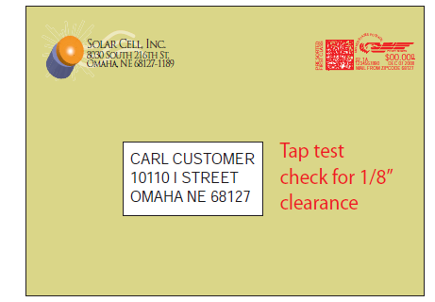

First-Class flats must meet the following standards in order to qualify for flat-size postage rates.

* Weigh no more than 13 oz. and be rectangular in shape
* Uniform thickness – no more than ¼ inch variance
* Flexible (must meet USPS flexibility requirements)
* Deflection (must meet USPS deflection requirements) Droop Test
* Clasps, strings, button closures or any protrusions are prohibited
* Meter strip should be parallel to the address
* Tyvek envelopes are not permitted
* Glossy stock envelopes are not recommended
* The orientation of the flat can be landscape or portrait

**Presort Flats**

USPS automation discounts apply to flat-size mailpieces that are barcoded by the mailer. Consolidated Mail Services sends qualifying First Class pieces to Pitney Bowes Presort Services for barcoding and submission to the USPS. The mailpiece itself must also meet the physical requirements for automated flat sortation.

* Delivery address must be more prominent than the return address
* Recommended 10 or 12 point font-size. ALL CAPS. Avoid script, bold and narrow fonts
* Some fonts that read very well: Arial, Courier, Helvetica and Tahoma
* Address left justified, not centered
* Delivery address to right and below return address
* At least 1/8” clear zone around entire delivery address
* Keep a clear area for the barcode to be printed at the bottom of the piece (at least 5/8”)

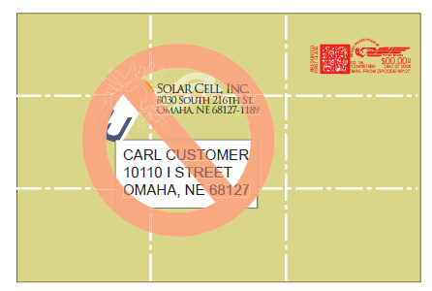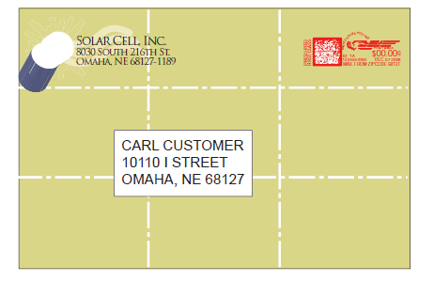Imagine your flat is divided into 9 equal parts. Place the delivery address in a different section than the return address.

All commercial flats must meet [USPS requirements](http://pe.usps.com/text/qsg300/Q201d.htm#1009536) to qualify for automation pricing.

Please note all First Class presort flats are sent **next-day** from CMS.

**Presort Flats – things to know**

* Average savings of $0.045 cents per piece.
* Presort flats are submitted to the Postal Service the next business day.
* Check the “other” box on the pink slips and write in “Presort flats” (pink slips ordered after 6/01/14 will have a 1st Class Presort box to check under “Flats”).
* Design and prepare the flats using the guidelines above.