GUIDANCE for APPLYING VETERANS PREFERENCE

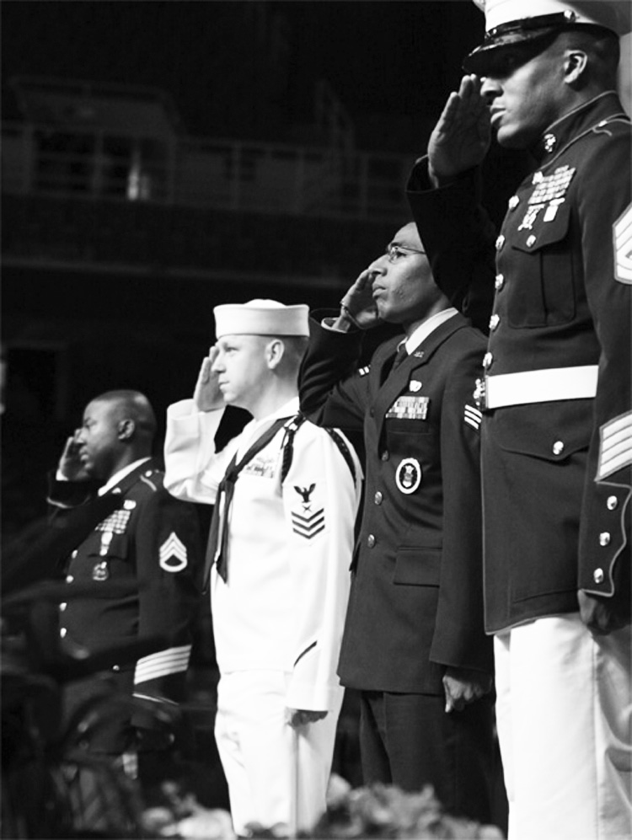

Revision Date: April 8, 2013

Guidance for Applying Veterans’ Preference
What is the purpose of Veterans’ Preference?
Recognizing that sacrifices are made by those serving in the Armed Forces (See Note 1), Washington State has enacted laws to assist veterans seeking State employment. Veterans of the Armed Forces as defined in RCW 41.04.007 have been given some degree of preference in appointments to State jobs.
Qualifying veterans, surviving spouses or registered domestic partners of eligible veterans, or spouses or registered domestic partners of honorably discharged veterans who have a service connected permanent and total disability, are eligible for veterans preference when applying for state employment.

Applying Veterans’ Preference - Competitive Service
If an employer administers an examination prior to certification, the employer must grant preference to veterans as defined in RCW 41.04.007 (see note 2), by adding veterans’ scoring criteria (Formerly a Preference Status) in accordance with RCW 41.04.010 and WAC 357.16.110(1).
For purposes of complying with RCW 41.04.010, examination is defined as the eligible candidate’s final examination score, plus any veterans’ scoring criteria or other applicable results. Veterans’ scoring criteria is only added to a passing score. When an examination is used to establish a certified referral, the examination score needs to be equivalent to a 0-100% scale. The veterans’ preference is a percentage added to the passing examination score based on a possible rating of one hundred points as a perfect percentage. The percent preferences are added as follows:
- Ten percent to a veteran who served during a period of war (See Note 4) or in an armed conflict as defined in RCW 41.04.005 (see note 4) and does not receive military retirement. The percentage shall be added to the passing mark, grade, or rating of competitive examinations until the veteran’s first appointment. The percentage shall not be utilized in promotional examinations.
- Five percent to a veteran who did not serve during a period of war or in an armed conflict as defined in RCW 41.04.005 or is receiving military retirement. The percentage shall be added to the passing mark, grade, or rating of competitive examinations until the veteran’s first appointment. The percentage shall not be utilized in promotional examinations.
- Five percent to a veteran who was called to active duty from employment with the state or any of its political subdivisions or municipal corporations. This percentage shall be added to promotional examinations until the first promotion only.
Veterans’ scoring criteria may be claimed upon release from active military service.
Q: Can veterans' scoring criteria status be applied to a competitive service examination if the applicant had claimed it on a previous examination which resulted in a permanent appointment, even if the appointment was with a public employer that is outside state government?
A: No, the veteran may not again use his or her scoring criteria status after it has been previously claimed and that person was hired based on the examination in which the status was claimed (See Note 13).
Veterans preference should not be given automatically because an applicant is a veteran. Applicants must provide a copy of a DD 214 or National Guard Bureau (NGB) Form 22, or signed verification of service letter from the U.S. Department of Veterans Affairs for verification of status (see note 6).
Competitive Service |  |  |  |  | (Notes are found on pages 5 and 6.)
Scenario |  |  | RCW |  | Entitlement |  | Reference Notes
Applicant served in the military from 1989-1993.  - Not receiving retirement benefits.  - Did not serve in an armed conflict.  - Served during period of war. |  |  | 41.04.010(1) |  | Entitled to 10%.  Persian Gulf War era is from 8-2-90 to present.  Persian Gulf era is a period of war. |  | See Note 1
Applicant served in the military from 1980-1985.  - Received no campaign medals.  - Not receiving retirement benefits.  - Did not serve during time of war. |  |  | 41.04.010(2)  41.04.005 |  | Entitled to 5%
Applicant served in the military from 1970-1985.  - Receiving military retirement.  - Served during period of conflict.  - Received Armed Forces Expeditionary Medal. |  |  | 41.04.010(2)  41.04.005(2) |  | Entitled to 5%
Applicant served in the military from 1972-1986.  - Not receiving military retirement.  - Did not receive campaign medal. |  |  | 41.04.010(1)  41.04.005(2) |  | Entitled to 10%.  Served during Vietnam Era (1964–1975).
Applicant served in the military from 1945-1963.  - Not receiving retirement.  - Received Korean Service Medal. |  |  | 41.04.010(1)  41.04.005(2) |  | Entitled to 10%  15-year limitation eliminated by 2003 legislature.
Applicant previously received Veterans’ Scoring Criteria.  - Percentage resulted in veterans’ first appointment.  - Called to active military service. | 41.04.010(3) |  |  |  | Entitled to 5%.  Percentage added to all competitive promotional examinations until the first promotion only.  Does not include Active Duty for Training (ADT). | See Note 14
Applicant served in military 1973-1975.  Received General Discharge Under Honorable Conditions. | 41.04.005(1) |  |  |  | Not entitled. | See Note 2
Applicant served in military 1973-1975.  Received Discharge Under Honorable Than Honorable Conditions. | 41.04.005(1) |  |  |  | Not entitled | See Note 3
Applicant served in military 1998-2000.  Received Dishonorable Discharge. | 41.04.005(1) |  |  |  | Not entitled
Applicant served in National Guard/ Armed Forces Reserves.  Completed initial military obligation.  Served during period of war or in an armed conflict or receive a campaign medal | 41.04.010(1) and 41.04.007(1) |  |  |  | Entitled to 10% | See Notes 4, 5, 6 and 8
Applicant served in National Guard/Armed Forces Reserves.  - Completed initial military obligation.  - Did not serve during period of war or in an armed conflict. | 41.04.010(2) and 41.04.007(1) |  |  |  | Entitled to 5% | See Notes 4 and 5
Applicant only served in the military for Active Duty for Training (ADT). |  | 41.04.007(1) |  | Not entitled, did not fulfill initial military service obligation. |  |  | See Note 14
Applicant is a United States documented Merchant Mariner with service aboard an ocean going vessel operated by the Department of Defense or one of its agents.  Received military commendation. |  | 41.04.007(6) and 41.04.010(1) |  | Entitled to 10% |  |  | See Note 7

Application of Veteran’s Non-Competitive Service Preference
If no examination is administered prior to certification, the employer must refer eligible veterans or eligible veterans’ surviving spouses or surviving registered domestic partners, or the spouse or registered domestic partner of an honorably discharged veteran who has a service connected permanent and total disability to the employing official under the provisions of RCW 73.16.010 and WAC 357.16.110(2) as long as the veteran or veteran’s spouse or registered domestic partner meets the competencies and other position requirements. Application of preference includes WMS and Exempt positions. (see notes 11 and 12)
Non-Competitive Service
Scenario | RCW | Entitlement | Reference Notes
Applicant is a veteran, surviving spouse or surviving registered domestic partner of a veteran who served during a period of war.  Veteran received an honorable discharge. | 73.16.010 | See Notes 10 and 11 | See Notes 2, 4, and 8
Applicant is veteran, surviving spouse or surviving registered domestic partner of a veteran of a military campaign for which a campaign ribbon or medal was awarded.  Veteran received an honorable discharge. | 73.16.010 | See Notes 10 and 11 | See Notes 2, 5 and 8
Applicant is spouse or registered domestic partner of a veteran who has service connected permanent and total disability.  Veteran received an honorable discharge. | 73.16.010 | See Notes 10 and 11 | See Notes 9 and 10
Related Notes: Note 1: U.S. Armed Services – Army, Navy, Marines, Air Force and Coast Guard. Note: National Oceanographic & Atmospheric Administration (NOAA) and the Public Health Services are considered Uniformed Services, but not Armed Services and are not eligible for Veterans Scoring Criteria.
Note 2: Block 24 of DD 214 or NGB Form 22 should reflect character of service as being Honorable. General discharge Under Honorable Conditions does not qualify. General discharges are given to service a service member whose performance is satisfactory, but is marked by a considerable departure in duty performance and conduct expected of military members who receive Honorable discharges.
Note 3: In 1980 the Manual for Courts Martial was amended and the Undesirable Discharge was changed to Under Other Than Honorable conditions.

Note 4: Periods of war are: (See block 12 of DD 214 or block 10 of NGB 22 for record of service dates)
- World War II
- The Korean Conflict
- Viet Nam Era (Aug 5, 1964 – May 7, 1975)
- Persian Gulf War (Aug 2, 1990 – to a date prescribed by presidential proclamation or law.)
Note 5: Current armed conflicts in which a campaign badge or medal may be awarded are:
Grenada, Operation Urgent Fury; Panama, Operation Just Cause; Somalia, Operation Restore Hope; Haiti, Operation Uphold Democracy; and Bosnia, Operation Joint Endeavor.
Note 6: See block 6, DD 214 or block 11, NGB 22 for Reserve Obligation Termination Date. Completion of initial military obligation is defined as the discharge or release of service member from National Guard/Armed Forces Reserves upon completion of the obligated term of service for which they enlisted or termination of their appointment as an officer of the National Guard/Armed Forces Reserve. Block 11 Terminal Date of Reserve/Military Service Obligation, NG Form 22 or block 6 Reserve Obligation Termination Date, DD 214 should be reviewed to identify when an applicant fulfills their initial military service obligation. When using U.S. Department of Veterans Affairs verification letter look at Entered on Active Duty, Released from Active Duty, and Character of Discharge (Honorable Discharge Only).
Note 7: Vessel must have served in either Korean territorial waters from June 25, 1950 through July 27, 1953 or Vietnam territorial waters from August 5, 1964 through May 7, 1975. Applicant must provide official documentation verifying that he or she was a documented Merchant Mariner along with copy of military commendation.
Note 8: Applicants may be awarded one of the following or equivalent campaign medals. Award should be reflected in section 13 of DD 214. See current list below of authorized campaign medals:

Navy/Marine Corps Expeditionary Medal
- Armed Forces Expeditionary Medal: Dates 1958 to a date to be determined.

Southwest Asia Service Medal: Dates Aug 2, 1990 – Nov 30, 1995
- Afghanistan Campaign Medal: Dates Oct 24, 2001 to a date to be determined.
- Iraq Campaign Medal: Dates Mar 19, 2003 to a date to be determined.
Note 9: Spouse or registered domestic partner should provide copy of spouses DD 214. See notes 2,4 and 5 above for verification of honorable discharge, service time during period of war or receipt of campaign medal.
Note 10: Spouse or registered domestic partner should provide copy of U.S. Department of Veterans Affairs Disability Awards letter. Letter must reflect 100% total disability.
Note 11: For purposes of this RCW the term “no examination” as specified in WAC 357.16.110(2) refers to the use of a non-competitive eligibility list containing the names of all the applicants who meet the position minimum or desirable qualifications. EX: Pass or Fail exam where those applicants who meet the position requirements all receive a score of 100 percent versus 0-100 percent requirement specified in RCW 41.04.010.
Note 12: The Washington State Court of Appeals Division II ruled in Gossage v. State of Washington (2002) ruled that “contrary to Gossage's claim, however, this preference operates as a “tie-breaker among equally qualified candidates, not an absolute preference for veterans once they pass the examination …. Where two or more candidates for employment have equal qualifications, including performance on examinations, interviews, and other testing, preference must be given the veteran”.
Note 13: In its AGO 1974 No. 22 dated October 30, 1974 the Attorney General concluded that RCW 41.04.010, as amended, does not permit the use of the veterans' preference in connection with an application by a veteran for covered public employment once the veteran has received the offer of a first appointment because of prior use of the preference. We believe this to be true regardless of whether such subsequent application for employment is for a position with the same state agency, municipal corporation or political subdivision as before, or one different from the public employer which offered the first appointment.
Note 14: AGLO 1975 No. 14 dated February 10, 1975 the Attorney General concluded that a person is not eligible for a veteran's preference in a competitive examination for public employment under RCW 41.04.010(1) solely on the basis of a six year enlistment in the Washington National Guard under 10 U.S.C.§ 511(d) with respect to which his only period of active duty (aside from drills and annual training exercises) was for a four month training period as required by that federal statute.

